**Ensyfi – Admin Module**

## 1) Objective of the Technical Document

The purpose of this document is to give technical information about Ensyfi Admin’s module design and development implementation.

**2) Functional Overview**

Admin login details (Web URL, Username and password provided by Happysanz Tech. After Login they can view Following Models.

**Login Module**

* Login
* Profile Update
* Change Password
* Notification settings
* Dashboard
* Logout

**Masters**

* Academic Years
* Academic Terms
* Class & Sections
* Subjects
* Class Management
* Co-curricular Activities
* Houses

**Admission**

* Student Profile
* Student Search
* Parents Search

**Allocation**

* Student Allocation
* List of Students

**Staff**

* Create Staff
* Staff Search
* Staff Leaves

**Fees**

* Quota
* Fees Master
* Fee Status

**Attendance**

* Daywise Attendance
* Monthwise Attendance
* Date view

**Calendar**

* Create/View Event
* Event Calendar
* Add/ View Leave

**Timetable**

* Create Timetable
* Manage Timetable

**Examination**

* Create/View Exams
* Examination Calendar
* Exam Results

**Circular**

* Circular Master
* Send Circular
* View Circular

**Group Messages**

* Create/ View Group
* Send Message

**Promotions**

* View Promotions

**On Duty**

* Teachers
* Students

**Control Panel**

* Teachers
* Parents
* Students

**School Report**

**Quick Links**

* Special Class
* Create Reminder
* Circular Master

## 3) Technologies used

Client scripting : HTML(V5),Css(v3),Javascript

CSS framework : Bootstrap v4.0.0

JavaScript library : jQuery v2.2.4, Google Map API

Server scripting : PHP(v5.2.8)

Framework : CodeIgniter(v3)

Data base : MySQL(v5.1)

Apache server,PHP, MySQL and .Except from Google technology that we just have access to the API list, all other technologies and component are open source.

**Application security**

Ensyfi web application is developed in CodeIgniter Application Development Framework(V.3). That is PHP with MYSQL open source Frame work. CodeIgniter lets you creatively focus on your project by minimizing the amount of code needed for a given task.

* Model-View-Controller Based System
* Extremely Light Weight
* Full Featured database classes with support for several platforms.
* Query Builder Database Support
* Form and Data Validation
* Security and XSS Filtering
* Session Management
* Password Encryption
* Email Sending Class. Supports Attachments, HTML/Text email, multiple protocols (sendmail, SMTP, and Mail) and more.
* Image Manipulation Library (cropping, resizing, rotating, etc.). Supports GD, ImageMagick, and NetPBM
* File Uploading Class
* FTP Class
* Localization
* Pagination
* Data Encryption
* Benchmarking
* Full Page Caching
* Error Logging
* Application Profiling
* Calendaring Class
* User Agent Class
* Zip Encoding Class
* Template Engine Class
* Trackback Class
* XML-RPC Library
* Unit Testing Class
* Search-engine Friendly URLs
* Flexible URI Routing
* Support for Hooks and Class Extensions
* Large library of “helper” functions

**Web Server security**

* Vigorous Password Strategy
* Regular Scanning and Testing
* Firewall Protection
* Maintain Database
* Update Software Regularly
* Data Backups – Daily, Weekly
* Stored Encrypted Data
* Secure SSH and Remote Access
* Basic SSL Certificate

**4) Server Specifications**

## Server and Database Requirement

* PHP 5.2.8
* Mysql 5.1
* Apache 2.2.1
* Linux

**High availability**

Our data centers set the standards for redundant power and climate control, giving you the confidence you will have the power necessary to run your mission-critical services.

**Security**

Our facilities are built in secure structures, located in geographic safe-zones. Multiple layers of security, including video surveillance and biometric access control, ensure that access is granted only to the appropriate individuals. Access is logged and retained.

Our data centers have no exterior signage. Client information is treated as confidential. Our staff are industry-trained and follow stringent security procedures.

**Power**

Our data center are powered by multiple power feeds from separate sources, backed up by multiple UPS and diesel powered generator systems.

**Carrier-neutral network**

Our facilities utilize multiple carrier-neutral, high-speed internet feeds, ensuring reasonably priced bandwidth delivered over a secure and redundant network.

**Environmental**

In several locations, Our employs a cold-aisle containment system, as well as a mix of climate cooling and mechanical cooling to create affordable, reliable and efficient environmental conditions throughout all our new concurrently maintainable facilities.

**Network Operations Center (NOC)**

Our NOC teams ensure top performance in event management, enforce security standards and assist with client requests. Each data center is protected and operated by an experienced NOC team. Several of our data centers have an in-house NOC team staffed 24/7/365.

**Features**

* Cloud based dedicated server
* 99.9% uptime guaranteed
  + Once your server's up, keep it up. We guarantee a 99.9% uptime for server availability.
* Two-Factor Authentication
  + Two-factor authentication increases the security of your Manager account by requiring two forms of authentication - something you have, and something you know.
* IPv6 Support
  + Native IPv6 support is available at all 9 of our datacenter locations. Each Linode starts off with one global IPv6 address and additional IPv6 addresses can be added at no charge.
* Rescue Mode
  + Use Rescue mode to recover from critical errors. Perform system recovery tasks and transfer data off your disk images, if necessary.
* DNS Manager
  + Oversee your domains with our full-featured DNS manager. Supports both master and slave zones.
* Scaling
  + Easily scale your server to handle increases in traffic with just a few clicks. Resizing is as simple as logging in, clicking, and letting our system do the rest of the work.
* Cloning
  + Clone an entire configuration or just the disk images you select to another server. Combine with the IP failover feature to create your own high-availability cluster.
* Supported Distributions
  + Quickly deploy Debian, Ubuntu, CentOS, Fedora, Arch, Gentoo, openSUSE, and Slackware images (see our full list) or run a custom distro.
* Images
  + Preserve your disk’s fully prepared software environment. Create snapshots of a disk volume preserving paths, files, boot information and filesystem details for subsequent replication.

# 

# 5) Table Structure

## edu_academic_year

|  |  |
| --- | --- |
| ***year_id*** | ***int(11)*** |
| from_month | date |
| to_month | date |
| status | varchar(10) |
| created_date | date |

## edu_admission

|  |  |
| --- | --- |
| ***admission_id*** | int(11) |
| admisn_year | int(11) |
| admisn_no | varchar(20) |
| emsi_num | varchar(100) |
| admisn_date | date |
| name | varchar(100) |
| sex | varchar(10) |
| dob | date |
| age | int(11) |
| nationality | varchar(100) |
| religion | varchar(50) |
| community_class | varchar(30) |
| community | varchar(100) |
| parnt_guardn | varchar(50) |
| parnt_guardn_id | varchar(120) |
| mother_tongue | varchar(100) |
| language | int(11) |
| mobile | varchar(100) |
| sec_mobile | varchar(20) |
| email | varchar(100) |
| sec_email | varchar(50) |
| student_pic | text |
| last_sch_name | varchar(100) |
| last_studied | varchar(100) |
| qualified_promotion | varchar(100) |
| transfer_certificate | varchar(100) |
| tccopy | varchar(50) |
| record_sheet | varchar(50) |
| status | varchar(10) |
| parents_status | int(11) |
| enrollment | int(11) |
| blood_group | int(11) |
| created_by | int(11) |
| created_at | datetime |
| updated_by | int(11) |
| updated_at | datetime |

## edu_attendance_calendar

|  |  |
| --- | --- |
| ***id*** | int(11) |
| Date | datetime |
| class_master_id | int(11) |

## edu_attendance_history

|  |  |
| --- | --- |
| ***absent_id*** | int(11) |
| attend_id | int(11) |
| class_id | int(11) |
| student_id | int(11) |
| abs_date | date |
| a_status | varchar(11) |
| attend_period | int(11) |
| a_val | int(11) |
| a_taken_by | int(11) |
| created_at | datetime |
| updated_by | int(11) |
| updated_at | datetime |
| status | varchar(20) |

## edu_attendence

|  |  |
| --- | --- |
| ***at_id*** | int(11) |
| ac_year | int(11) |
| class_id | int(11) |
| class_total | int(11) |
| no_of_present | int(11) |
| no_of_absent | int(11) |
| attendence_period | int(11) |
| created_by | int(11) |
| created_at | datetime |
| updated_by | int(11) |
| updated_at | int(11) |
| status | varchar(20) |
| sent_status | int(11) |

## edu_blood_group

|  |  |
| --- | --- |
| ***id*** | int(11) |
| blood_group_name | varchar(20) |
| status | varchar(20) |
| created_by | int(11) |
| created_at | datetime |
| updated_by | int(11) |
| updated_at | datetime |

## edu_circular

|  |  |
| --- | --- |
| ***id*** | int(11) |
| user_type | int(11) |
| user_id | int(11) |
| circular_master_id | int(11) |
| circular_type | varchar(50) |
| circular_date | date |
| status | varchar(10) |
| created_by | int(11) |
| created_at | datetime |
| updated_by | int(11) |
| updated_at | datetime |

## edu_circular_master

|  |  |
| --- | --- |
| ***id*** | int(11) |
| academic_year_id | int(11) |
| circular_title | varchar(100) |
| circular_description | varchar(250) |
| circular_doc | varchar(100) |
| status | varchar(10) |
| created_by | int(11) |
| created_at | datetime |
| updated_by | int(11) |
| updated_at | datetime |

## edu_class

|  |  |
| --- | --- |
| ***class_id*** | int(11) |
| class_name | varchar(100) |
| status | varchar(10) |

## edu_classmaster

|  |  |
| --- | --- |
| ***class_sec_id*** | int(11) |
| class | int(10) |
| section | varchar(10) |
| subject | varchar(100) |
| status | varchar(30) |
| created_at | date |

## edu_class_marks

|  |  |
| --- | --- |
| ***mark_id*** | int(11) |
| enroll_mas_id | int(11) |
| hw_mas_id | int(11) |
| marks | varchar(50) |
| remarks | text |
| status | varchar(10) |
| created_by | int(11) |
| created_at | datetime |
| updated_by | int(11) |
| updated_at | datetime |

## edu_communication

|  |  |
| --- | --- |
| ***commu_id*** | int(11) |
| commu_title | varchar(250) |
| commu_details | text |
| commu_date | date |
| teacher_id | varchar(50) |
| class_id | varchar(30) |
| status | varchar(20) |
| created_at | date |
| updated_at | date |

## edu_communication_review

|  |  |
| --- | --- |
| ***review_id*** | int(11) |
| commu_id | int(11) |
| details | text |
| reply_by | int(11) |

## edu_days

|  |  |
| --- | --- |
| ***d_id*** | int(11) |
| list_day | varchar(50) |

## edu_enrollment

|  |  |
| --- | --- |
| ***enroll_id*** | int(11) |
| admission_id | int(11) |
| admit_year | varchar(20) |
| admit_date | date |
| admisn_no | int(11) |
| name | varchar(200) |
| class_id | int(11) |
| house_id | int(11) |
| extra_curicullar_id | int(11) |
| quota_id | int(11) |
| created_at | datetime |
| created_by | int(11) |
| updated_at | datetime |
| updated_by | int(11) |
| status | varchar(10) |

## edu_events

|  |  |
| --- | --- |
| ***event_id*** | int(11) |
| year_id | int(11) |
| event_name | varchar(250) |
| event_date | date |
| event_details | text |
| status | varchar(10) |
| sub_event_status | int(11) |
| created_at | date |

## edu_events_galllery

|  |  |
| --- | --- |
| ***gallery_id*** | int(11) |
| event_id | int(11) |
| event_tb | varchar(100) |
| event_ori | varchar(100) |

## edu_event_coordinator

|  |  |
| --- | --- |
| ***co_id*** | int(11) |
| event_id | int(11) |
| sub_event_name | varchar(240) |
| co_name_id | int(11) |
| status | varchar(50) |
| created_at | date |
| updated_at | date |

## edu_examination

|  |  |
| --- | --- |
| ***exam_id*** | int(11) |
| exam_year | int(11) |
| exam_name | varchar(100) |
| exam_flag | int(11) |
| grade_flag | int(11) |
| status | varchar(10) |
| created_at | date |
| updated_at | date |

## edu_exam_details

|  |  |
| --- | --- |
| ***exam_detail_id*** | int(11) |
| exam_id | int(11) |
| subject_id | int(11) |
| exam_date | date |
| times | varchar(50) |
| exam_time_from | varchar(20) |
| exam_time_to | varchar(20) |
| classmaster_id | int(11) |
| teacher_id | int(11) |
| subject_total | int(11) |
| is_internal_external | int(11) |
| internal_mark | int(11) |
| external_mark | int(11) |
| notes | text |
| status | varchar(50) |
| created_at | date |
| created_by | int(11) |
| updated_at | date |
| updated_by | int(11) |

## edu_exam_marks

|  |  |
| --- | --- |
| ***exam_marks_id*** | int(11) |
| exam_id | int(11) |
| teacher_id | int(11) |
| subject_id | int(11) |
| stu_id | int(11) |
| classmaster_id | int(11) |
| internal_mark | varchar(20) |
| internal_grade | varchar(10) |
| external_mark | varchar(20) |
| external_grade | varchar(10) |
| total_marks | varchar(50) |
| total_grade | varchar(10) |
| created_by | int(11) |
| created_at | date |
| updated_by | int(11) |
| updated_at | date |

## edu_exam_marks_status

|  |  |
| --- | --- |
| ***exam_status_id*** | int(11) |
| exam_id | int(11) |
| classmaster_id | int(11) |
| status | varchar(20) |
| created_by | int(11) |
| created_at | datetime |
| updated_by | int(11) |
| updated_at | datetime |

## edu_extra_curricular

|  |  |
| --- | --- |
| ***id*** | int(11) |
| extra_curricular_name | varchar(30) |
| status | varchar(10) |
| created_by | int(11) |
| created_at | datetime |
| updated_by | int(11) |
| updated_at | datetime |

## edu_fees_master

|  |  |
| --- | --- |
| ***id*** | int(11) |
| year_id | int(11) |
| term_id | int(11) |
| class_master_id | int(11) |
| quota_id | int(11) |
| fees_amount | float |
| due_date_from | date |
| due_date_to | date |
| notes | varchar(240) |
| status | varchar(10) |
| created_by | int(11) |
| created_at | datetime |
| updated_by | int(11) |
| updated_at | datetime |

## edu_grade

|  |  |
| --- | --- |
| ***id*** | int(11) |
| internal_mark | varchar(20) |
| internal_grade | varchar(10) |
| external_mark | varchar(20) |
| external_grade | varchar(10) |
| total_mark | varchar(20) |
| total_grade | varchar(10) |

## edu_grouping_history

|  |  |
| --- | --- |
| ***id*** | int(11) |
| group_title_id | int(11) |
| notes | varchar(160) |
| notification_type | varchar(50) |
| status | varchar(10) |
| created_by | int(11) |
| created_at | datetime |
| updated_by | int(11) |
| updated_at | datetime |

## edu_grouping_master

|  |  |
| --- | --- |
| ***id*** | int(11) |
| group_title | varchar(50) |
| group_lead_id | int(11) |
| year_id | int(11) |
| status | varchar(10) |
| created_by | int(11) |
| created_at | datetime |
| updated_by | int(11) |
| updated_at | datetime |

## edu_grouping_members

|  |  |
| --- | --- |
| ***id*** | int(11) |
| group_title_id | int(11) |
| group_member_id | int(11) |
| member_type | int(11) |
| class_sec_id | int(11) |
| status | varchar(10) |
| created_by | int(11) |
| created_at | datetime |
| updated_by | int(11) |
| updated_at | datetime |

## edu_groups

|  |  |
| --- | --- |
| ***id*** | int(11) |
| group_name | varchar(30) |
| status | varchar(10) |
| created_by | int(11) |
| created_at | datetime |
| updated_by | int(11) |
| updated_at | datetime |

## edu_holidays_list_history

|  |  |
| --- | --- |
| ***id*** | int(11) |
| leave_list_date | date |
| day | varchar(30) |
| on_week | varchar(30) |
| sno | int(11) |
| leave_masid | int(11) |
| leave_id | int(11) |

## edu_homework

|  |  |
| --- | --- |
| ***hw_id*** | int(11) |
| year_id | int(11) |
| class_id | int(11) |
| teacher_id | int(11) |
| hw_type | varchar(10) |
| subject_id | int(11) |
| title | text |
| test_date | date |
| due_date | date |
| hw_details | text |
| status | varchar(10) |
| mark_status | int(11) |
| send_option_status | int(3) |
| created_by | int(11) |
| created_at | datetime |
| updated_by | int(11) |
| updated_at | datetime |

## edu_leavemaster

|  |  |
| --- | --- |
| ***leave_id*** | int(11) |
| leave_year | int(11) |
| leave_type | varchar(100) |
| leave_classes | varchar(30) |
| status | varchar(30) |
| created_at | date |
| updated_at | date |

## edu_leaves

|  |  |
| --- | --- |
| ***id*** | int(11) |
| leaves_name | varchar(100) |
| leave_date | date |
| days | varchar(11) |
| week | int(11) |
| leave_mas_id | int(11) |
| status | varchar(30) |
| created_at | date |
| updated_at | date |

## edu_notification

|  |  |
| --- | --- |
| ***id*** | int(11) |
| user_id | int(11) |
| gcm_key | text |
| mobile_type | int(11) |

## edu_on_duty

|  |  |
| --- | --- |
| ***id*** | int(11) |
| user_type | int(11) |
| user_id | int(11) |
| year_id | int(11) |
| od_for | varchar(100) |
| from_date | date |
| to_date | date |
| notes | varchar(250) |
| status | varchar(10) |
| created_by | int(11) |
| created_at | datetime |
| updated_by | int(11) |
| updated_at | datetime |

## edu_parents

|  |  |
| --- | --- |
| ***id*** | int(11) |
| admission_id | varchar(50) |
| name | varchar(240) |
| occupation | varchar(100) |
| income | varchar(20) |
| home_address | text |
| email | varchar(50) |
| sec_email | varchar(50) |
| mobile | varchar(20) |
| sec_mobile | varchar(20) |
| home_phone | varchar(20) |
| office_address | text |
| office_phone | varchar(20) |
| relationship | varchar(20) |
| user_pic | varchar(50) |
| status | varchar(10) |
| primary_flag | varchar(10) |
| created_by | int(11) |
| created_at | datetime |
| updated_by | int(11) |
| updated_at | datetime |

## edu_promotion_history

|  |  |
| --- | --- |
| ***id*** | int(11) |
| current_academic_year_id | int(11) |
| promotion_academic_year_id | int(11) |
| student_admission_id | int(11) |
| student_reg_id_for_last_academic_year | int(11) |
| student_name | varchar(50) |
| class_master_id_for_last_academic_year | int(11) |
| result_status | varchar(10) |
| promotion_class_master_id | int(11) |
| promoted_by | int(11) |
| promoted_at | datetime |
| updated_by | int(11) |
| updated_at | datetime |
| status | varchar(10) |

## edu_quota

|  |  |
| --- | --- |
| ***id*** | int(11) |
| quota_name | varchar(100) |
| status | varchar(10) |
| created_by | int(11) |
| created_at | datetime |
| updated_by | int(11) |
| updated_at | datetime |

## edu_reminder

|  |  |
| --- | --- |
| ***id*** | int(11) |
| user_id | int(11) |
| to_do_date | date |
| to_do_title | varchar(100) |
| to_do_description | text |
| status | varchar(10) |
| created_by | int(11) |
| created_at | datetime |
| updated_by | int(11) |
| updated_at | datetime |

## edu_role

|  |  |
| --- | --- |
| ***role_id*** | int(11) |
| user_type_name | varchar(100) |
| staff_status | varchar(10) |
| status | varchar(1) |

## edu_sections

|  |  |
| --- | --- |
| ***sec_id*** | int(11) |
| sec_name | varchar(10) |
| status | varchar(10) |

## edu_special_class

|  |  |
| --- | --- |
| ***id*** | int(11) |
| year_id | int(11) |
| class_master_id | int(11) |
| teacher_id | int(11) |
| subject_id | int(11) |
| subject_topic | varchar(50) |
| special_class_date | date |
| start_time | varchar(10) |
| end_time | varchar(10) |
| status | varchar(10) |
| created_by | int(11) |
| created_at | datetime |
| updated_by | int(11) |
| updated_at | datetime |

## edu_subject

|  |  |
| --- | --- |
| ***subject_id*** | int(11) |
| subject_name | varchar(100) |
| is_preferred_lang | int(11) |
| status | varchar(10) |

## edu_subject_to_class

|  |  |
| --- | --- |
| ***id*** | int(11) |
| class_master_id | int(11) |
| subject_id | int(11) |
| exam_flag | int(11) |
| status | varchar(10) |
| created_at | datetime |
| created_by | int(11) |
| updated_at | datetime |
| updated_by | int(11) |

## edu_substitution

|  |  |
| --- | --- |
| ***id*** | int(11) |
| teacher_id | int(11) |
| sub_teacher_id | int(11) |
| sub_date | date |
| class_master_id | int(11) |
| period_id | int(11) |
| status | varchar(10) |
| created_by | int(11) |
| created_at | datetime |
| updated_by | int(11) |
| updated_at | datetime |

## edu_teachers

|  |  |
| --- | --- |
| ***teacher_id*** | int(11) |
| role_type_id | int(11) |
| name | varchar(100) |
| parnt_guardn | varchar(100) |
| sex | varchar(10) |
| dob | date |
| age | int(11) |
| nationality | varchar(100) |
| religion | varchar(100) |
| community_class | varchar(10) |
| community | varchar(100) |
| address | text |
| email | varchar(200) |
| sec_email | varchar(100) |
| phone | varchar(20) |
| sec_phone | varchar(50) |
| profile_pic | text |
| class_teacher | varchar(10) |
| class_name | varchar(50) |
| subject | int(11) |
| subject_handling | varchar(100) |
| qualification | varchar(50) |
| house_id | int(11) |
| extra_curicullar_id | int(11) |
| status | varchar(15) |
| created_by | int(11) |
| created_at | datetime |
| updated_by | int(11) |
| update_at | date |

## edu_teacher_handling_subject

|  |  |
| --- | --- |
| ***id*** | int(11) |
| subject_id | int(11) |
| teacher_id | int(11) |
| class_master_id | int(11) |
| status | varchar(10) |
| created_at | datetime |
| created_by | int(11) |
| updated_at | datetime |
| updated_by | int(11) |

## edu_terms

|  |  |
| --- | --- |
| ***term_id*** | int(11) |
| year_id | int(11) |
| from_date | date |
| to_date | date |
| term_name | varchar(100) |
| status | varchar(10) |
| created_date | date |

## edu_term_fees_status

|  |  |
| --- | --- |
| ***id*** | int(11) |
| year_id | int(11) |
| fees_id | int(11) |
| student_id | int(11) |
| quota_id | int(11) |
| class_master_id | int(11) |
| fees_amt | float |
| status | varchar(10) |
| paid_by | varchar(100) |
| created_by | int(11) |
| created_at | datetime |
| updated_by | int(11) |
| updated_at | datetime |

## table edu_timetable

|  |  |
| --- | --- |
| ***table_id*** | int(11) |
| year_id | int(11) |
| term_id | int(11) |
| class_id | int(11) |
| from_time | time |
| to_time | time |
| is_break | int(11) |
| break_name | varchar(20) |
| subject_id | int(11) |
| teacher_id | int(11) |
| day_id | int(11) |
| period | int(11) |
| status | varchar(30) |
| created_at | date |
| updated_at | date |

## edu_timetable_review

|  |  |
| --- | --- |
| ***timetable_id*** | int(11) |
| timetable_mas_id | int(11) |
| time_date | datetime |
| year_id | int(11) |
| class_id | int(11) |
| subject_id | int(11) |
| period_id | int(11) |
| from_time | time |
| to_time | time |
| user_type | int(11) |
| user_id | int(11) |
| comments | text |
| remarks | text |
| status | varchar(10) |
| created_at | datetime |
| updated_at | datetime |

## edu_users

|  |  |  |
| --- | --- | --- |
| ***user_id*** | int(11) |  |
| school_id | varchar(20) |  |
| name | varchar(100) |  |
| user_name | varchar(100) |  |
| user_password | varchar(100) |  |
| user_pic | text |  |
| user_type | int(11) |  |
| user_master_id | int(11) |  |
| parent_id | int(11) |  |
| teacher_id | int(11) |  |
| student_id | int(11) |  |
| mail_prefs | varchar(1) | Y |
| sms_prefs | varchar(1) | Y |
| push_prefs | varchar(1) | Y |
| created_date | datetime |  |
| updated_date | datetime |  |
| status | varchar(20) |  |
| last_login_date | datetime |  |
| login_count | int(11) |  |
| web_login_count | int(11) |  |
| password_status | int(11) | 1 |

## edu_user_leave

|  |  |
| --- | --- |
| ***leave_id*** | int(11) |
| year_id | int(11) |
| user_type | int(11) |
| user_id | int(11) |
| leave_master_id | int(11) |
| type_leave | varchar(100) |
| from_leave_date | date |
| to_leave_date | date |
| frm_time | varchar(30) |
| to_time | varchar(30) |
| leave_description | varchar(100) |
| status | varchar(30) |
| created_at | date |
| updated_at | date |
| sub_status | int(11) |

## edu_user_leave_master

|  |  |
| --- | --- |
| ***id*** | int(11) |
| leave_title | varchar(100) |
| leave_type | int(11) |
| status | varchar(10) |
| created_by | int(11) |
| created_at | datetime |
| updated_by | int(11) |
| updated_at | datetime |

|  |  |
| --- | --- |
|  | **Primary Key** |
|  | **Foreign Key** |

**6) Flow Diagram**

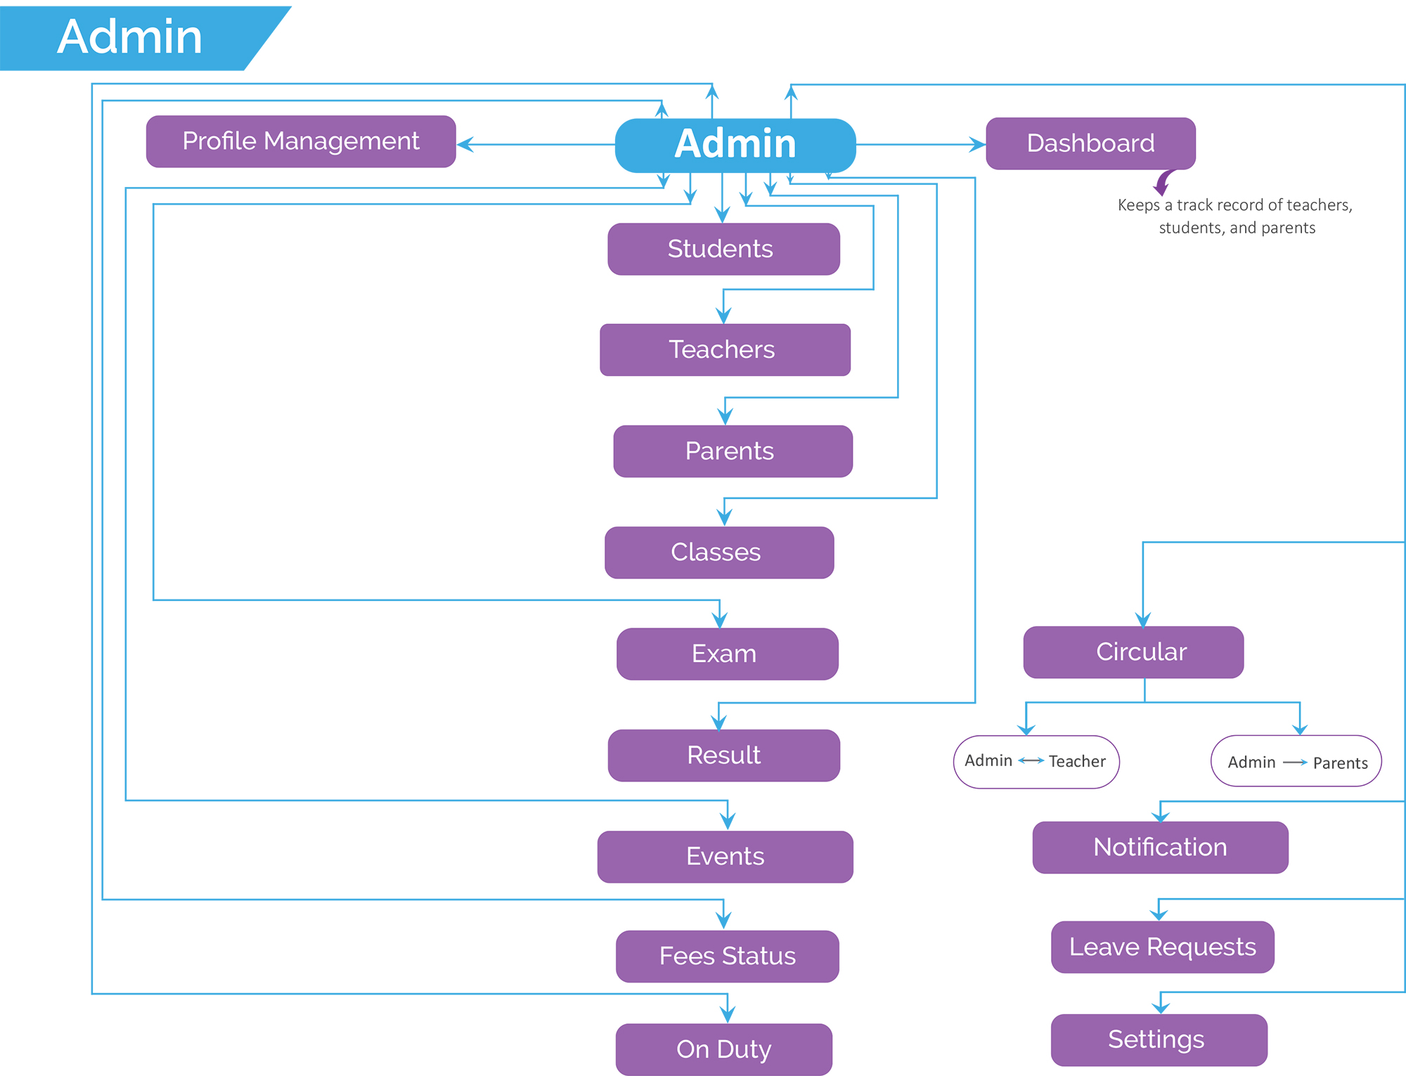

**1. Login**

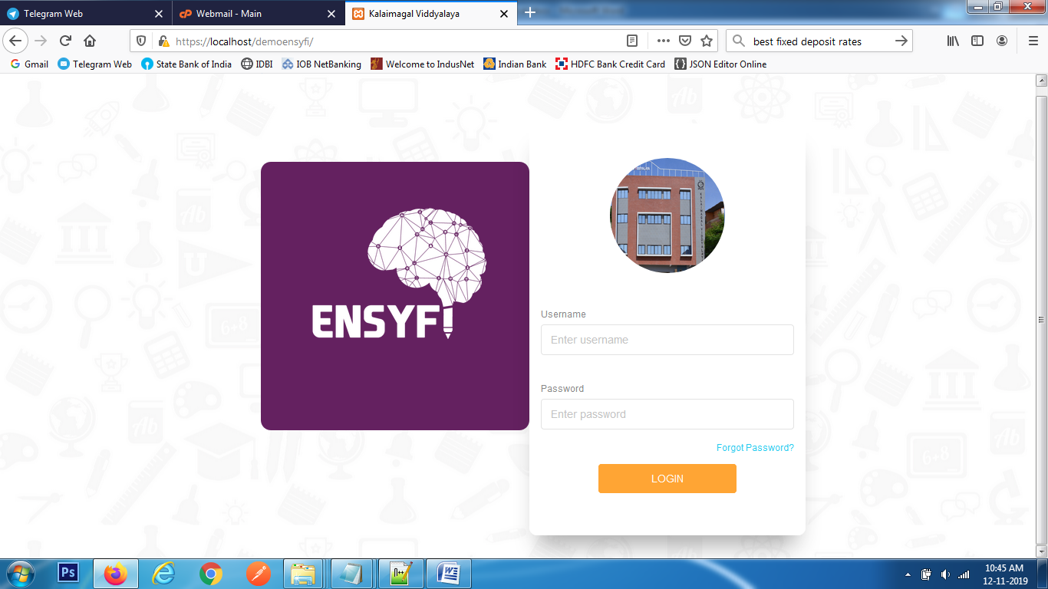

|  |  |  |
| --- | --- | --- |
| **Controller** | **Model** | **View** |
| Home (index) |  | login |
| Adminlogin (home) | Login (login) | login |

**2. Forgot Password**

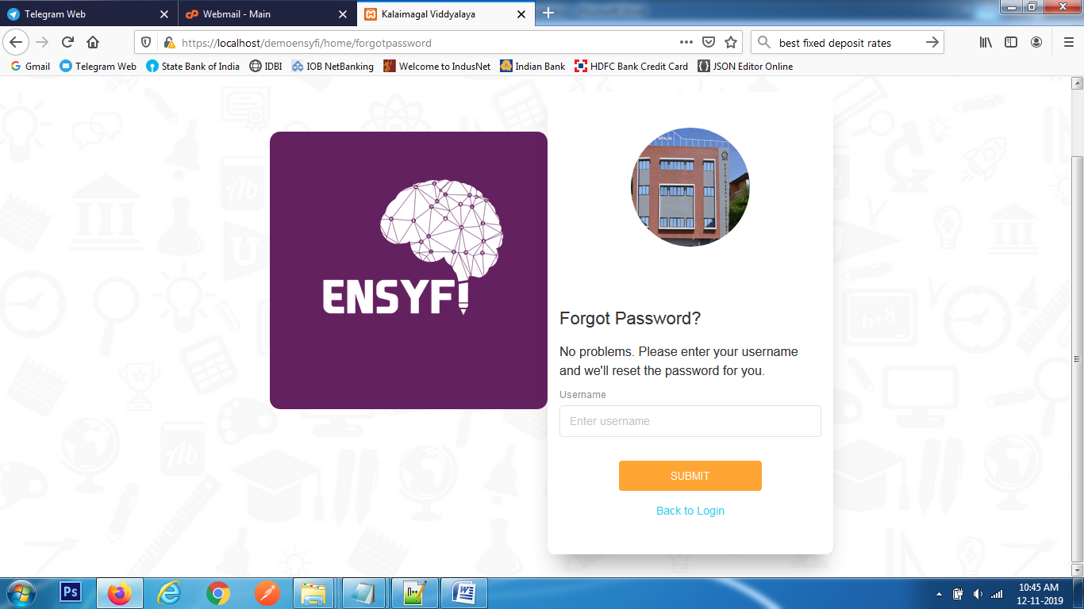

|  |  |  |
| --- | --- | --- |
| **Controller** | **Model** | **View** |
| Home (forgotpassword) |  | forgotpassword |
| Adminlogin (forgotpassword) | Dashboard (forgotpassword) | forgotpassword |

**3. Admin Dashboard**

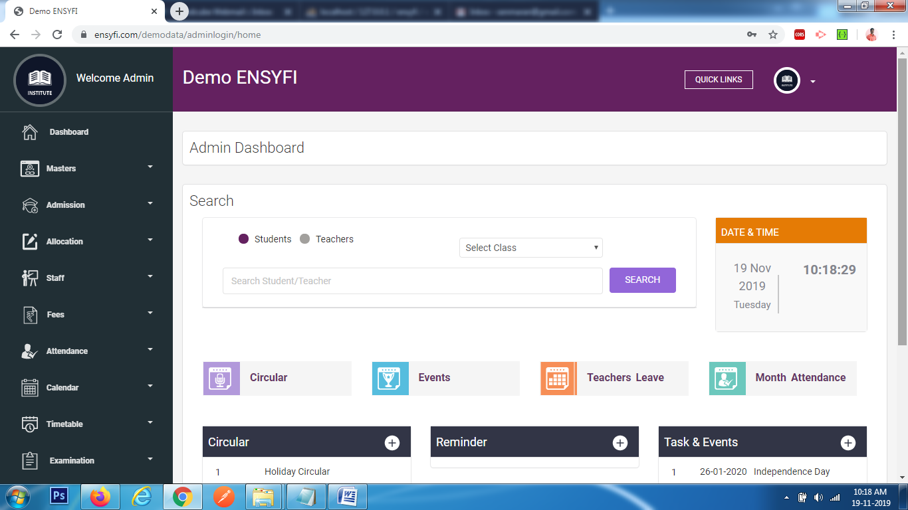

|  |  |  |
| --- | --- | --- |
| **Controller** | **Model** | **View** |
| Adminlogin (home) |  | home |
| Adminlogin (home) | Dashboard (get_user_count_student) | home |
| Adminlogin (home) | Dashboard (get_user_count_parents) | home |
| Adminlogin (home) | Dashboard (dash_teacher_users) | home |
| Adminlogin (home) | Dashboard (pending_leave) | home |
| Adminlogin (home) | Dashboard (dash_events) | home |
| Adminlogin (home) | Dashboard (dash_users) | home |
| Adminlogin (home) | Dashboard ( dash_comm ) | home |
| Adminlogin (home) | Dashboard ( dash_reminder ) | home |
| Adminlogin (home) | Dashboard ( get_all_class_sec) | home |

**4. Masters - Create/List Academic Year**

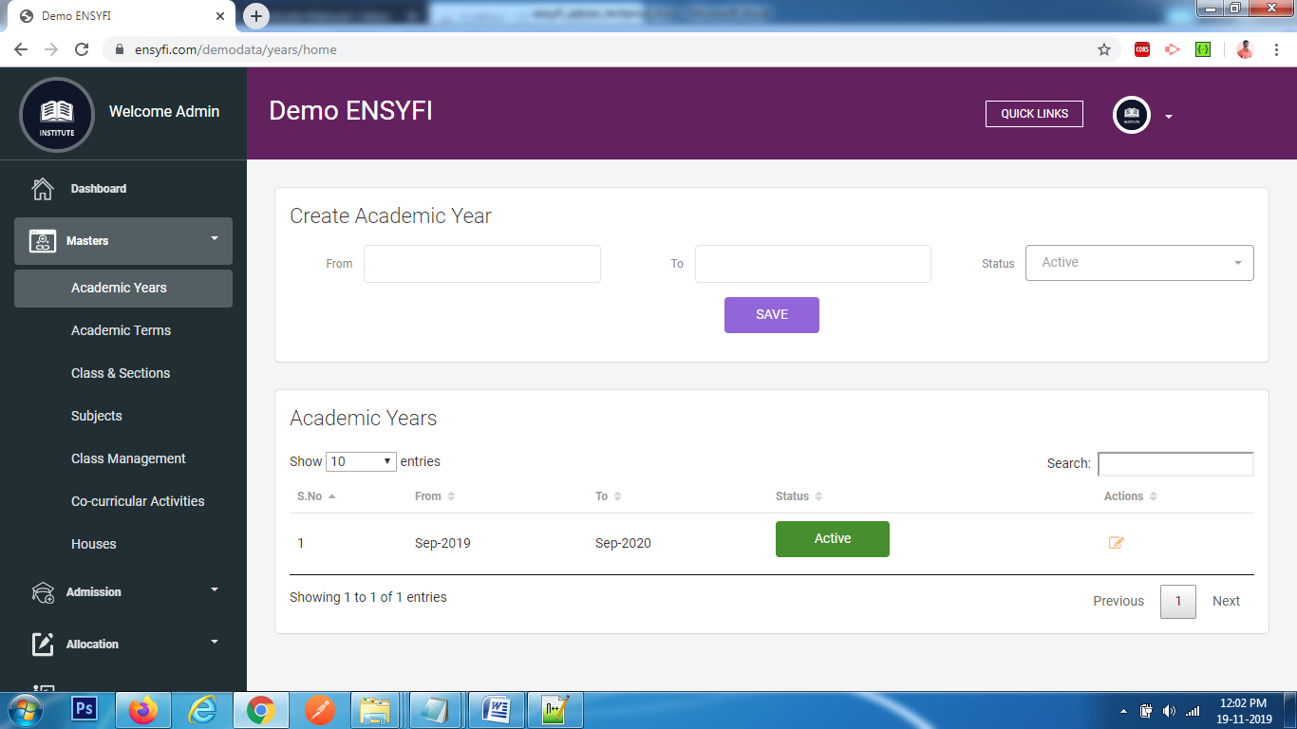

|  |  |  |
| --- | --- | --- |
| **Controller** | **Model** | **View** |
| Years (home) | Yearsmodel (getall_years) | years/add_years |
| Years (create) | Yearsmodel (add_years) | years/add_years |

**5. Masters - Edit Academic Year**

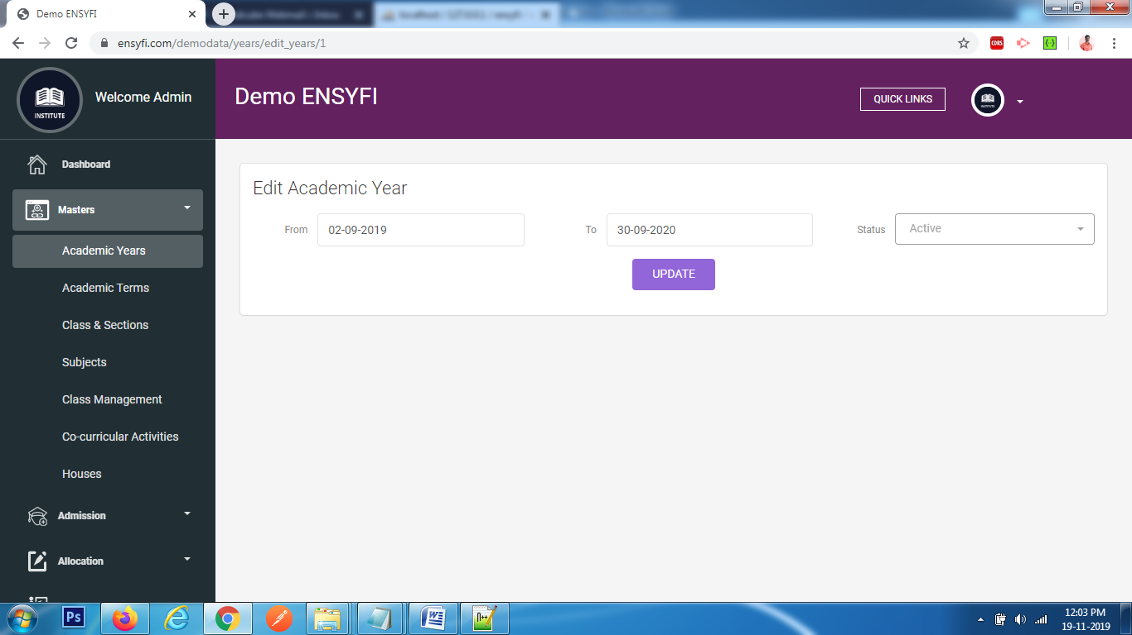

|  |  |  |
| --- | --- | --- |
| **Controller** | **Model** | **View** |
| Years (edit_years) | Yearsmodel (edit_year) | years/edit_year |
| Years (update_year) | Yearsmodel (update_years) | years/edit_year |

**6. Masters - Create/List Academic Term** 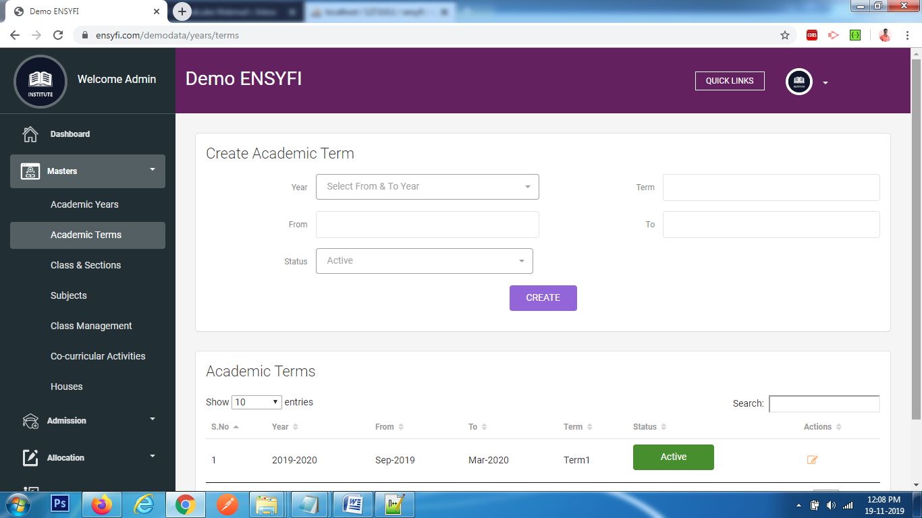

|  |  |  |
| --- | --- | --- |
| **Controller** | **Model** | **View** |
| Years (terms) | Yearsmodel (getall_years) | years/add_terms |
| Years (terms) | Yearsmodel (getall_terms) | years/add_terms |
| Years (add_terms) | Yearsmodel (add_terms) | years/add_terms |

**7. Masters - Edit Academic Term** 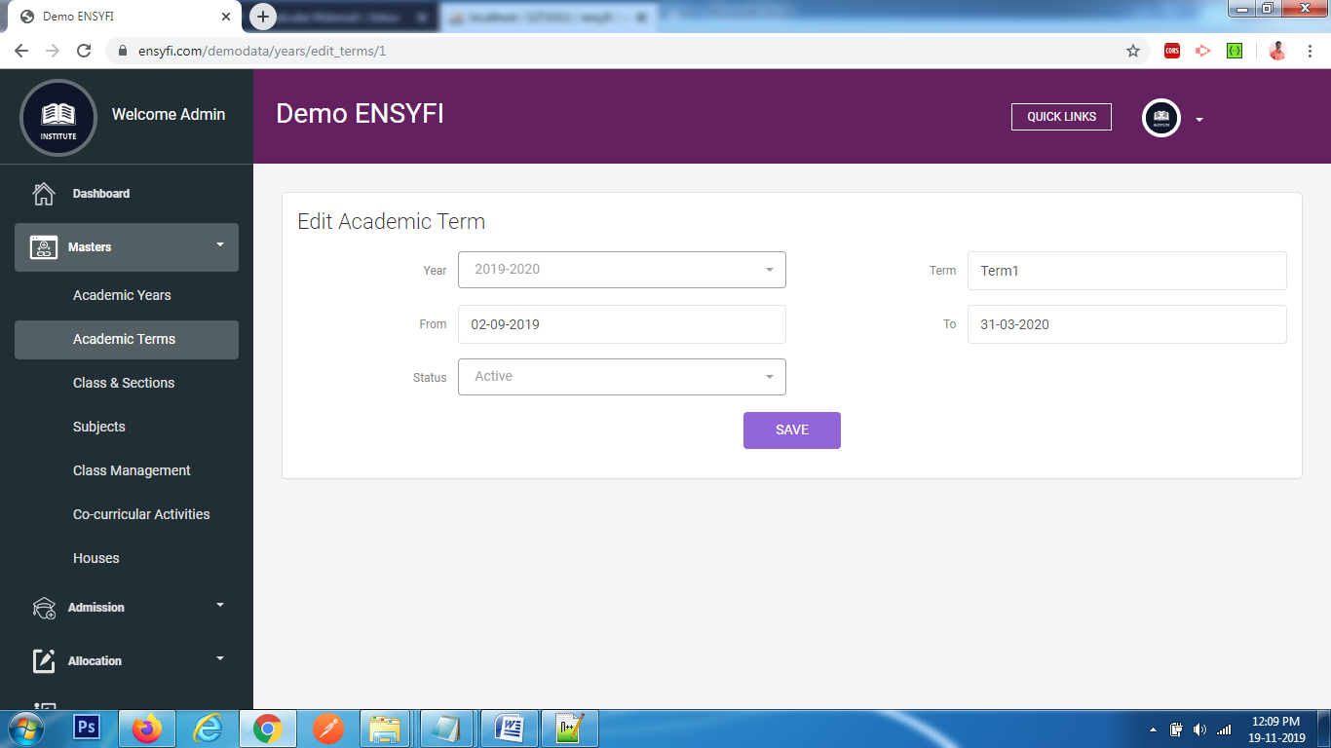

|  |  |  |
| --- | --- | --- |
| **Controller** | **Model** | **View** |
| Years (edit_terms) | Yearsmodel (edit_term) | years/edit_term |
| Years (terms) | Yearsmodel (getall_years) | years/edit_term |
| Years (update_term) | Yearsmodel (update_terms) | years/edit_term |

**8. Masters - Create/List Class** 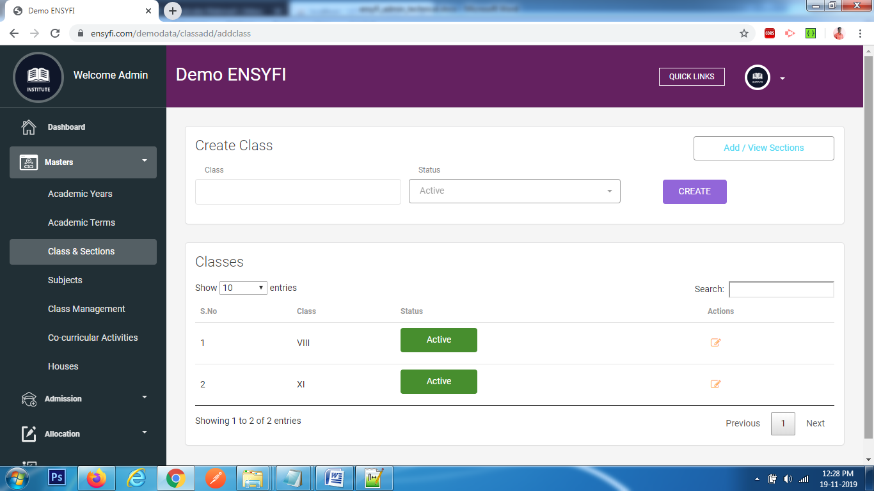

|  |  |  |
| --- | --- | --- |
| **Controller** | **Model** | **View** |
| Classadd (addclass) | Classmodel (getclass) | class/add |
| Classadd (createclass) | Classmodel (addclass) | class/add |

**9. Masters - Edit Class**

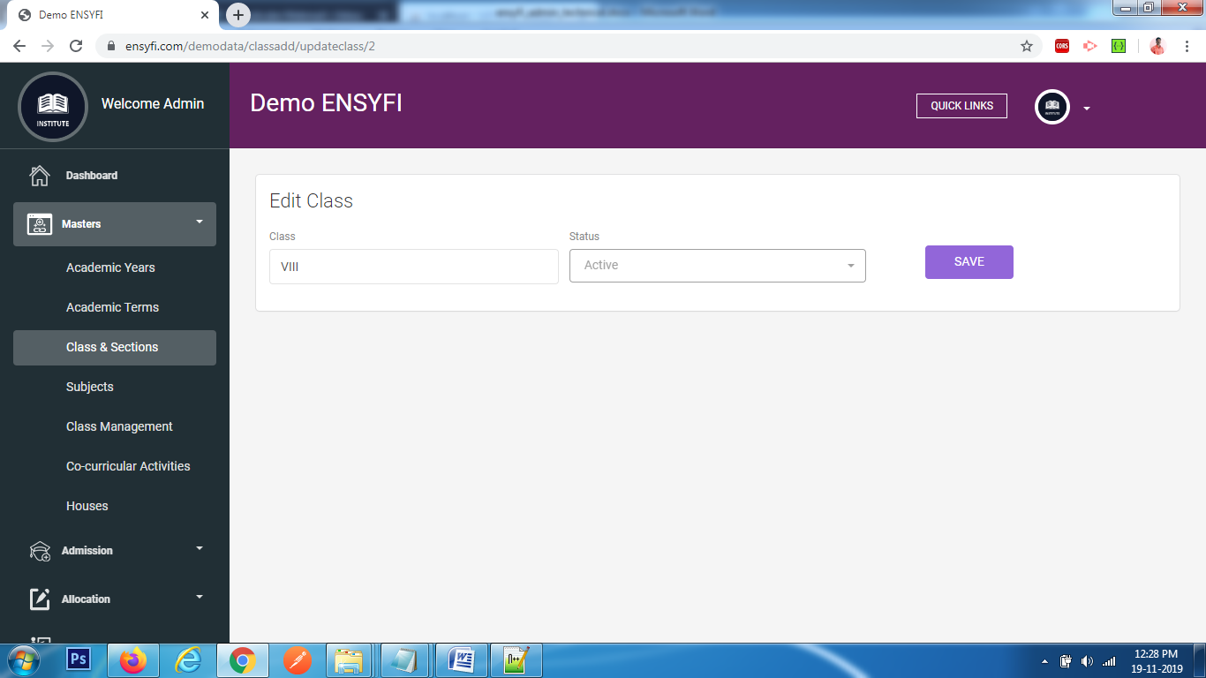

|  |  |  |
| --- | --- | --- |
| **Controller** | **Model** | **View** |
| Classadd (updateclass) | Classmodel (update_class) | class/edit |
| Classadd (save_class) | Classmodel (save_class) | class/ edit |

**10. Masters - Create/List Section**

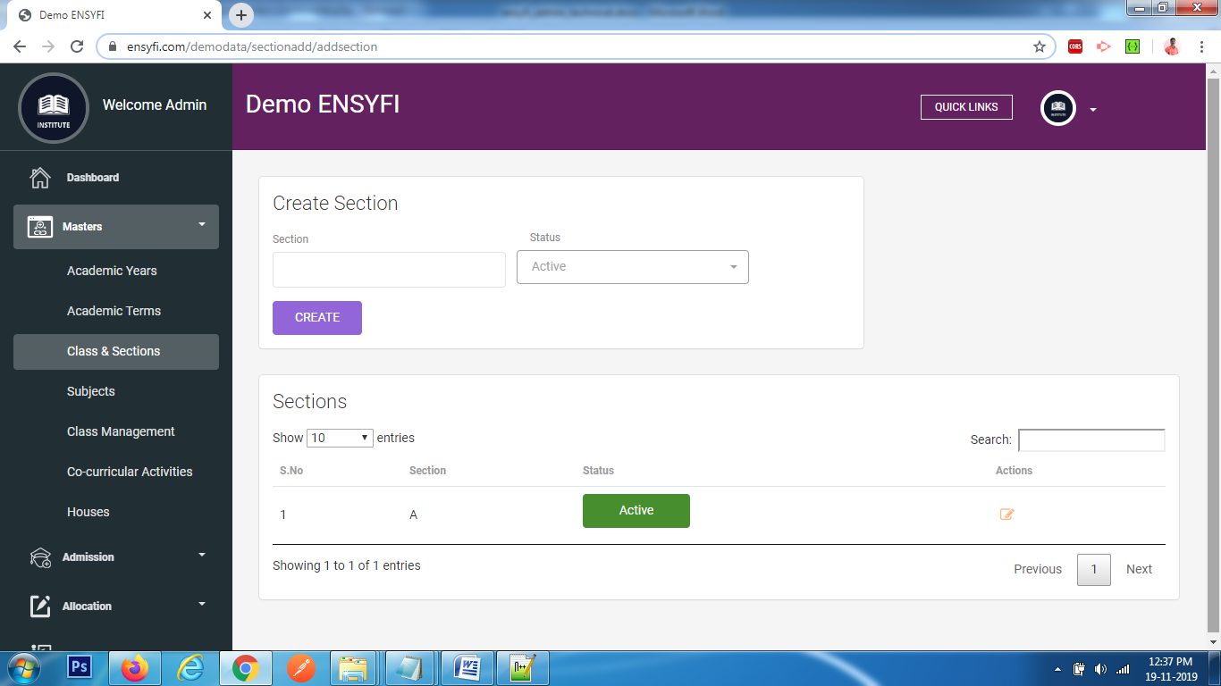

|  |  |  |
| --- | --- | --- |
| **Controller** | **Model** | **View** |
| Sectionadd (addsection) | Sectionmodel (getsection) | section/add |
| Sectionadd (addsection) | Sectionmodel (addsection) | section/add |

**11. Masters - Edit Section**

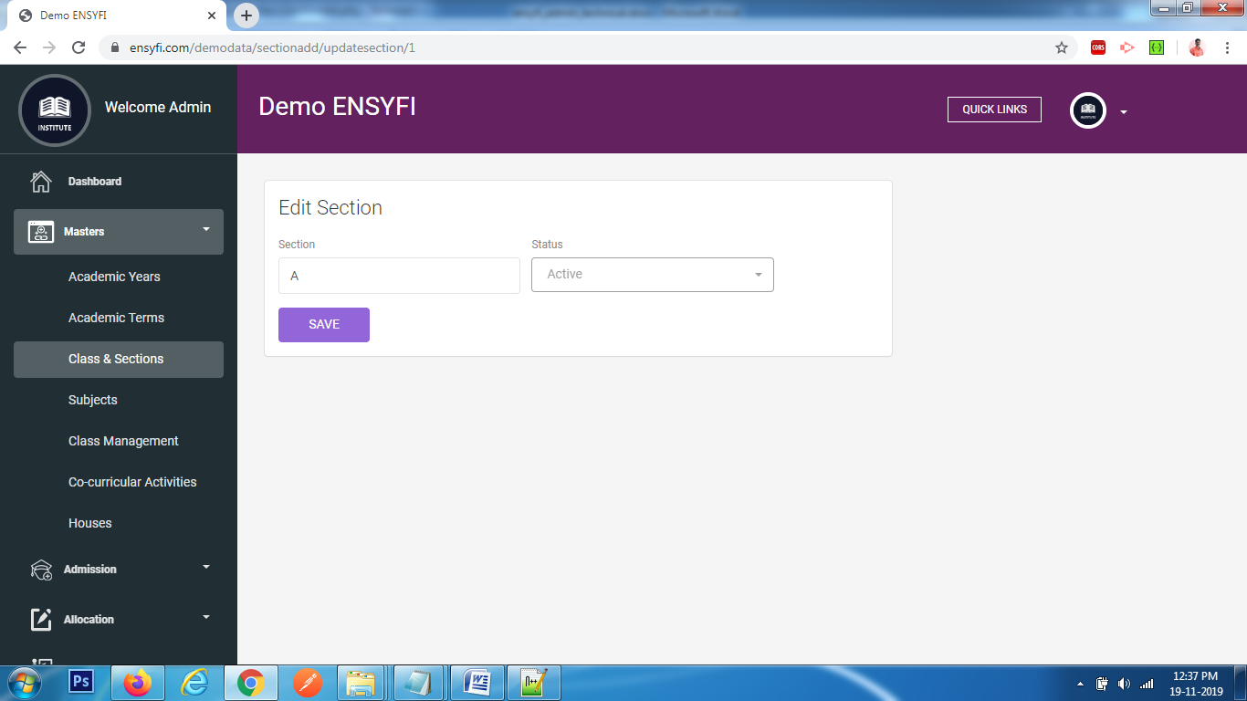

|  |  |  |
| --- | --- | --- |
| **Controller** | **Model** | **View** |
| Sectionadd (updatesection) | Sectionmodel (update_section) | section/edit |
| Sectionadd (save_section) | Sectionmodel (save_section) | section/edit |

**12. Masters - Create/List Subject**

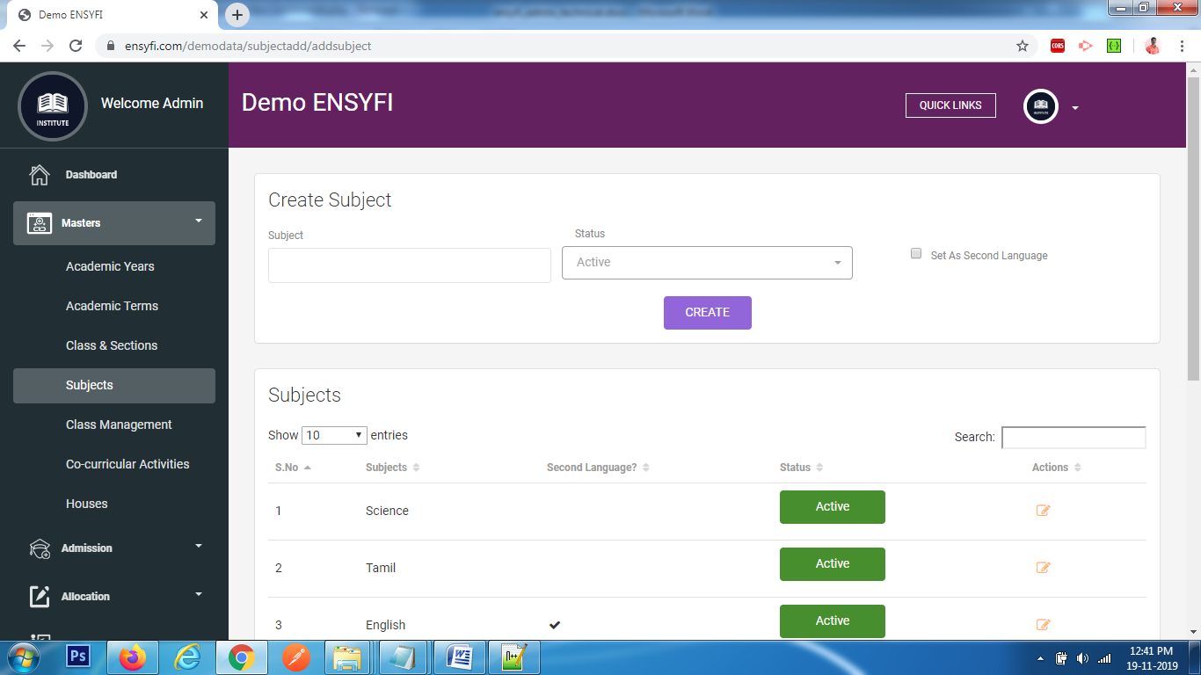

|  |  |  |
| --- | --- | --- |
| **Controller** | **Model** | **View** |
| Subjectadd (addsubject) | Subjectmodel (getsubject) | subject/add |
| Subjectadd (createsubject) | Subjectmodel (addsubject) | subject/add |

**13. Masters – Edit Subject**

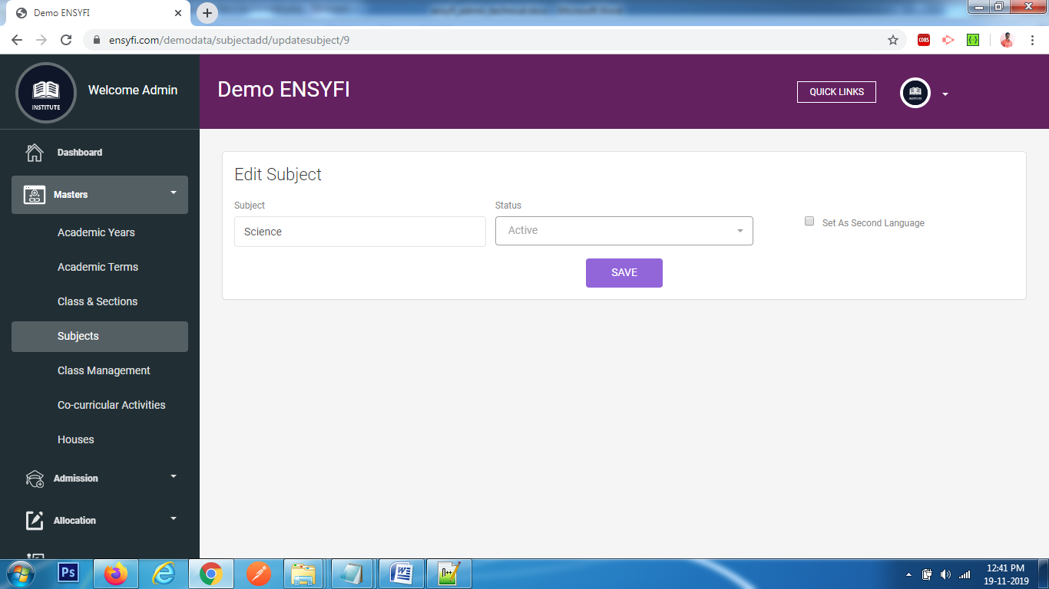

|  |  |  |
| --- | --- | --- |
| **Controller** | **Model** | **View** |
| Subjectadd (updatesubject) | Subjectmodel (update_subject) | subject/edit |
| Subjectadd (save_subject) | Subjectmodel (save_subject) | subject/edit |

**14. Masters – Assign Section and Class - Class Management**

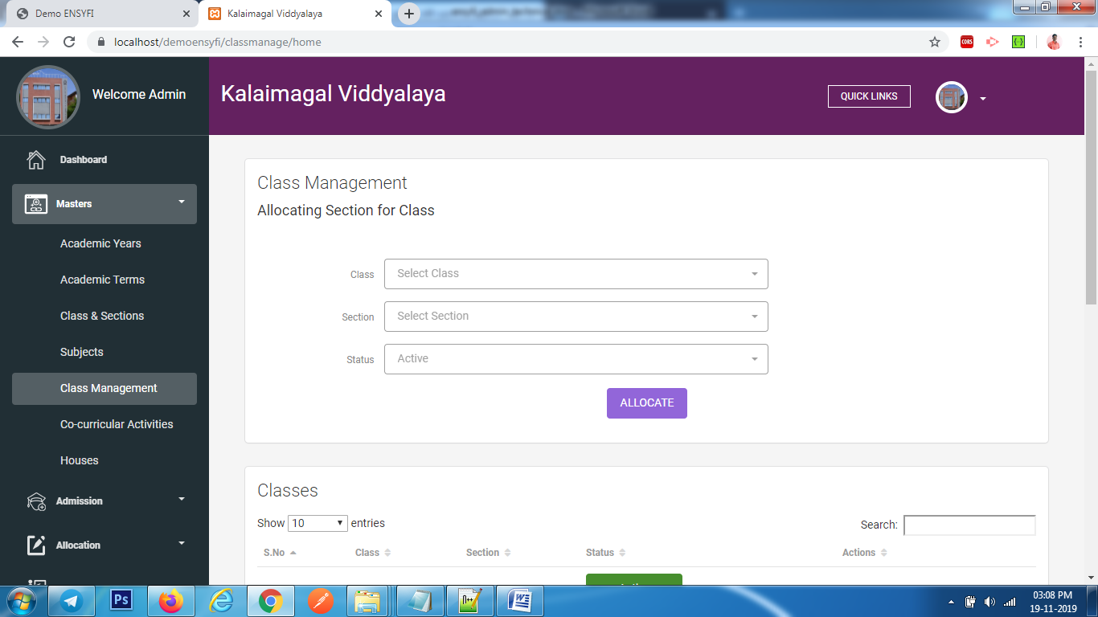

|  |  |  |
| --- | --- | --- |
| **Controller** | **Model** | **View** |
| Classmanage (home) | Classmodel (getclass) | classmanage/add |
| Classmanage (home) | Sectionmodel (getsection) | classmanage/add |
| Classmanage (assign) | Class_manage (assign) | classmanage/add |

**15. Masters – Class Management**

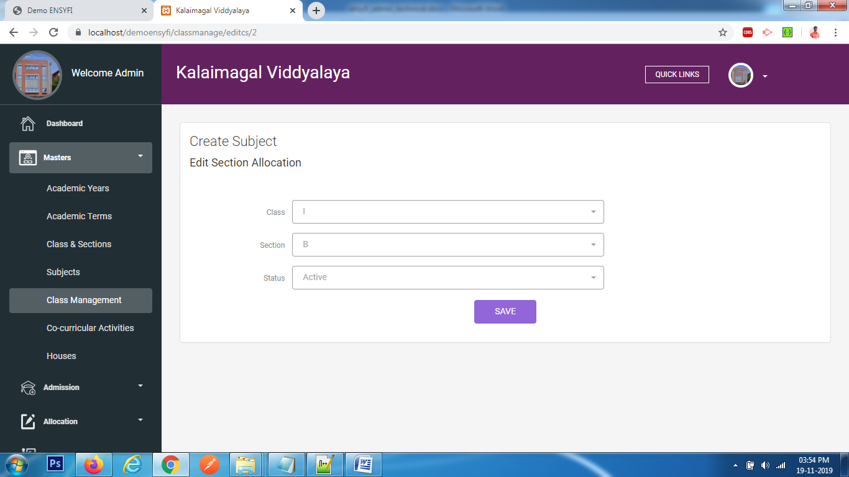

|  |  |  |
| --- | --- | --- |
| **Controller** | **Model** | **View** |
| Classmanage (editcs) | Classmodel (getclass) | classmanage/edit |
| Classmanage (editcs) | Sectionmodel (getsection) | classmanage/edit |
| Classmanage (editcs) | Class_manage (class_manage) | classmanage/edit |
| Classmanage (update_cs) | Class_manage (save_cs) | classmanage/edit |

**16. Masters – List Class Subjects**

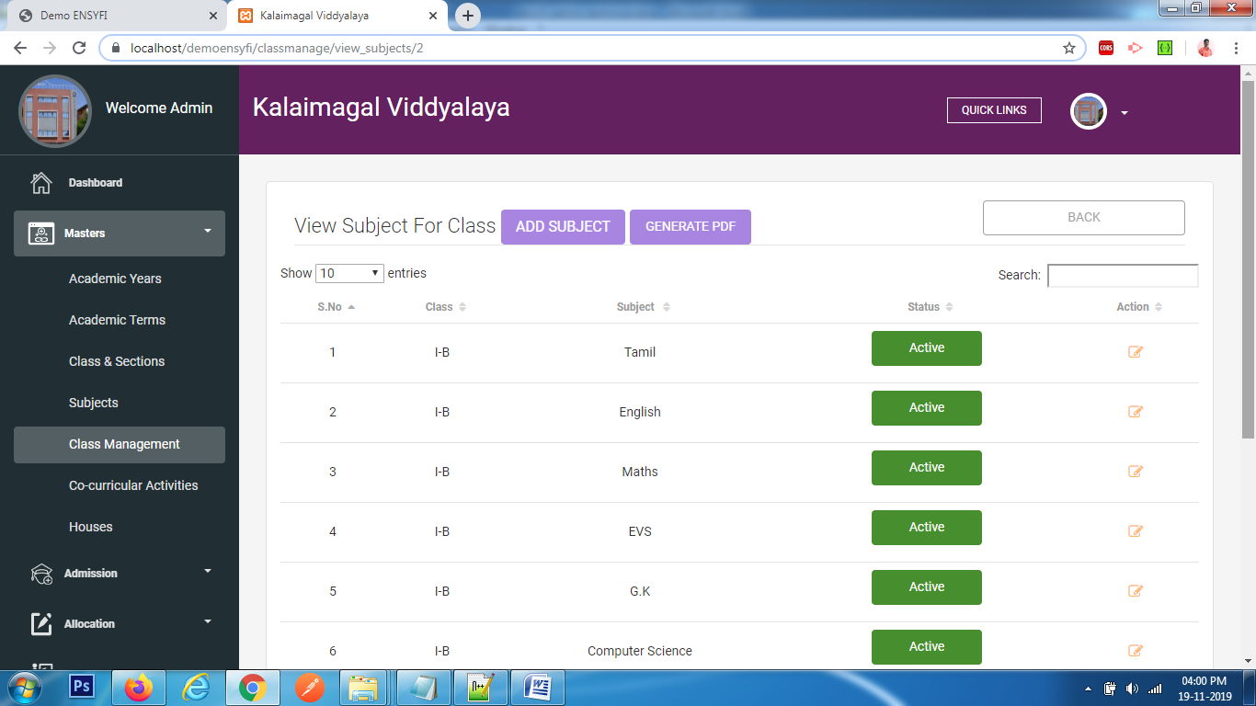 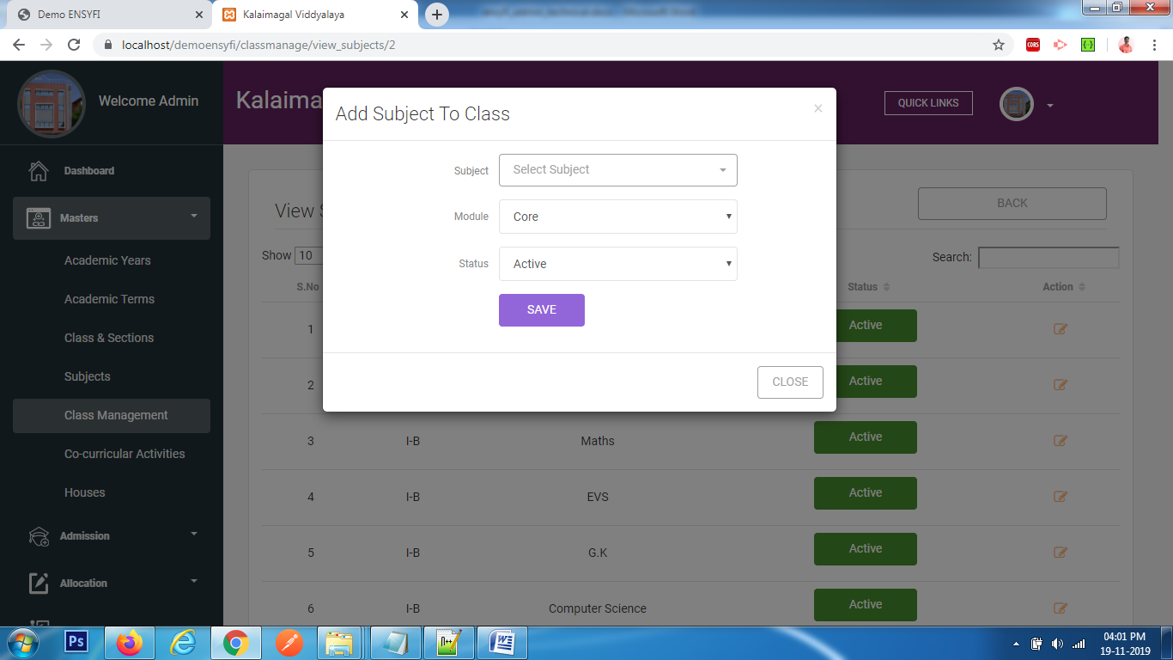

|  |  |  |
| --- | --- | --- |
| **Controller** | **Model** | **View** |
| Classmanage (view_subjects) | Classmodel (getclass) | classmanage/view_subjects |
| Classmanage (view_subjects) | Sectionmodel (getsection) | classmanage/view_subjects |
| Classmanage (view_subjects) | Class_manage (getall_class) | classmanage/view_subjects |
| Classmanage (view_subjects) | Subjectmodel (getsubject) | classmanage/view_subjects |
| Classmanage (view_subjects) | Class_manage (view_subjects) | classmanage/view_subjects |

**17. Masters – Edit Subjects**

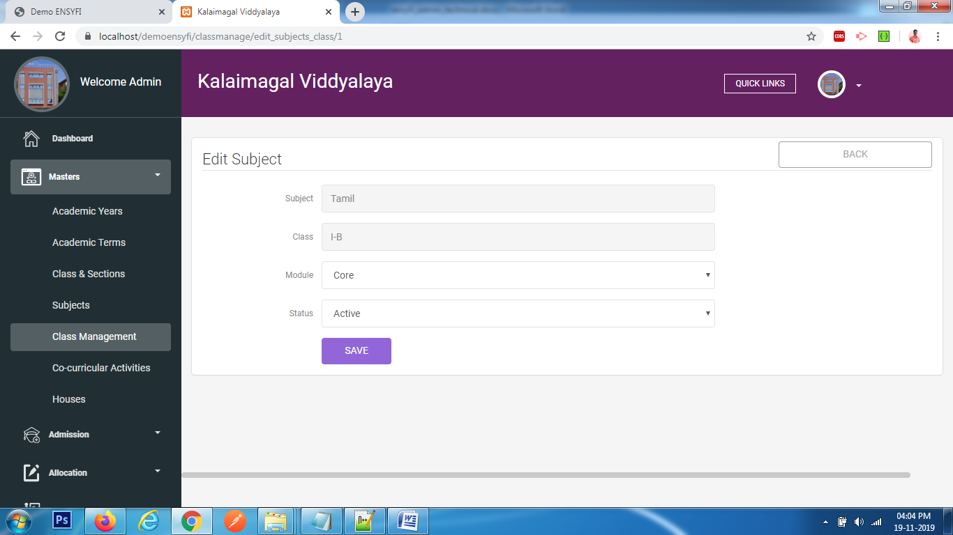

|  |  |  |
| --- | --- | --- |
| **Controller** | **Model** | **View** |
| Classmanage (edit_subjects_class) | Class_manage (edit_subjects_class) | classmanage/edit_subjects |
| Classmanage (save_subject) | Class_manage (save_subject) | classmanage/edit_subjects |

**18. Masters – Create/List Co-curricular Activity**

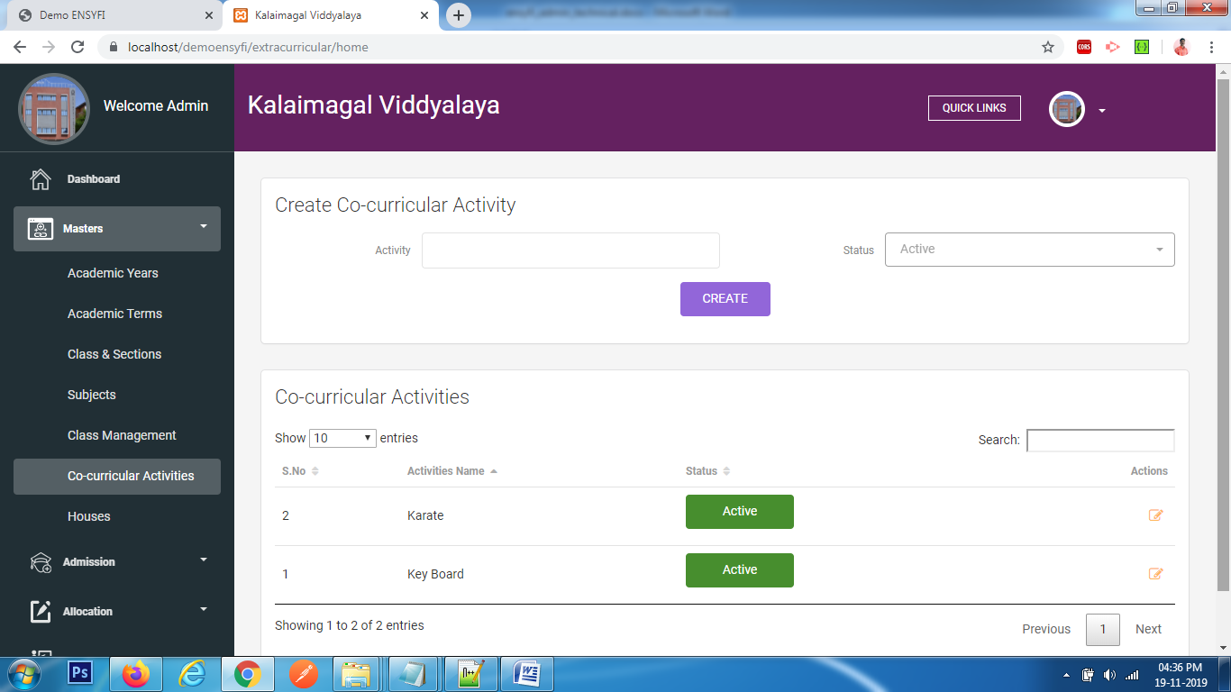

|  |  |  |
| --- | --- | --- |
| **Controller** | **Model** | **View** |
| Extracurricular (home) | Extracurricularmodel (getall_activities_list) | extracurricular/add_extracurricular |
| Extracurricular (create_extracurricular) | Extracurricularmodel (create) | extracurricular/add_extracurricular |

**19. Masters – Edit Co-curricular Activity** 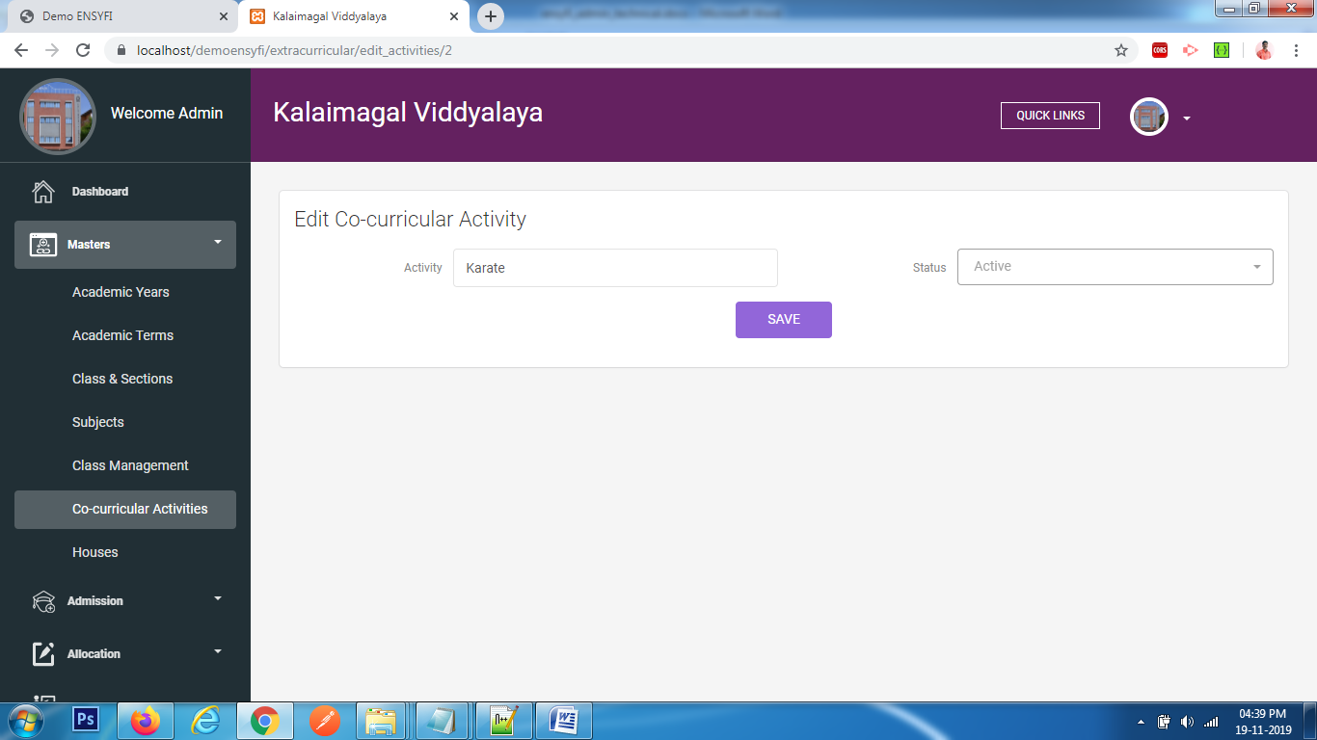

|  |  |  |
| --- | --- | --- |
| **Controller** | **Model** | **View** |
| Extracurricular (edit_activities) | Extracurricularmodel (edit_activities) | extracurricular/edit_extracurricular |
| Extracurricular (update_activities) | Extracurricularmodel (update_activities_list) | extracurricular/edit_extracurricular |

**20. Masters – Create / List Houses** 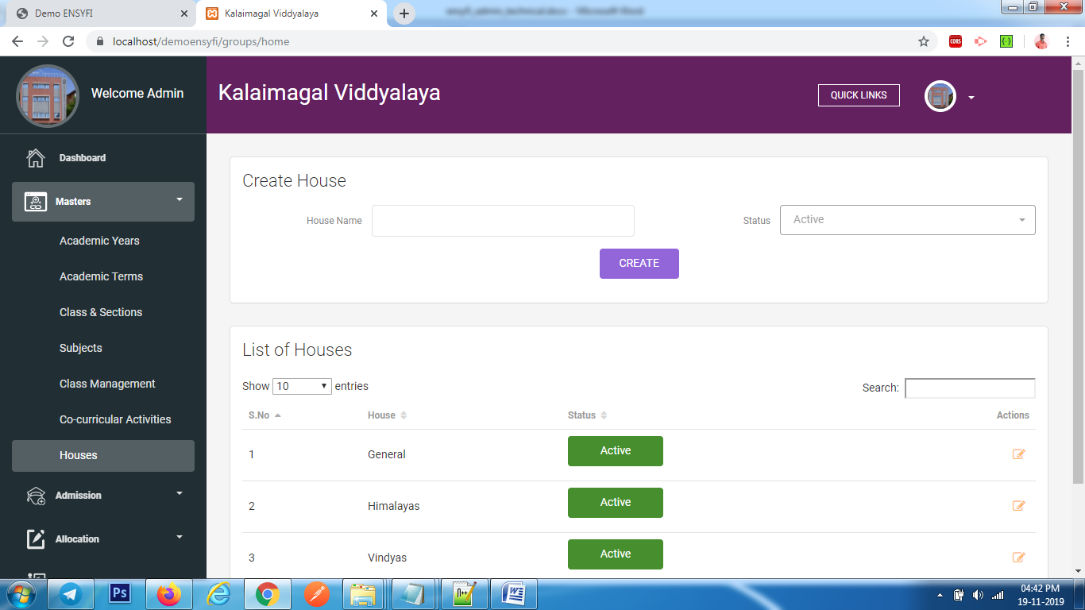

|  |  |  |
| --- | --- | --- |
| **Controller** | **Model** | **View** |
| Groups (home) | Groupsmodel (getall_groups_list) | groups/add_groups |
| Groups (create_groups) | Groupsmodel (create_group_list) | groups/add_groups |

**21. Masters – Edit House**

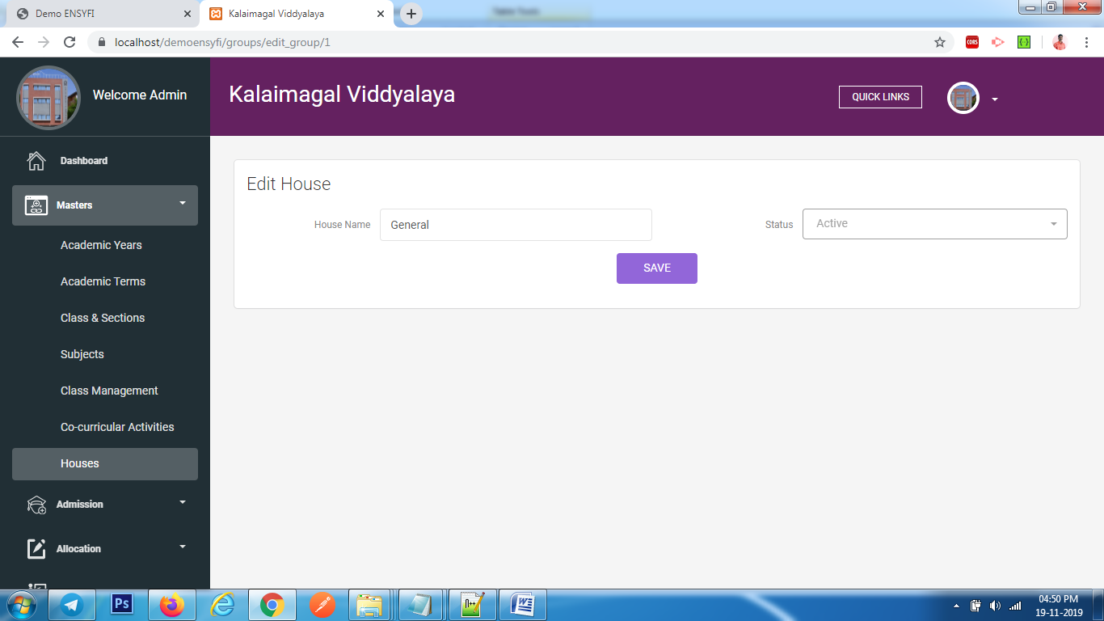

|  |  |  |
| --- | --- | --- |
| **Controller** | **Model** | **View** |
| Groups (edit_group) | Groupsmodel (edit_groups_list) | groups/edit_groups |
| Groups (update_groups) | Groupsmodel (update_groups_list) | groups/edit_groups |

**22. Create Student Admission (Profile)**

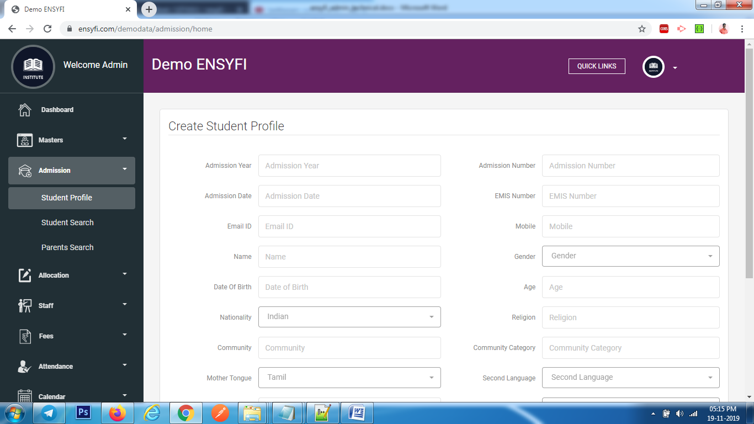

|  |  |  |
| --- | --- | --- |
| **Controller** | **Model** | **View** |
| Admission (home) | Classmodel (getclass) | admission/add |
| Admission (home) | Yearsmodel (getall_years) | admission/add |
| Admission (home) | Admissionmodel (getall_language_proposed) | admission/add |
| Admission (home) | Admissionmodel (getall_blood_group) | admission/add |
| Admission (create) | Admissionmodel (ad_create) | admission/add |

**23. Students Admission List**

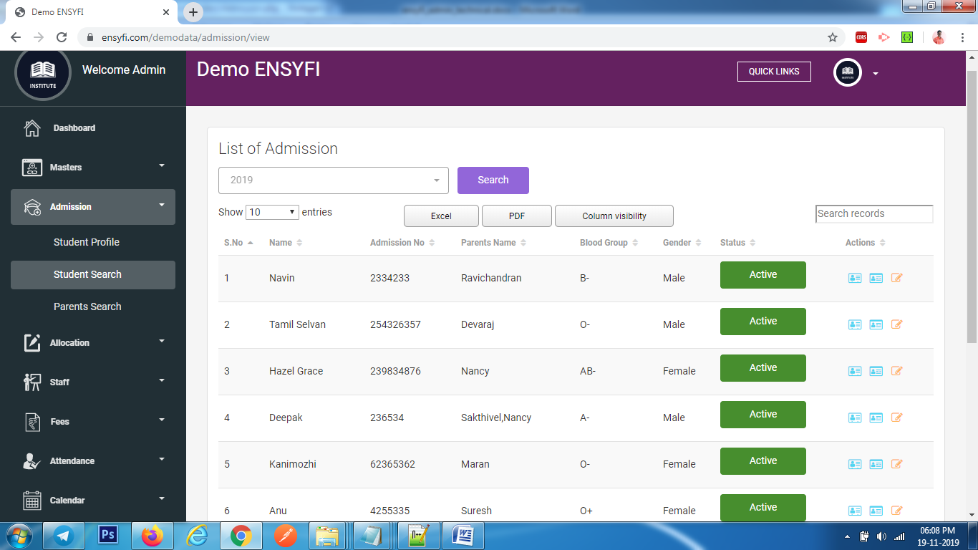

|  |  |  |
| --- | --- | --- |
| **Controller** | **Model** | **View** |
| Admission (view) | Admissionmodel (get_all_admission_years) | admission/view |
| Admission (home) | Admissionmodel (get_all_admission) | admission/view |

**24. Edit Students Admission**

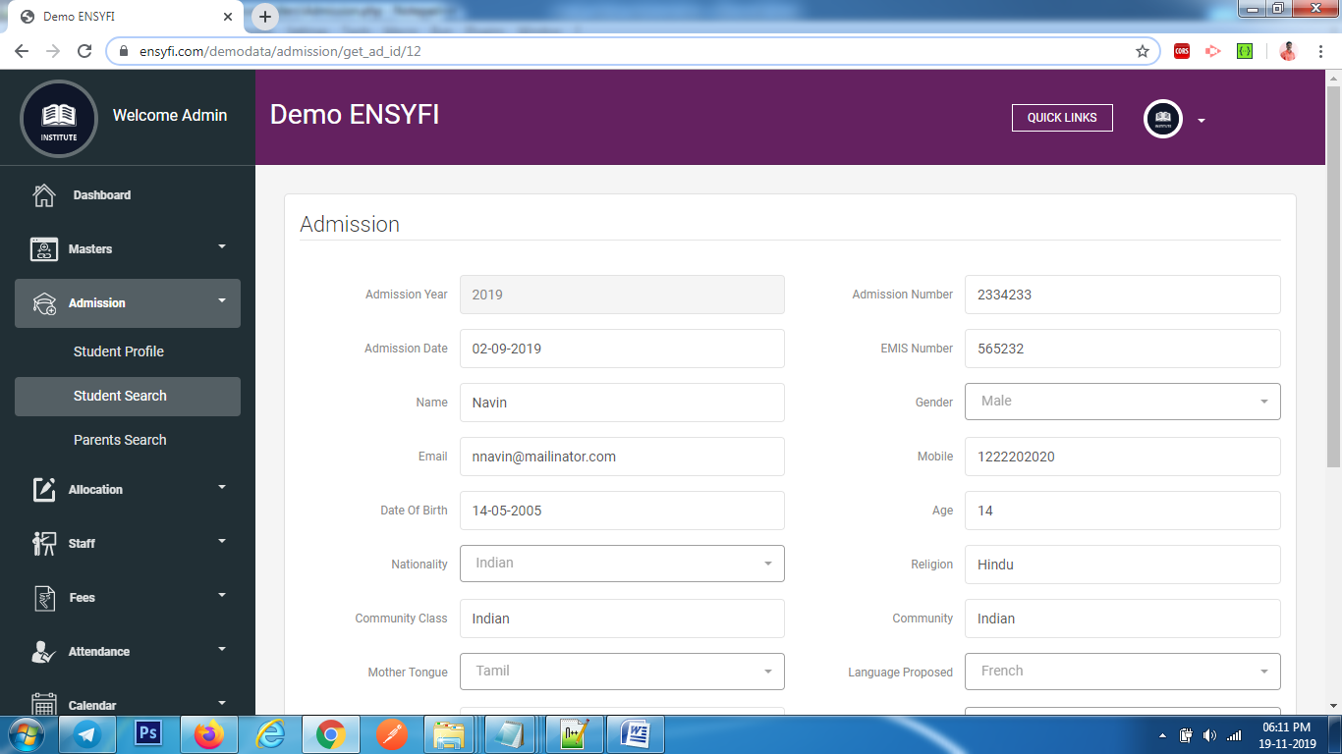

|  |  |  |
| --- | --- | --- |
| **Controller** | **Model** | **View** |
| Admission (get_ad_id) | Classmodel (getclass) | admission/edit |
| Admission (get_ad_id) | Yearsmodel (getall_years) | admission/edit |
| Admission (get_ad_id) | Admissionmodel (getall_language_proposed) | admission/edit |
| Admission (get_ad_id) | Admissionmodel (getall_blood_group) | admission/edit |
| Admission (get_ad_id) | Admissionmodel (get_ad_id) | admission/edit |
| Admission (save_ad) | Admissionmodel (save_ad) | admission/edit |

**25. Class Allocation**

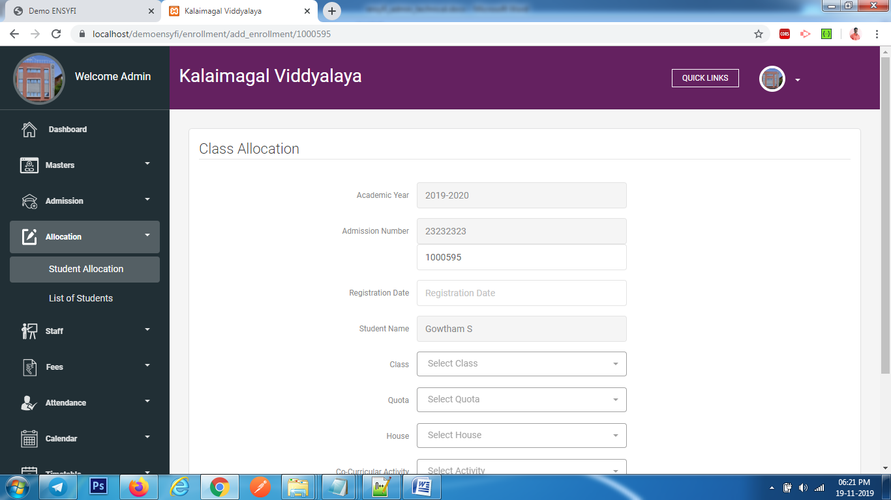

|  |  |  |
| --- | --- | --- |
| **Controller** | **Model** | **View** |
| Enrollment (add_enrollment) | Yearsmodel (getall_years) | enrollment/add_enroll |
| Enrollment (add_enrollment) | Classmodel (getclass) | enrollment/add_enroll |
| Enrollment (add_enrollment) | Sectionmodel (getsection) | enrollment/add_enroll |
| Enrollment (add_enrollment) | class_manage (getall_active_class) | enrollment/add_enroll |
| Enrollment (add_enrollment) | Enrollmentmodel (get_current_years) | enrollment/add_enroll |
| Enrollment (add_enrollment) | Enrollmentmodel (add_enrollment) | enrollment/add_enroll |
| Enrollment (add_enrollment) | Enrollmentmodel (get_all_quota_details) | enrollment/add_enroll |
| Enrollment (add_enrollment) | Enrollmentmodel (get_all_groups_details) | enrollment/add_enroll |
| Enrollment (add_enrollment) | Enrollmentmodel (get_all_activities_details) | enrollment/add_enroll |
| Enrollment (create) | Enrollmentmodel (ad_enrollment) | enrollment/add_enroll |

**26. Edit Class Allocation**

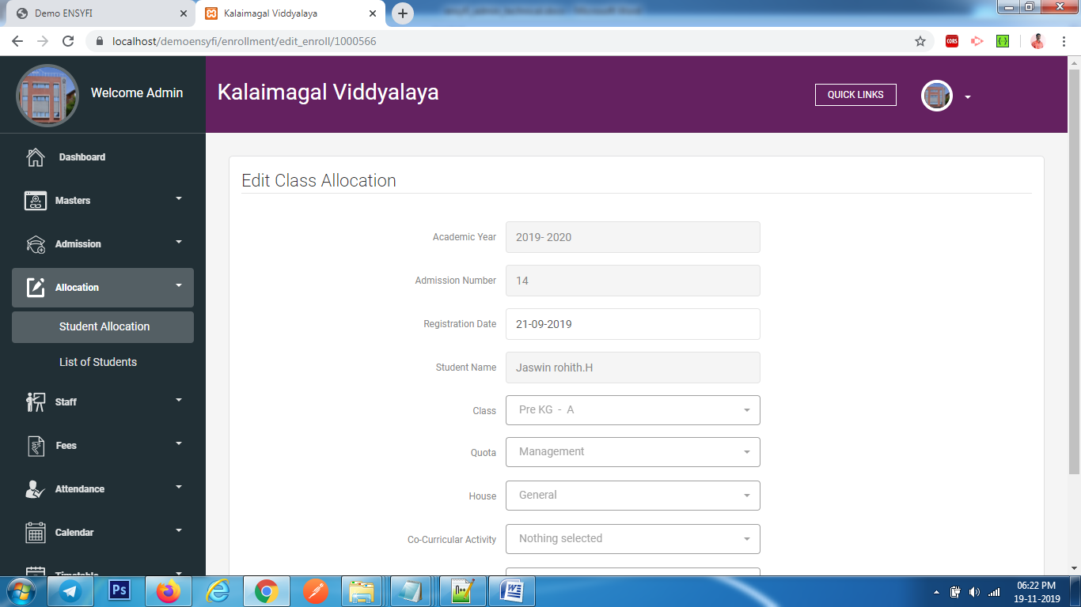

|  |  |  |
| --- | --- | --- |
| **Controller** | **Model** | **View** |
| Enrollment (edit_enroll) | Enrollmentmodel (get_enrollmentid) | enrollment/edit |
| Enrollment (edit_enroll) | Enrollmentmodel (get_all_quota_details) | enrollment/edit |
| Enrollment (edit_enroll) | Enrollmentmodel (get_all_groups_details) | enrollment/edit |
| Enrollment (edit_enroll) | Enrollmentmodel (get_all_activities_details) | enrollment/edit |
| Enrollment (edit_enroll) | Enrollmentmodel (getall_active_class) | enrollment/edit |
| Enrollment (save) | Enrollmentmodel (save_enrollment) | enrollment/edit |

**27. Parent Details**

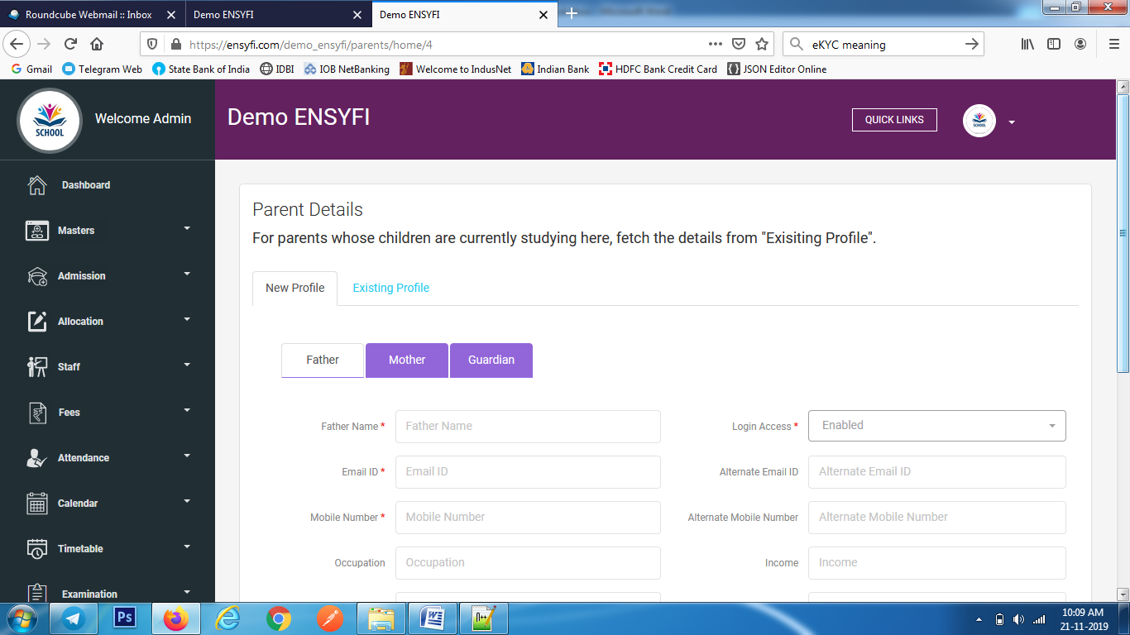

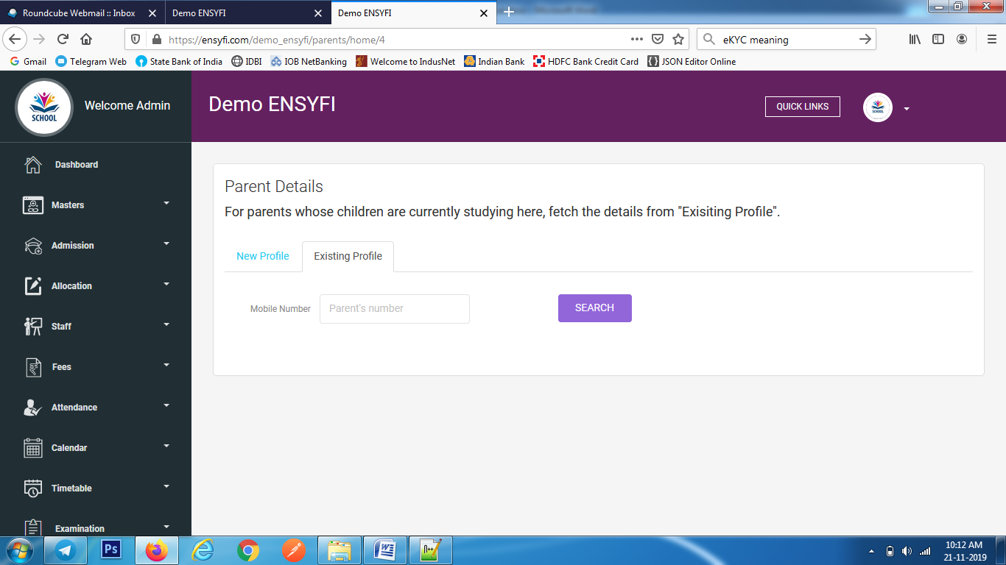

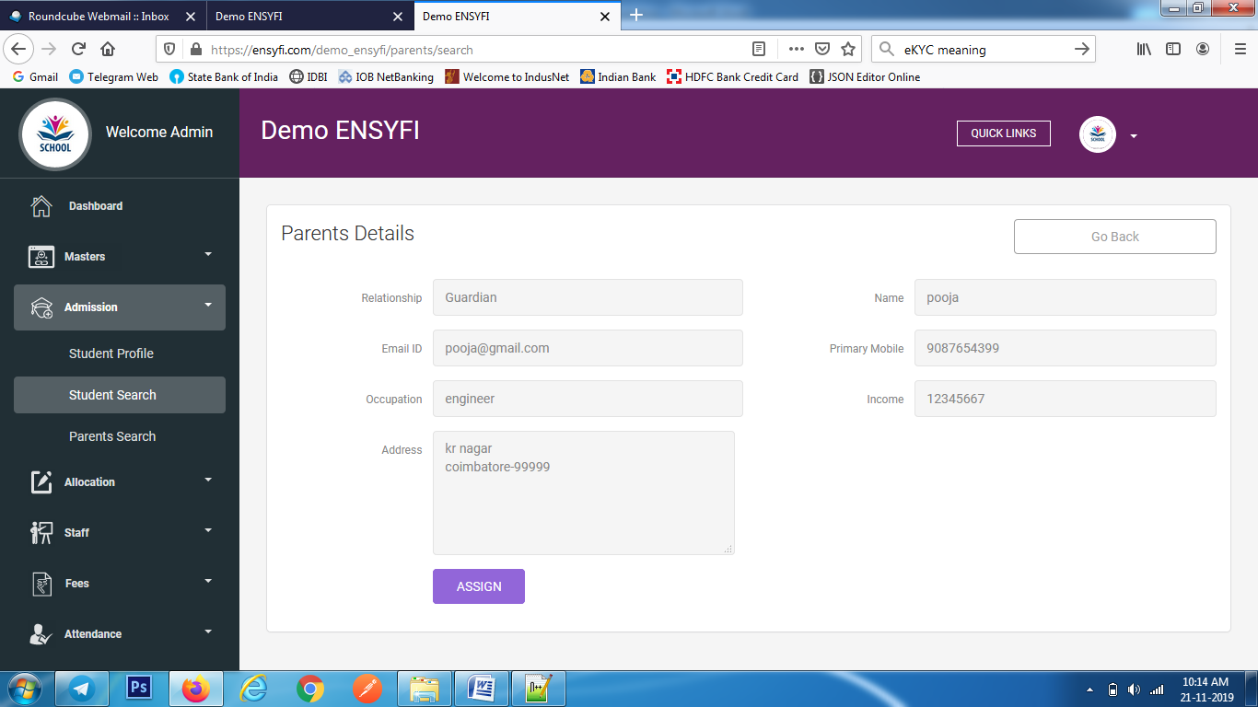

|  |  |  |
| --- | --- | --- |
| **Controller** | **Model** | **View** |
| Parents (home) |  | parents/add |
| Parents (create) | Parentsmodel (add_parents) | parents/add |
| Parents (search) | Parentsmodel (get_stu_name) | parents/add_parent_to_students |
| Parents (search) | Parentsmodel (search_parent) | parents/add_parent_to_students |
| Parents (update_exiting_parents_assign) | Parentsmodel (update_exiting_parents_assign) | parents/parents/view_parents_details |

**28. Edit Parent Profile**

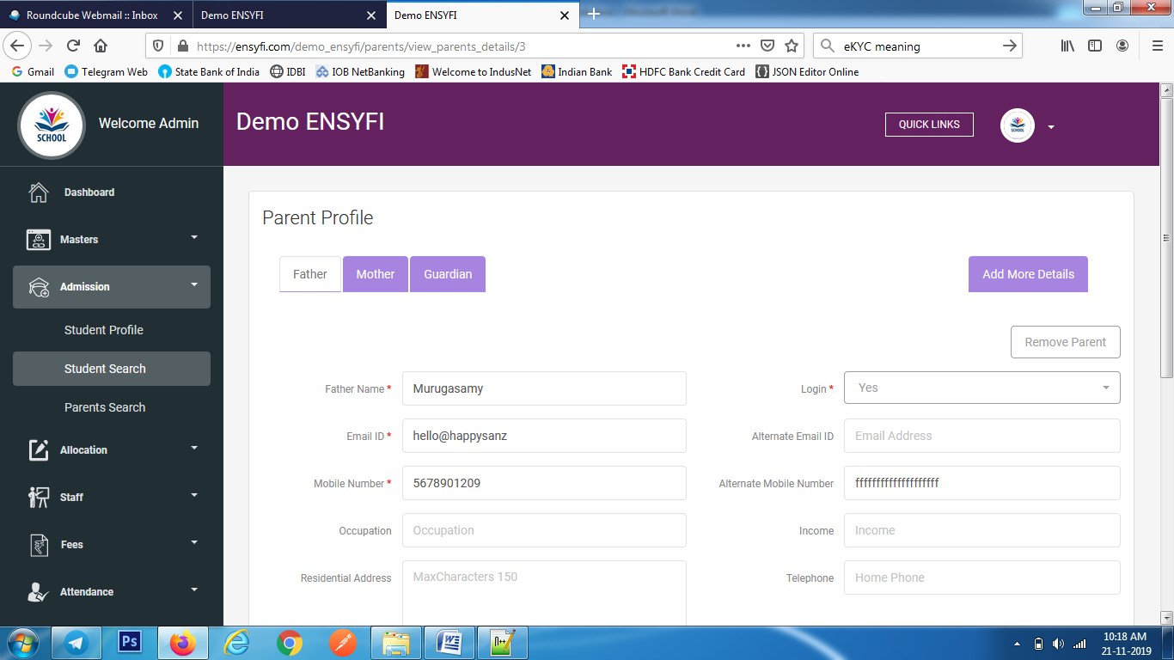

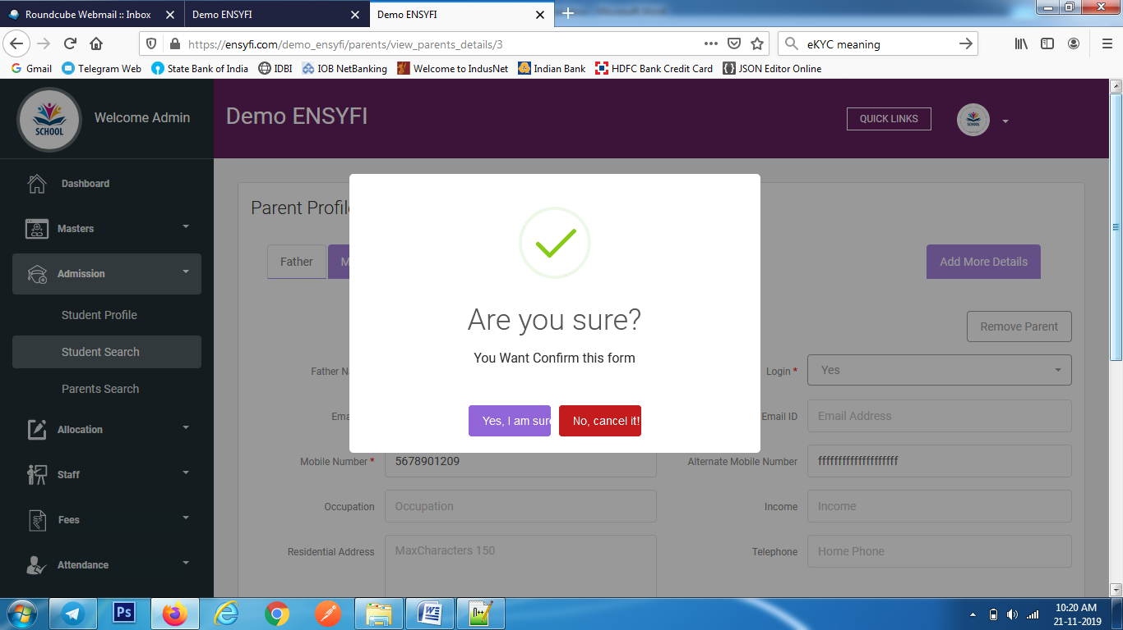

|  |  |  |
| --- | --- | --- |
| **Controller** | **Model** | **View** |
| Parents (view_parents_details) | Parentsmodel (edit_parents) | parents/view_parents_details |
| Parents (update_father_details) | Parentsmodel (update_parents_info) | parents/view_parents_details |
| Parents (update_mother_details) | Parentsmodel (update_parents_info) | parents/view_parents_details |
| Parents (update_guardian_details) | Parentsmodel (update_parents_info) | parents/view_parents_details |
| Parents (remove_parents_from_students) | Parentsmodel (remove_parents_from_students) | parents/view_parents_details |

**29. Add more details from Parent Edit**

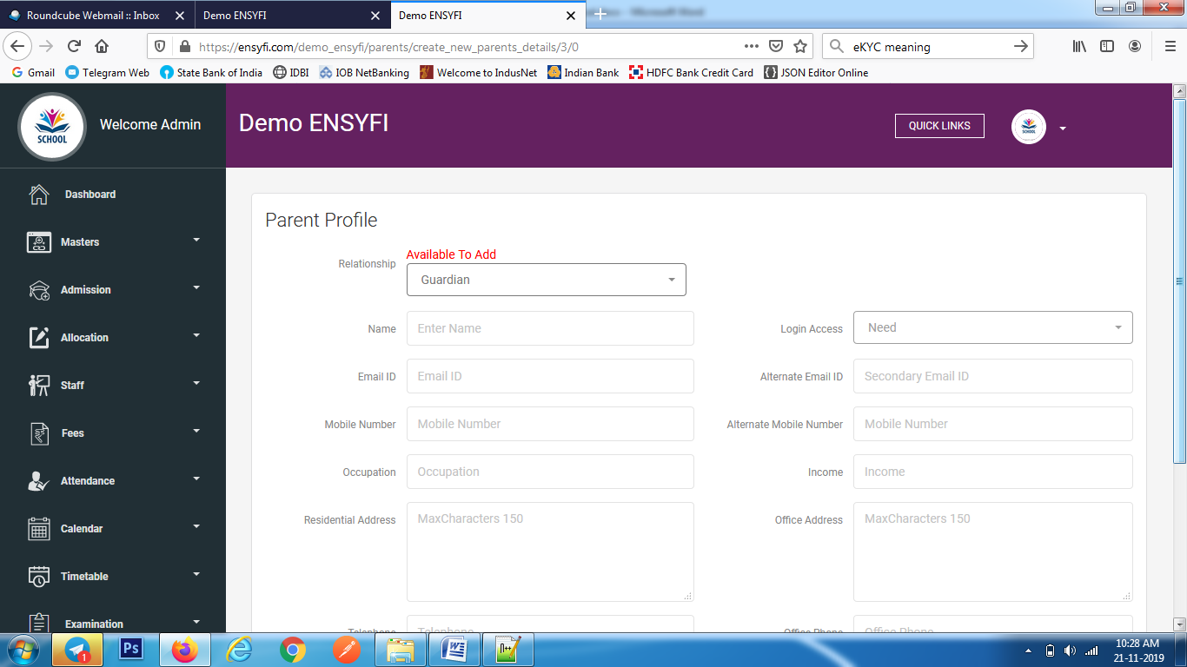

|  |  |  |
| --- | --- | --- |
| **Controller** | **Model** | **View** |
| Parents (create_new_parents_details) | Parentsmodel (get_all_details) | parents/add_new_parents |
| Parents (create_new_parents_details) | Parentsmodel (get_relation_ship) | parents/add_new_parents |
| Parents (create_new_parents) | Parentsmodel (add_new_parents) | parents/add_new_parents |

**30. List Parents**

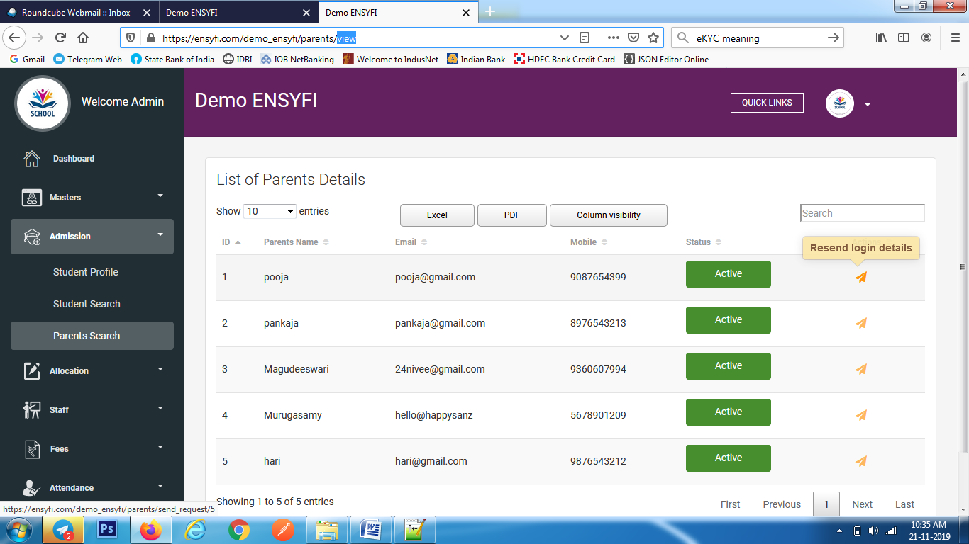

|  |  |  |
| --- | --- | --- |
| **Controller** | **Model** | **View** |
| Parents (view) | Parentsmodel (get_all_parents_details) | parents/view |
| Parents (send_request) | Parentsmodel (send_request) | parents/view |

**31. Class Allocation for students**

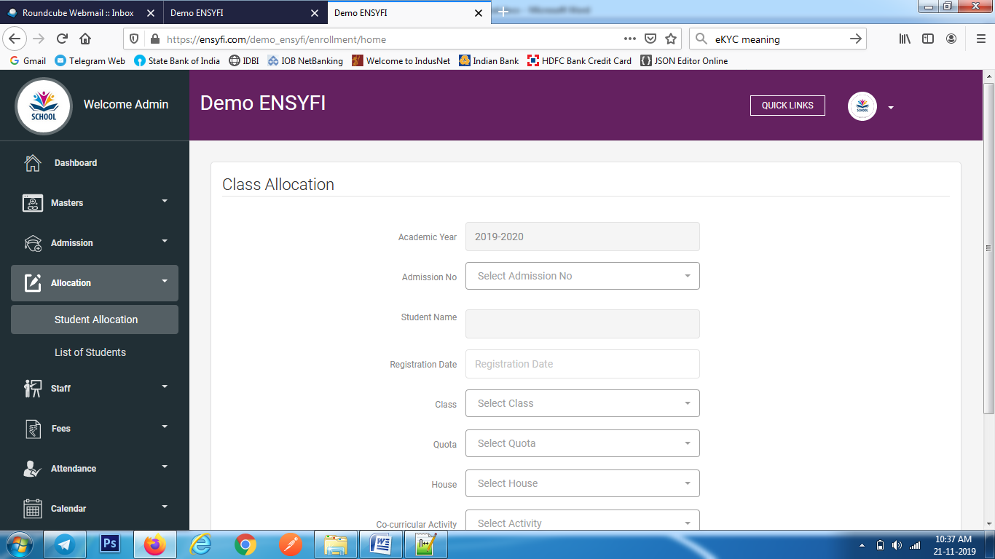

|  |  |  |
| --- | --- | --- |
| **Controller** | **Model** | **View** |
| Enrollment (home) | Yearsmodel (getall_years) | enrollment/add |
| Enrollment (home) | Admissionmodel (get_all_admission) | enrollment/add |
| Enrollment (home) | Classmodel (getclass) | enrollment/add |
| Enrollment (home) | Sectionmodel (getsection) | enrollment/add |
| Enrollment (home) | class_manage (getall_active_class) | enrollment/add |
| Enrollment (home) | Admissionmodel (get_enrollment_admisno) | enrollment/add |
| Enrollment (home) | Enrollmentmodel get_current_years) | enrollment/add |
| Enrollment (home) | Enrollmentmodel (get_all_quota_details) | enrollment/add |
| Enrollment (home) | Enrollmentmodel (get_all_groups_details) | enrollment/add |
| Enrollment (home) | Enrollmentmodel (get_all_activities_details) | enrollment/add |
| Enrollment (create) | Enrollmentmodel (ad_enrollment) | enrollment/add |

**32. Students Allocated to Classes**

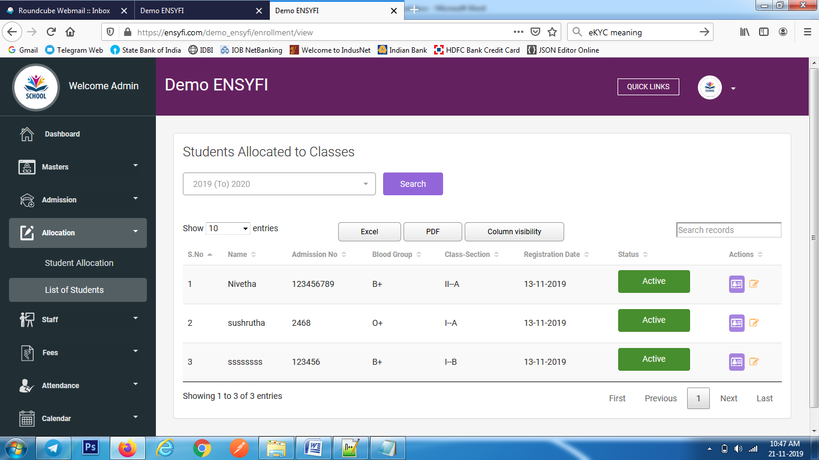

|  |  |  |
| --- | --- | --- |
| **Controller** | **Model** | **View** |
| Enrollment (view) | Yearsmodel (getall_years) | enrollment/view |
| Enrollment (view) | Enrollmentmodel (get_all_enrollment) | enrollment/view |
| Enrollment (view) | Enrollmentmodel (get_current_years) | enrollment/view |

**33. Edit Class Allocation**

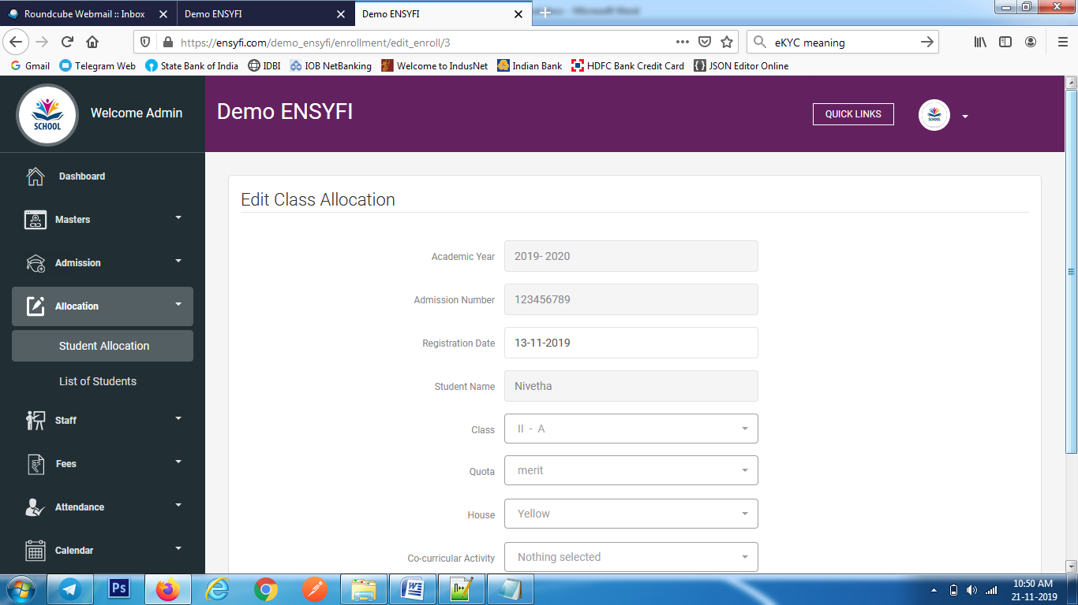

|  |  |  |
| --- | --- | --- |
| **Controller** | **Model** | **View** |
| Enrollment (edit_enroll) | class_manage (getall_active_class) | enrollment/edit |
| Enrollment (edit_enroll) | Admissionmodel (get_enrollmentid) | enrollment/edit |
| Enrollment (edit_enroll) | Enrollmentmodel (get_all_quota_details) | enrollment/edit |
| Enrollment (edit_enroll) | Enrollmentmodel (get_all_groups_details) | enrollment/edit |
| Enrollment (edit_enroll) | Enrollmentmodel (get_all_activities_details) | enrollment/edit |
| Enrollment (save) | Enrollmentmodel (save_enrollment) | enrollment/edit |

**34. Create Staff**

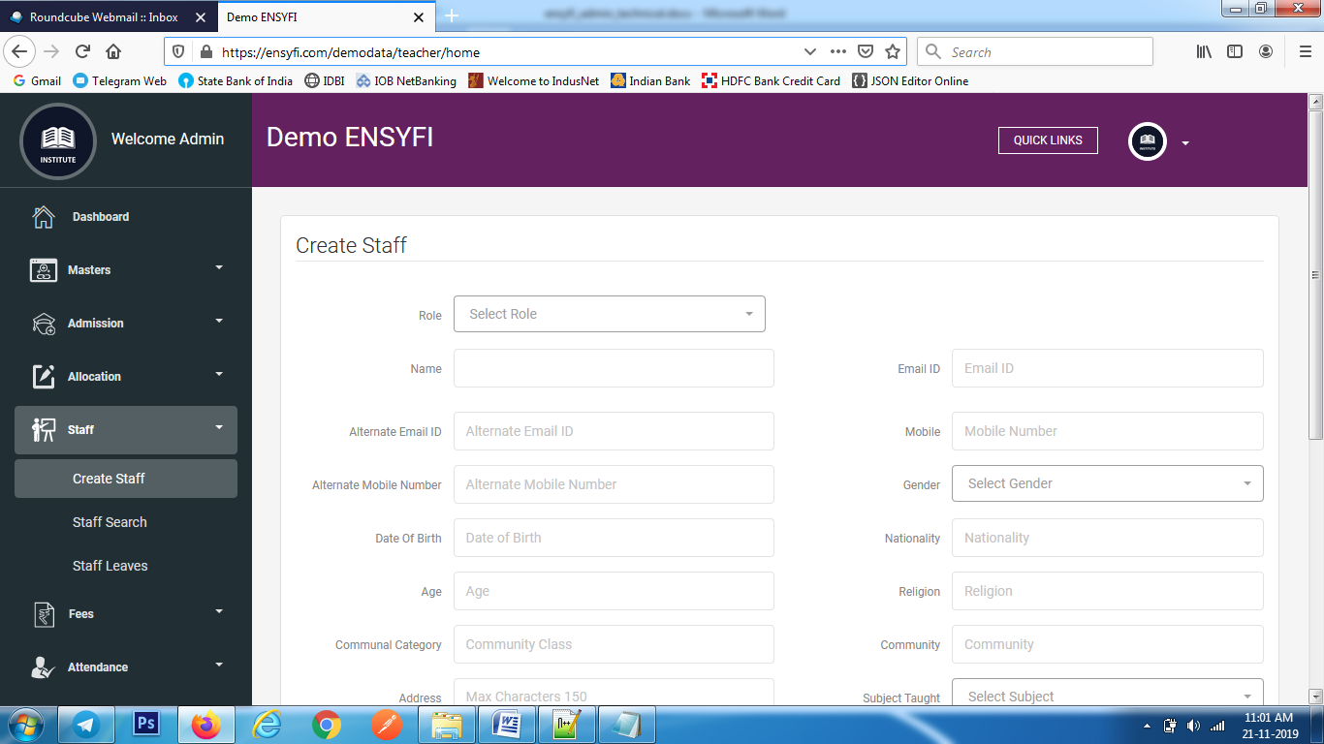

|  |  |  |
| --- | --- | --- |
| **Controller** | **Model** | **View** |
| Teacher (home) | Class_manage (get_all_class_notexist) | teacher/add |
| Teacher (home) | Class_manage (getall_class) | teacher/add |
| Teacher (home) | Subjectmodel (getsubject) | teacher/add |
| Teacher (home) | Teachermodel (get_all_groups_details) | teacher/add |
| Teacher (home) | Teachermodel (get_all_activities_details) | teacher/add |
| Teacher (home) | Teachermodel (get_user_rolename) | teacher/add |
| Teacher (create) | Teachermodel (teacher_create) | teacher/add |

**35. Create Staff**



|  |  |  |
| --- | --- | --- |
| **Controller** | **Model** | **View** |
| Teacher (home) | Class_manage (get_all_class_notexist) | teacher/add |
| Teacher (home) | Class_manage (getall_class) | teacher/add |
| Teacher (home) | Subjectmodel (getsubject) | teacher/add |
| Teacher (home) | Teachermodel (get_all_groups_details) | teacher/add |
| Teacher (home) | Teachermodel (get_all_activities_details) | teacher/add |
| Teacher (home) | Teachermodel (get_user_rolename) | teacher/add |
| Teacher (create) | Teachermodel (teacher_create) | teacher/add |

**36. Staff Details**

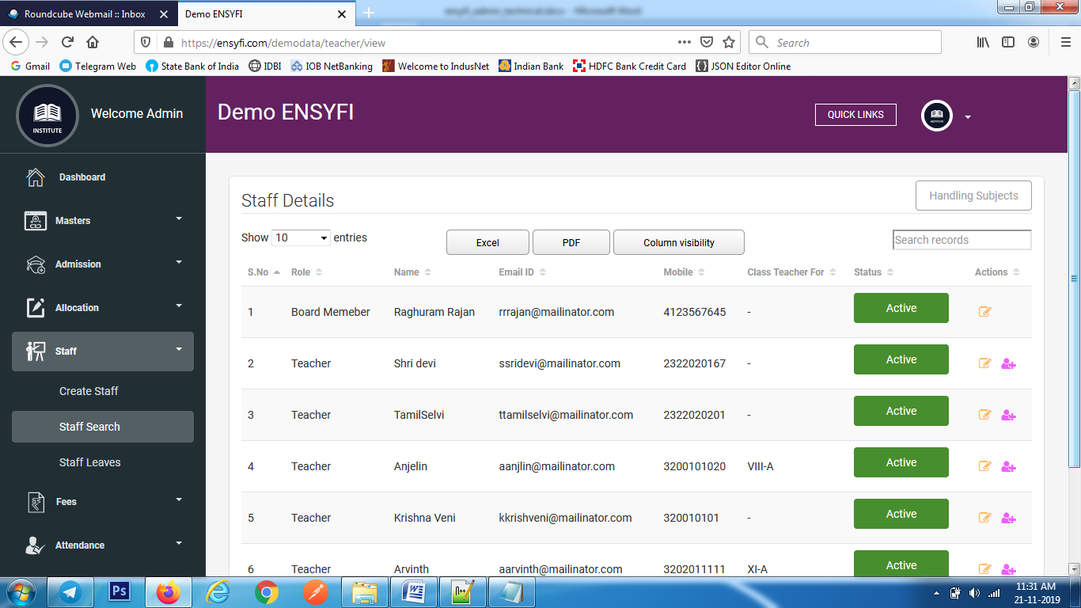

|  |  |  |
| --- | --- | --- |
| **Controller** | **Model** | **View** |
| Teacher (view) | Class_manage (getall_class) | teacher/view |
| Teacher (view) | Subjectmodel (getsubject) | teacher/view |
| Teacher (view) | Teachermodel (get_all_teacher) | teacher/view |
| Teacher (view) | Teachermodel (get_all_sorting_result) | teacher/view |

**37. Edit Staff**

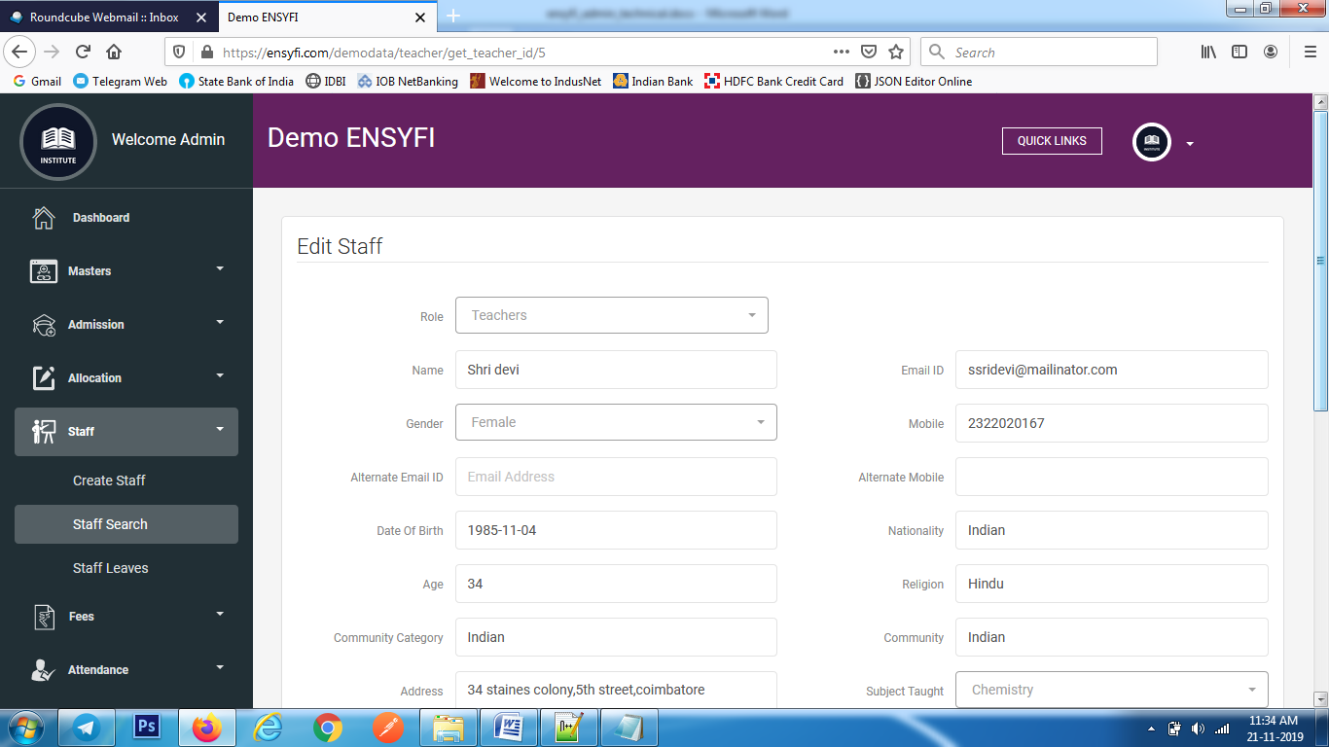

|  |  |  |
| --- | --- | --- |
| **Controller** | **Model** | **View** |
| Teacher (get_teacher_id) | Class_manage (getall_class) | teacher/edit |
| Teacher (get_teacher_id) | Subjectmodel (getsubject) | teacher/edit |
| Teacher (get_teacher_id) | Teachermodel (get_teacher_id) | teacher/edit |
| Teacher (get_teacher_id) | Teachermodel (get_all_groups_details) | teacher/edit |
| Teacher (get_teacher_id) | Teachermodel (get_all_activities_details) | teacher/edit |
| Teacher (get_teacher_id) | Teachermodel (get_user_rolename) | teacher/edit |
| Teacher (save) | Teachermodel (save_teacher) | teacher/edit |

**38. Add subject for teacher**

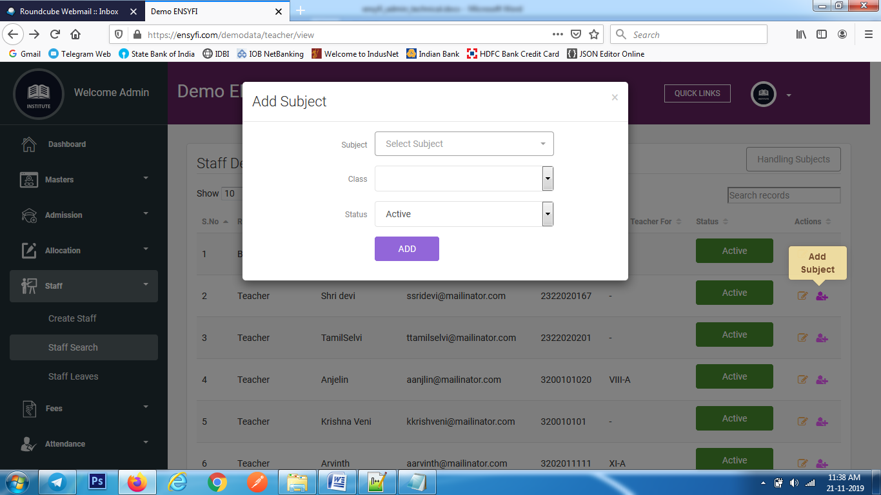

|  |  |  |
| --- | --- | --- |
| **Controller** | **Model** | **View** |
| Teacher (subject_handling) | Teachermodel (subject_handling) | teacher/view |

**39. List Handling Subjects**

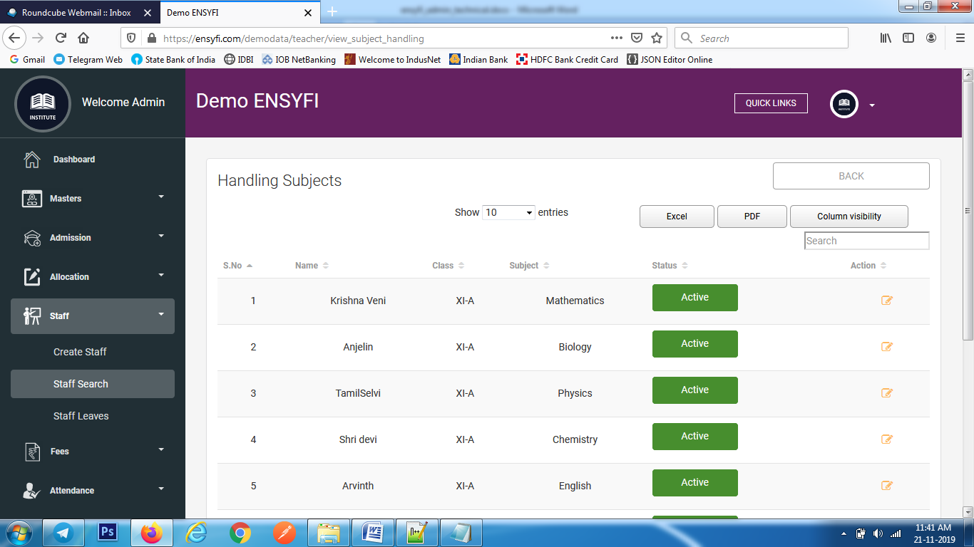

|  |  |  |
| --- | --- | --- |
| **Controller** | **Model** | **View** |
| Teacher (view_subject_handling) | Teachermodel (view_subject_handling_teacher) | teacher/teacher_subject_handling |

**40. Edit Handling Subjects**

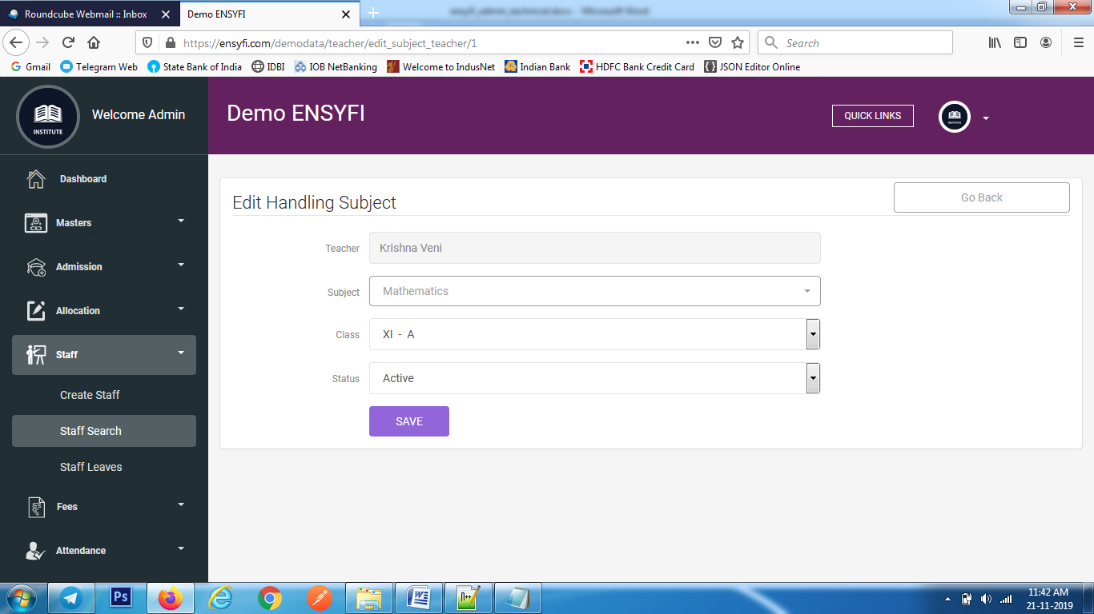

|  |  |  |
| --- | --- | --- |
| **Controller** | **Model** | **View** |
| Teacher (edit_subject_teacher) | Teachermodel (get_subject_handling_teacher) | teacher/edit_subject_handling |
| Teacher (edit_subject_teacher) | Subjectmodel (getsubject) | teacher/edit_subject_handling |
| Teacher (edit_subject_teacher) | Class_manage (getall_class) | teacher/edit_subject_handling |
| Teacher (save_subject_handling) | Teachermodel (save_subject_handling) | teacher/edit_subject_handling |

**41. Staff Leaves**

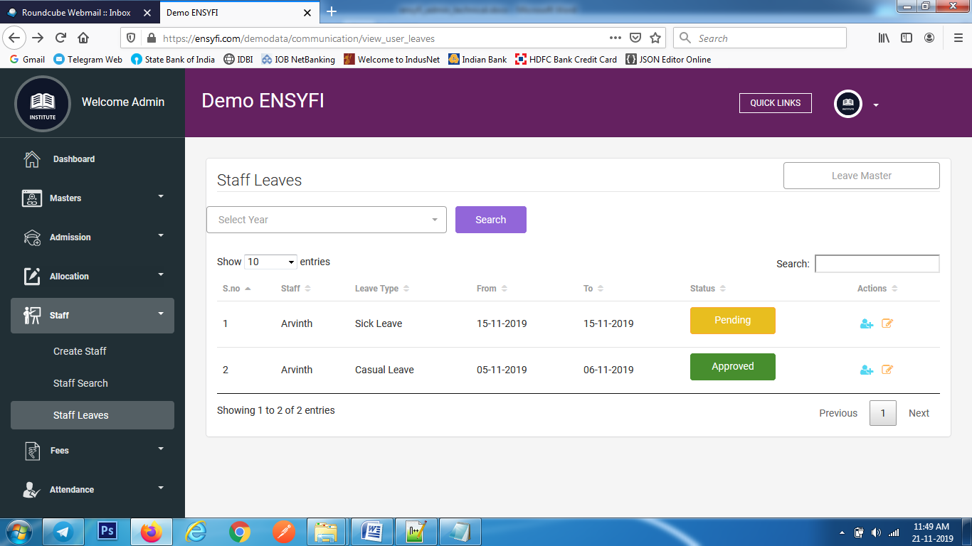

|  |  |  |
| --- | --- | --- |
| **Controller** | **Model** | **View** |
| communication (view_user_leaves) | yearsmodel (getall_years) | communication/users_leave |
| communication (view_user_leaves) | Communicationmodel (user_leaves) | communication/users_leave |

**42. Status update staff Leaves**

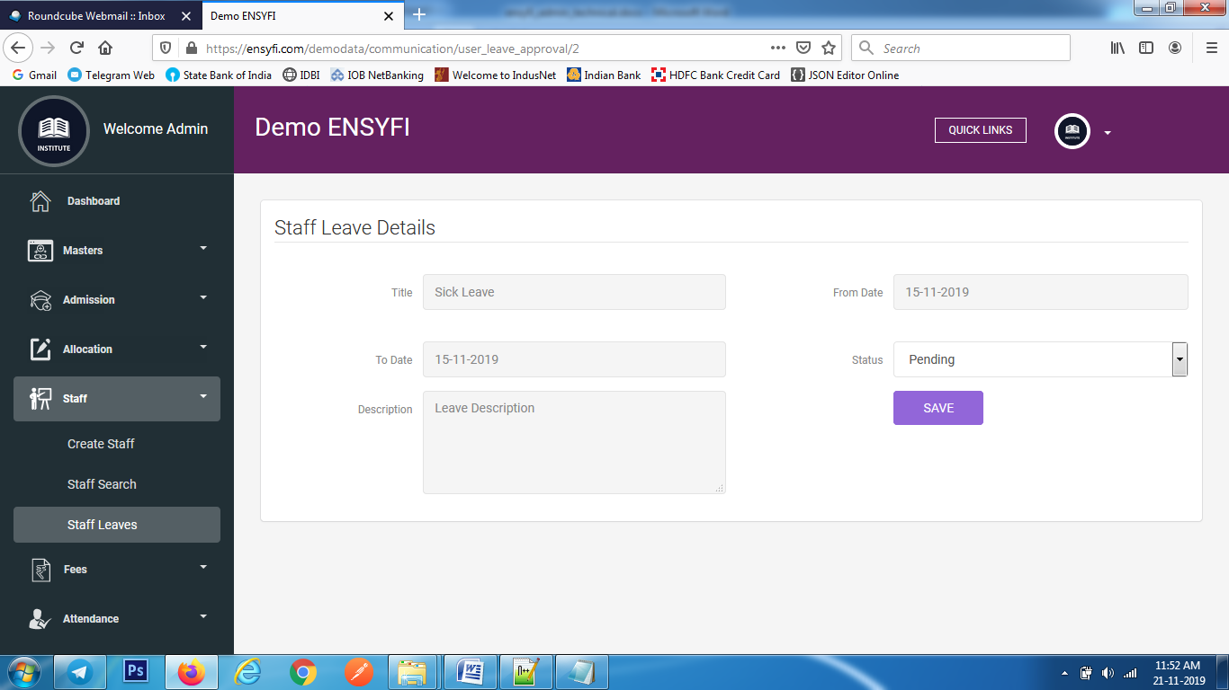

|  |  |  |
| --- | --- | --- |
| **Controller** | **Model** | **View** |
| communication (user_leave_approval) | Communicationmodel (edit_leave) | communication/ user_leave_approval |
| communication (user_leave_approval) | Communicationmodel (get_all_leave) | communication/ user_leave_approval |
| communication (update_status) | Communicationmodel (update_leave) | communication/ user_leave_approval |

**43. Substitute Teacher**

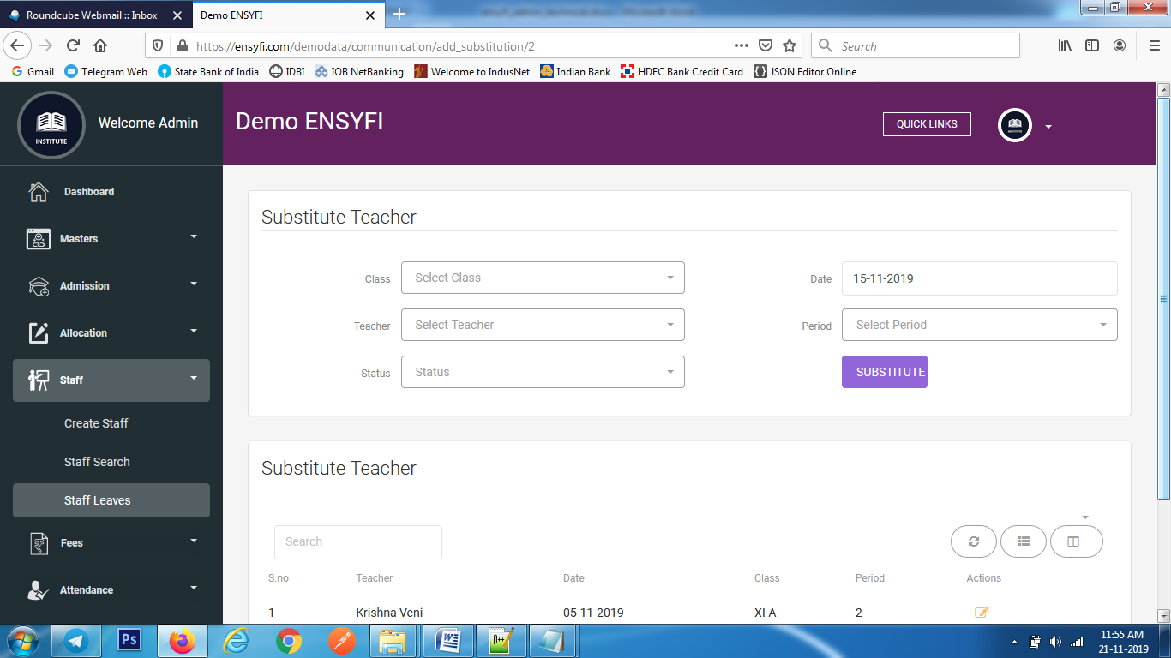

|  |  |  |
| --- | --- | --- |
| **Controller** | **Model** | **View** |
| communication (add_substitution) | Communicationmodel (get_all_class_list) | communication/add_substitution |
| communication (add_substitution) | Communicationmodel (get_all_teachers_list) | communication/add_substitution |
| communication (add_substitution) | Communicationmodel (get_all_view_list) | communication/add_substitution |
| communication (create_substition) | Communicationmodel (add_substitution_list) – SMS, Mail, Notification send | communication/add_substitution |

**44. Edit Substitute Teacher**

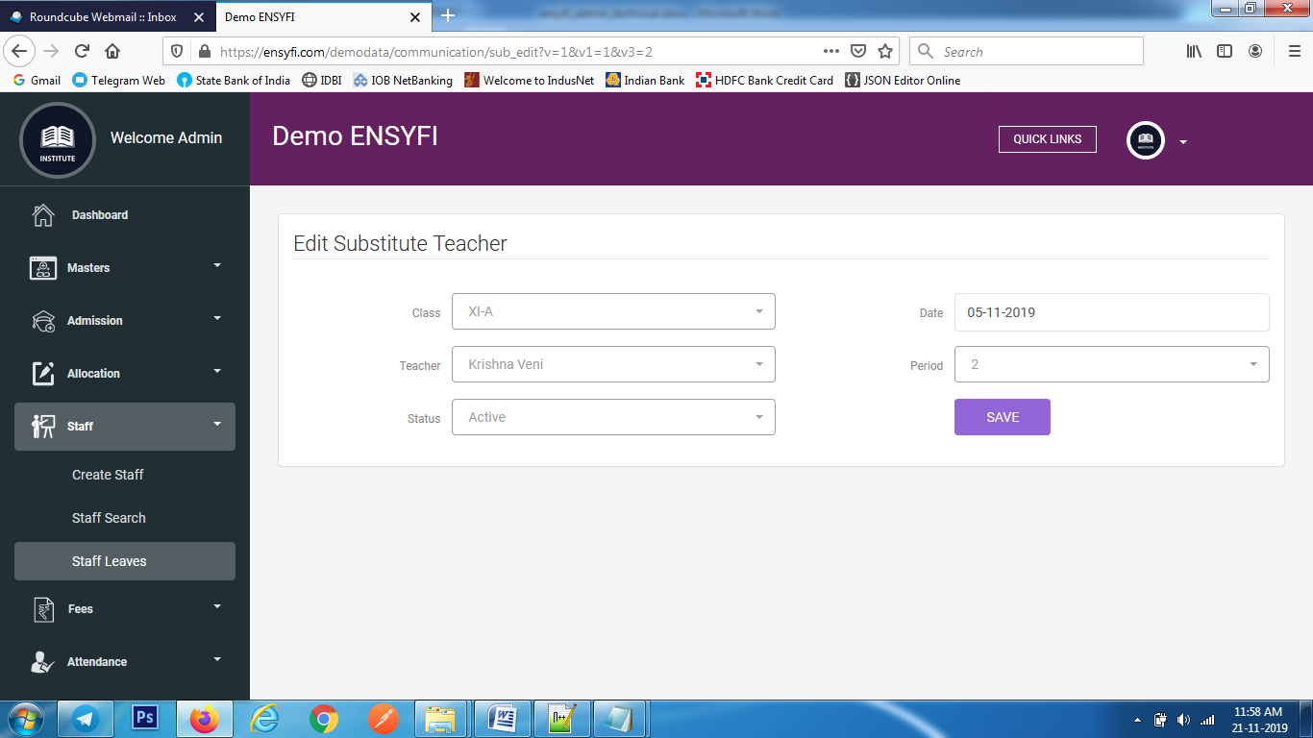

|  |  |  |
| --- | --- | --- |
| **Controller** | **Model** | **View** |
| communication (sub_edit) | Communicationmodel (get_all_class_list1) | communication/edit_substitution |
| communication (sub_edit) | Communicationmodel (edit_substitution_list) | communication/edit_substitution |
| communication (update_substition) | Communicationmodel (update_substitution_list) | communication/edit_substitution |

**45. Leave Master**

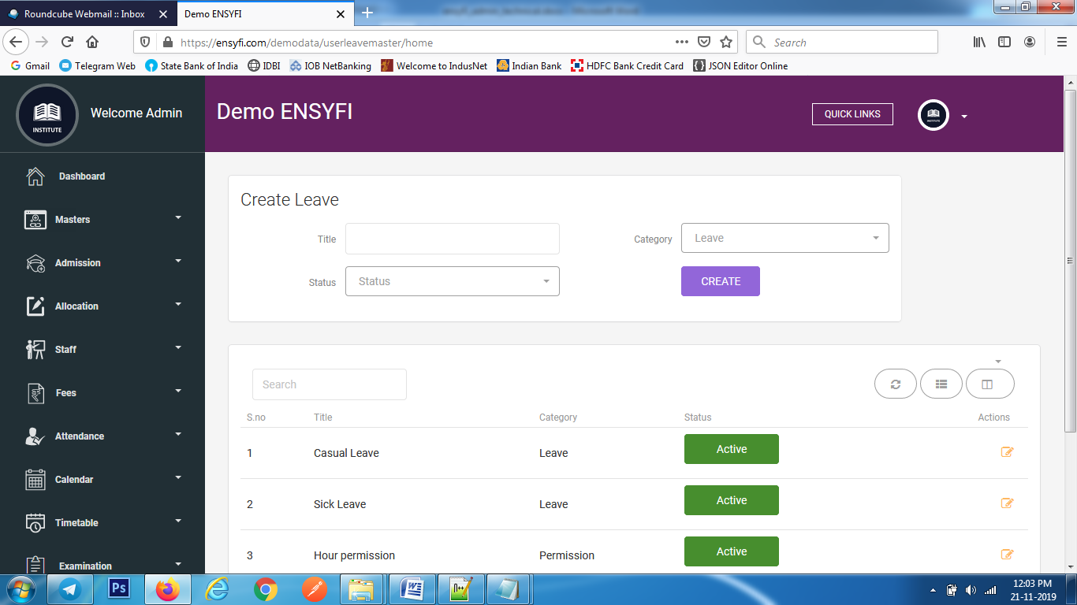

|  |  |  |
| --- | --- | --- |
| **Controller** | **Model** | **View** |
| Userleavemaster (home) | Userleavemastermodel (getall_leave_list) | userleave/add_user_leave |
| Userleavemaster (create_leave) | Userleavemastermodel (create_leave) | userleave/add_user_leave |

**46. Edit Leave Master**



|  |  |  |
| --- | --- | --- |
| **Controller** | **Model** | **View** |
| Userleavemaster (edit_leave) | Userleavemastermodel (edit_leave_list) | userleave/edit_user_leave |
| Userleavemaster (update_leave) | Userleavemastermodel (update_leave_list) | userleave/edit_user_leave |

**47. Create Quota**

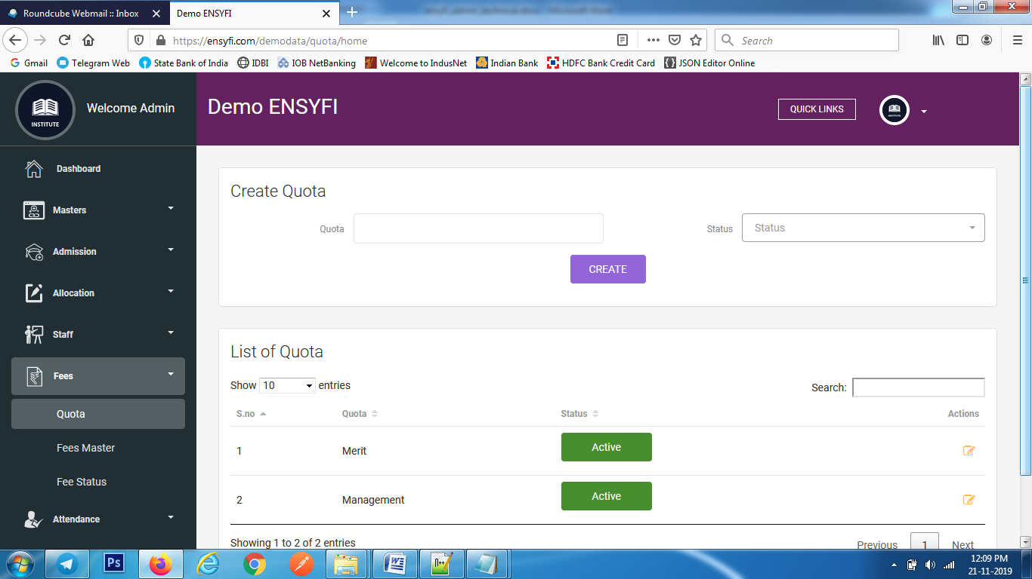

|  |  |  |
| --- | --- | --- |
| **Controller** | **Model** | **View** |
| Quota (home) | Quotamodel (getall_quota_list) | quota/add_quota |
| Quota (create_quota) | Quotamodel (create_quota_list) | quota/add_quota |

**48. Edit Quota**

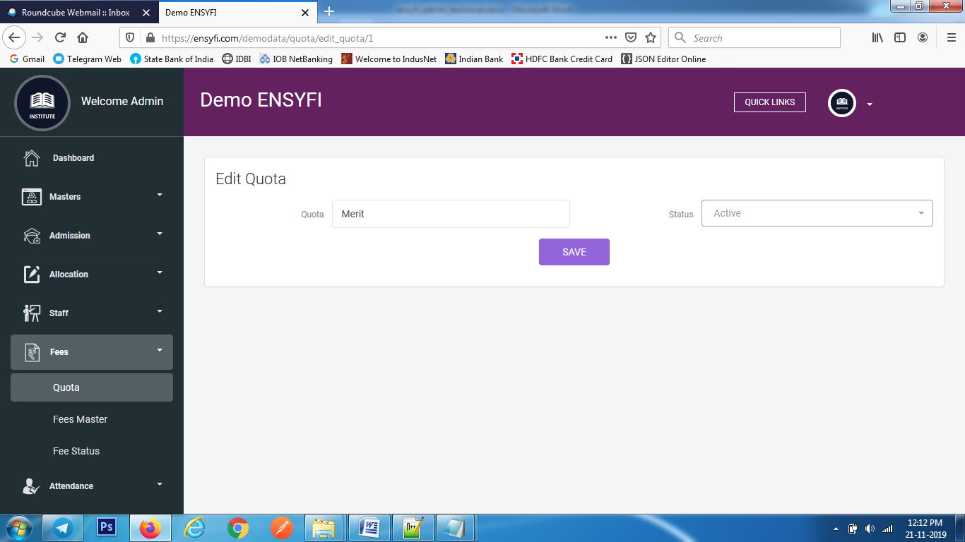

|  |  |  |
| --- | --- | --- |
| **Controller** | **Model** | **View** |
| Quota (edit_quota) | Quotamodel (edit_quota_list) | quota/edit_quota |
| Quota (update_quota) | Quotamodel (update_quota_list) | quota/ edit_quota |

**49. Fees Master Create/List/Edit**

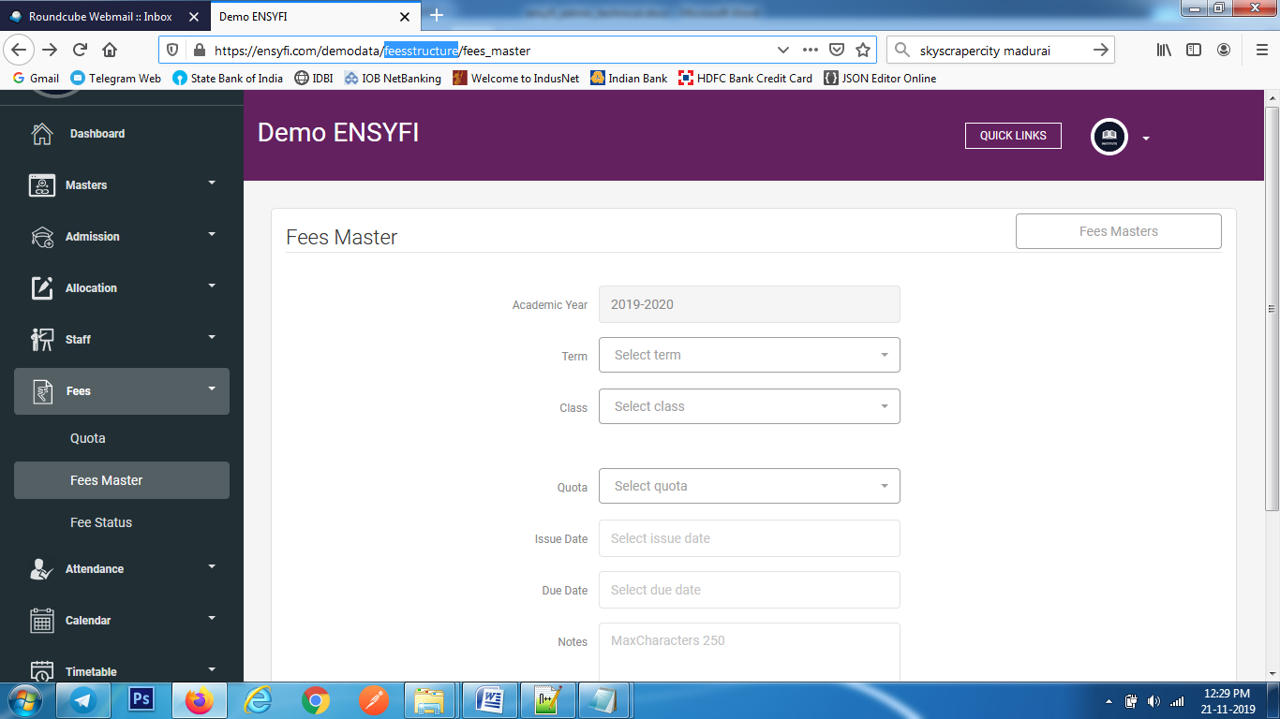

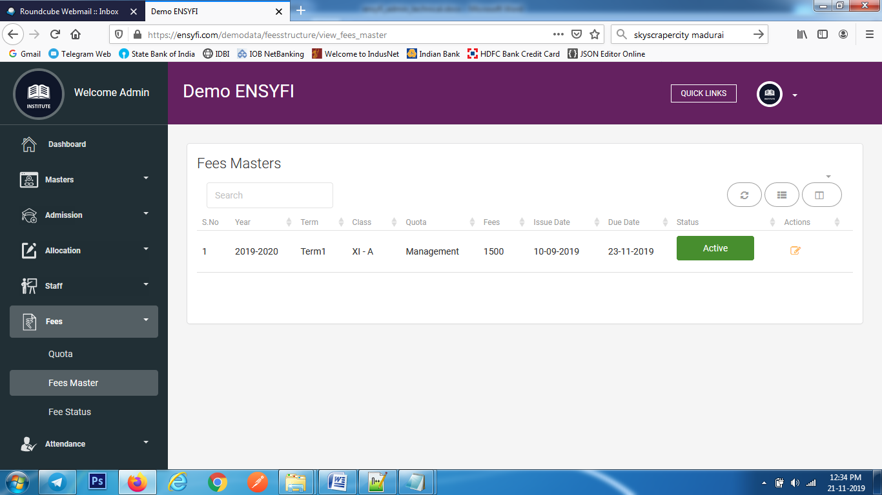

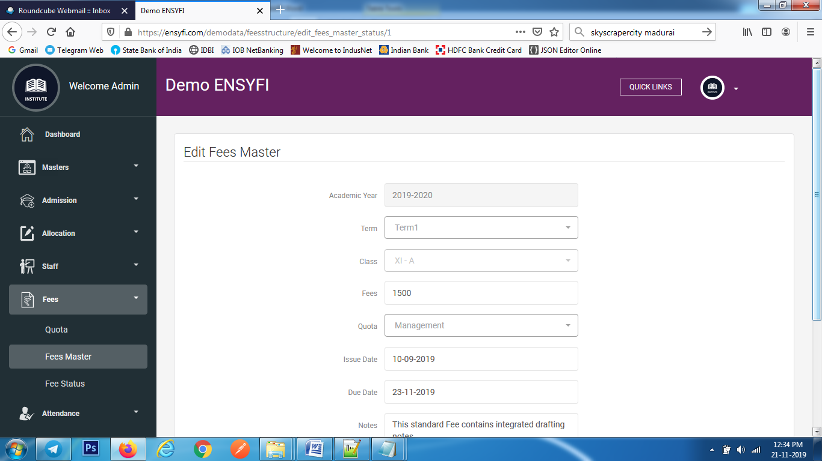

|  |  |  |
| --- | --- | --- |
| **Controller** | **Model** | **View** |
| Feesstructure (fees_master) | Feesstructuremodel (get_current_years) | fees/fees_master |
| Feesstructure (fees_master) | Feesstructuremodel (get_terms) | fees/fees_master |
| Feesstructure (fees_master) | Feesstructuremodel (get_all_enr_cls) | fees/fees_master |
| Feesstructure (fees_master) | Feesstructuremodel (get_all_quota) | fees/fees_master |
| Feesstructure (fees_master) | Class_manage (getall_class) | fees/fees_master |
| Feesstructure (fees_master) | Classmodel (getclass) | fees/fees_master |
| Feesstructure (create_fees_structure) | Feesstructuremodel (add_fees_details) | fees/fees_master |
| Feesstructure (view_fees_master) | Feesstructuremodel (view_fees_master_details) | fees/fees_master_view |
| Feesstructure (edit_fees_master_status) | Feesstructuremodel (edit_fees_master_status) | fees/edit_fees_master |
| Feesstructure (update_fees_master) | Feesstructuremodel (update_fees_details) | fees/edit_fees_master |

**50. List Fees Status**

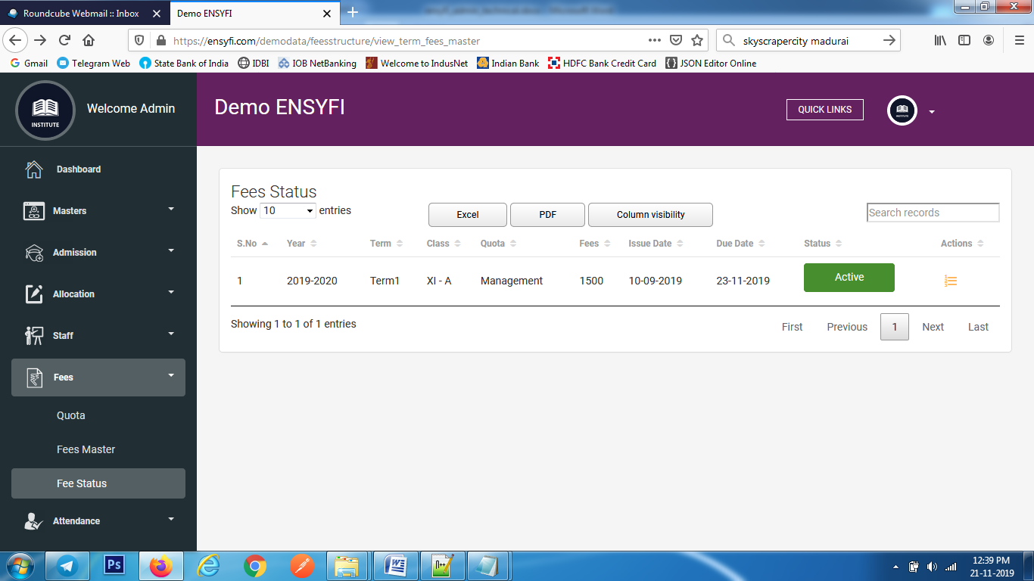

|  |  |  |
| --- | --- | --- |
| **Controller** | **Model** | **View** |
| Feesstructure (view_term_fees_master) | Feesstructuremodel (view_fees_master_details) | fees/term__fees_master_view |
| Quota (update_quota) | Quotamodel (update_quota_list) | quota/ edit_quota |

**51. List/Update Students term fees**

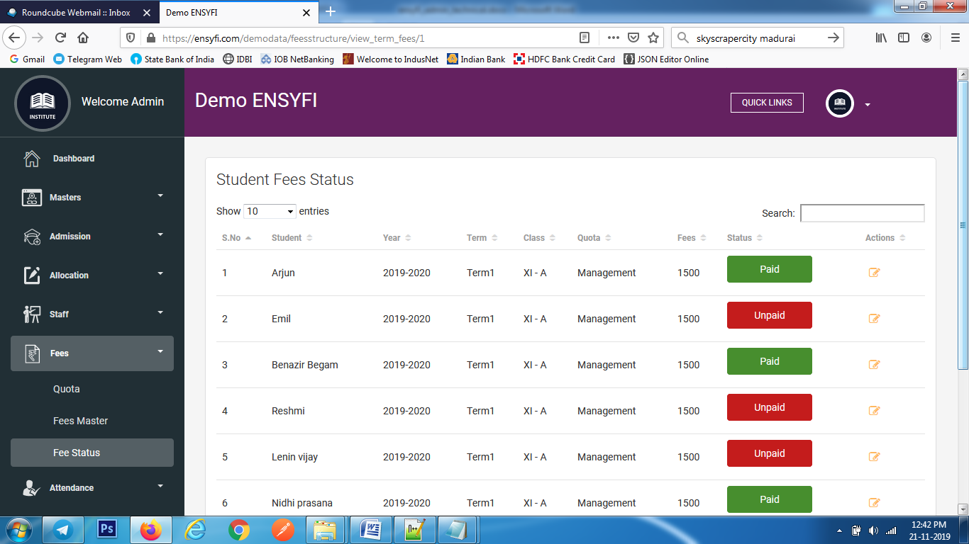

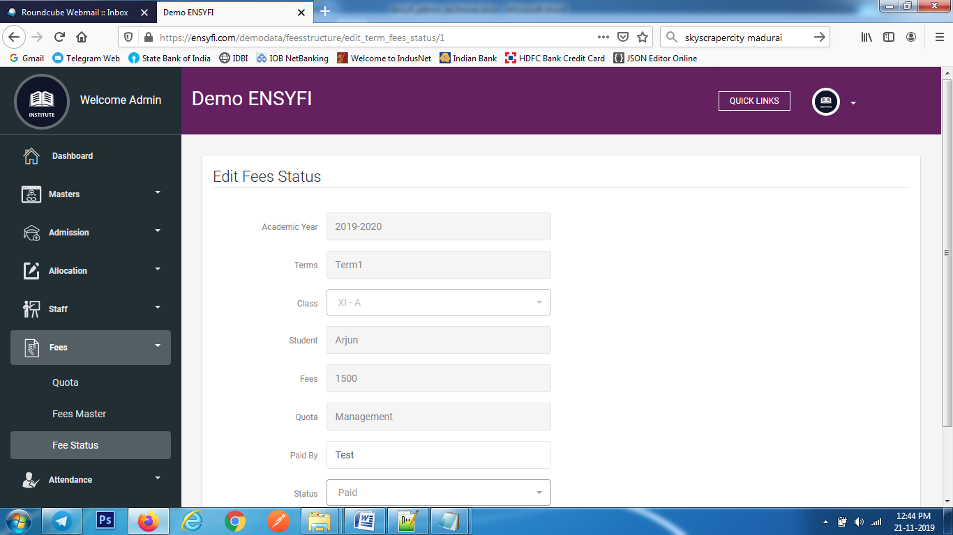

|  |  |  |
| --- | --- | --- |
| **Controller** | **Model** | **View** |
| Feesstructure (view_term_fees) | Feesstructuremodel (view_term_fees_status) | fees/view_term_fees_status |
| Feesstructure (edit_term_fees_status) | Feesstructuremodel (edit_term_fees_status) | fees/edit_term_fees_status |
| Feesstructure (update_term_fees_status) | Feesstructuremodel (update_term_fees_status) | fees/edit_term_fees_status |

**52. List Students term fees**



|  |  |  |
| --- | --- | --- |
| **Controller** | **Model** | **View** |
| Feesstructure (view_term_fees) | Feesstructuremodel (view_term_fees_status) | fees/view_term_fees_status |

**53. Update Students term fees**



|  |  |  |
| --- | --- | --- |
| **Controller** | **Model** | **View** |
| Feesstructure (edit_term_fees_status) | Feesstructuremodel (edit_term_fees_status) | fees/edit_term_fees_status |
| Feesstructure (update_term_fees_status) | Feesstructuremodel (update_term_fees_status) | fees/edit_term_fees_status |

**54. Daywise Class Attendance**

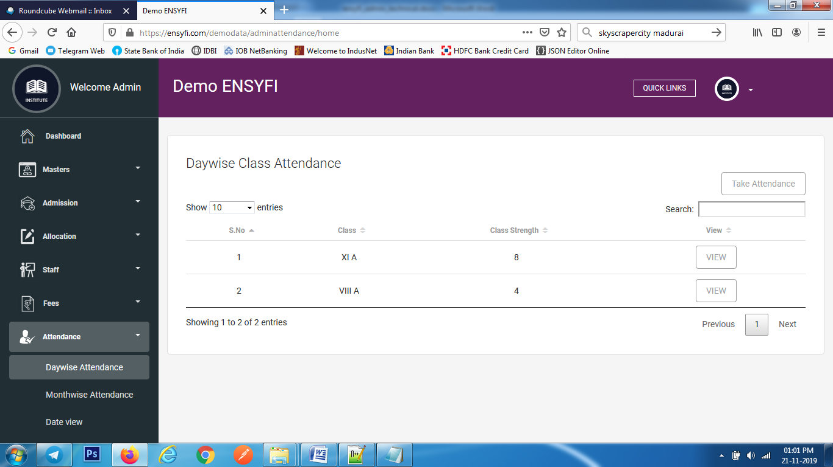

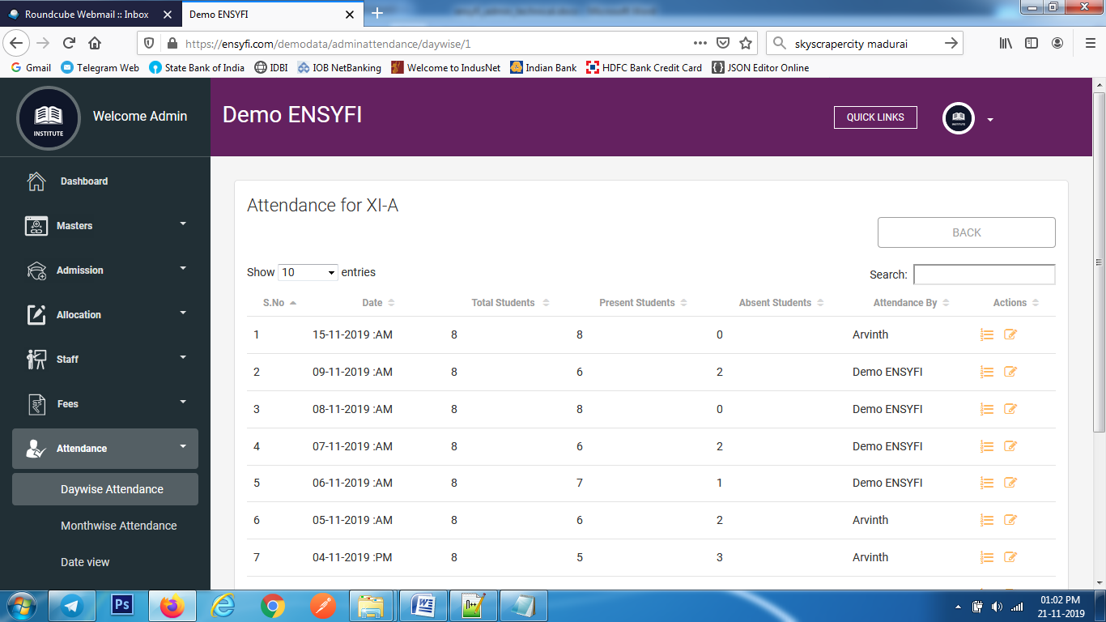

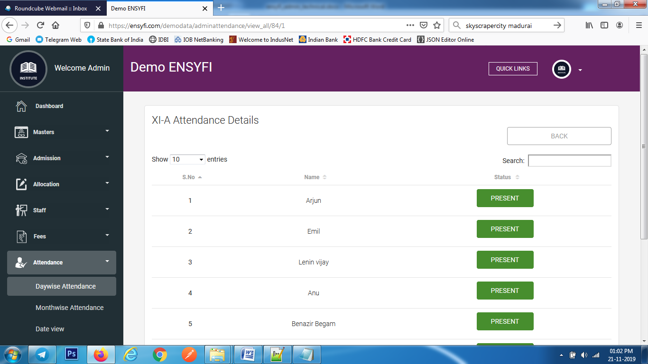

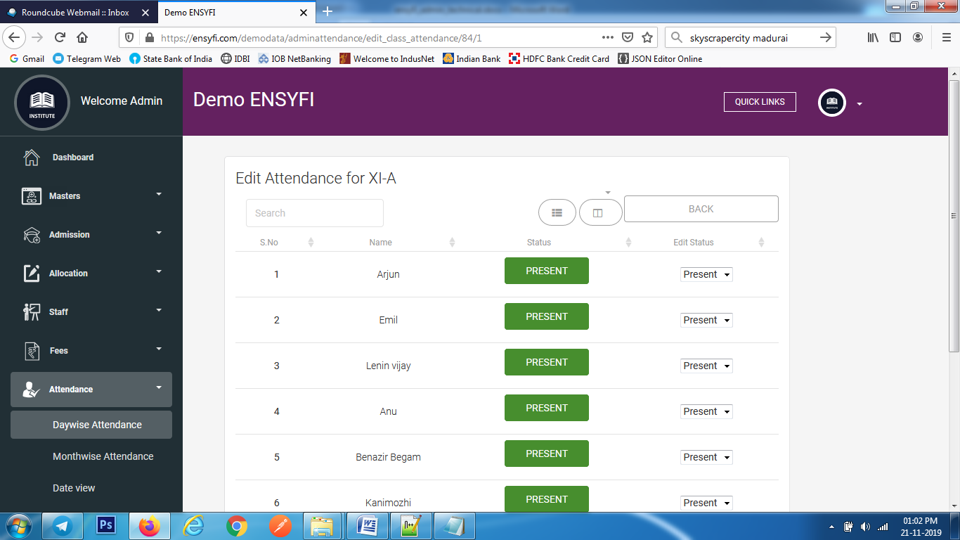

|  |  |  |
| --- | --- | --- |
| **Controller** | **Model** | **View** |
| Adminattendance (home) | Adminattendancemodel (get_all_class) | attendance/viewattendance |
| Adminattendance (daywise) | Class_manage (edit_cs) | attendance/classattendance |
| Adminattendance (daywise) | Adminattendancemodel (get_class_list) | attendance/classattendance |
| Adminattendance (view_all) | Adminattendancemodel (get_list_record) | attendance/ class_view_attendance |
| Adminattendance (edit_class_attendance) | Adminattendancemodel (get_list_record) | attendance/ edit_class_attendance |
| Adminattendance (update_attendance) | Adminattendancemodel (update_attendance_class) | attendance/ edit_class_attendance |

**55. Monthwise Class Attendance**

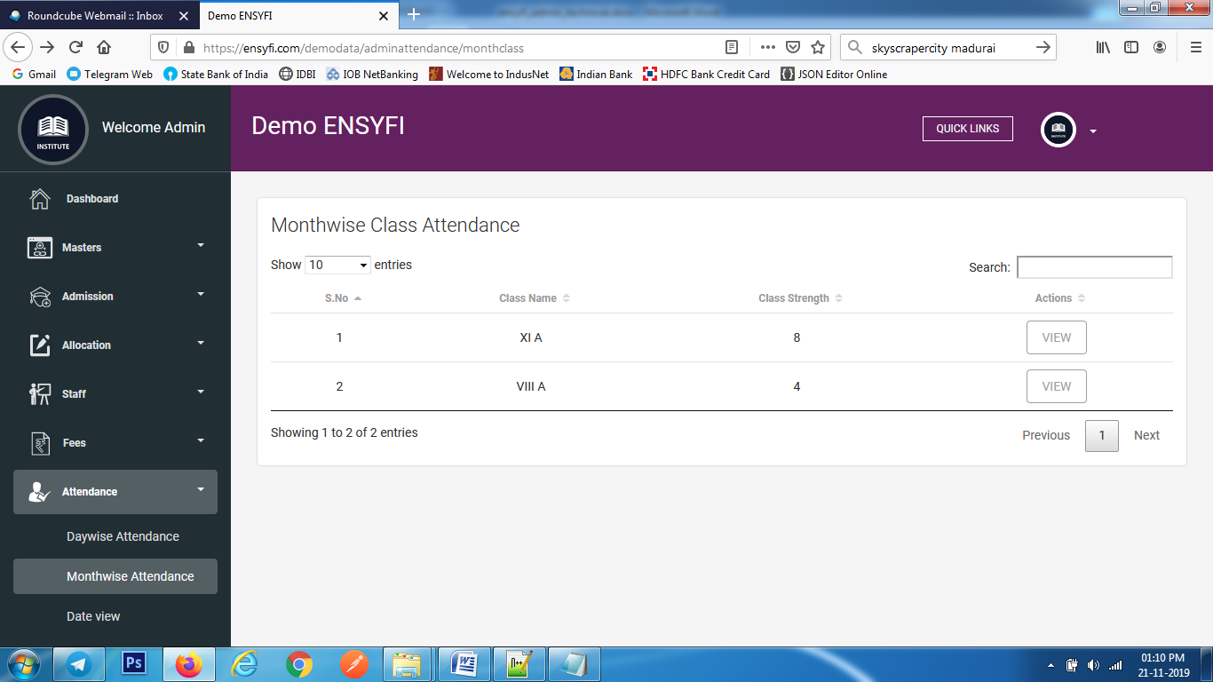

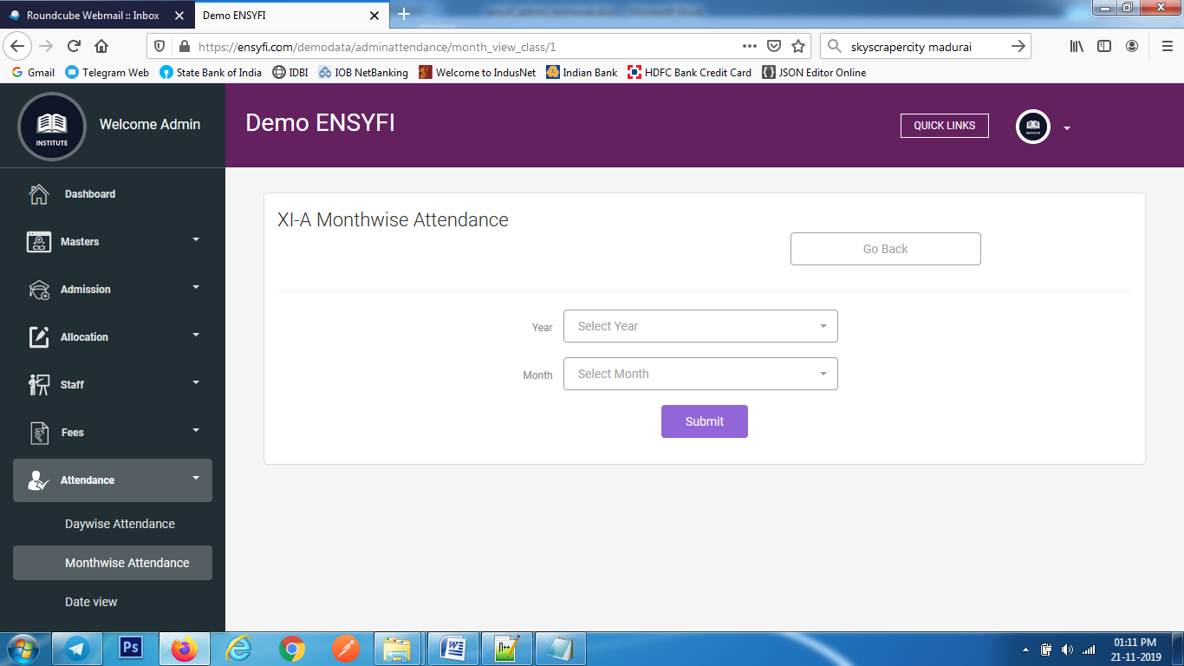

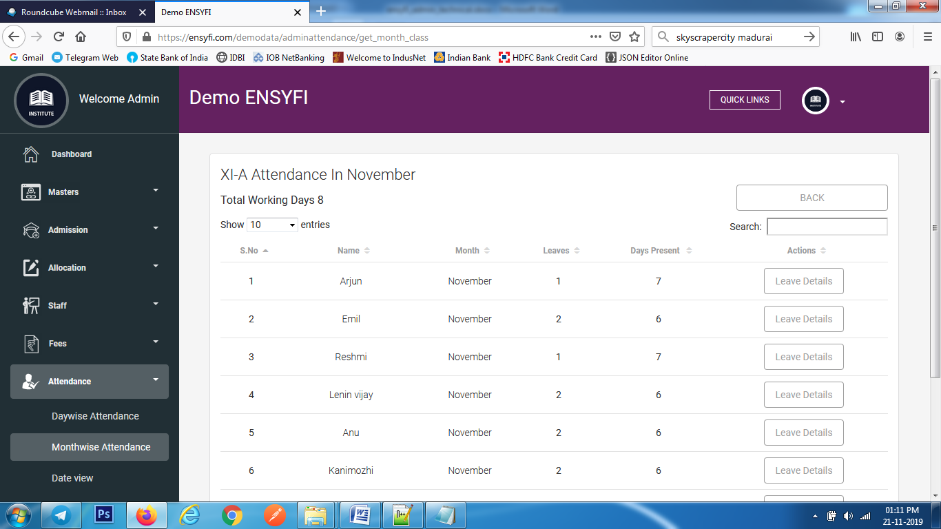

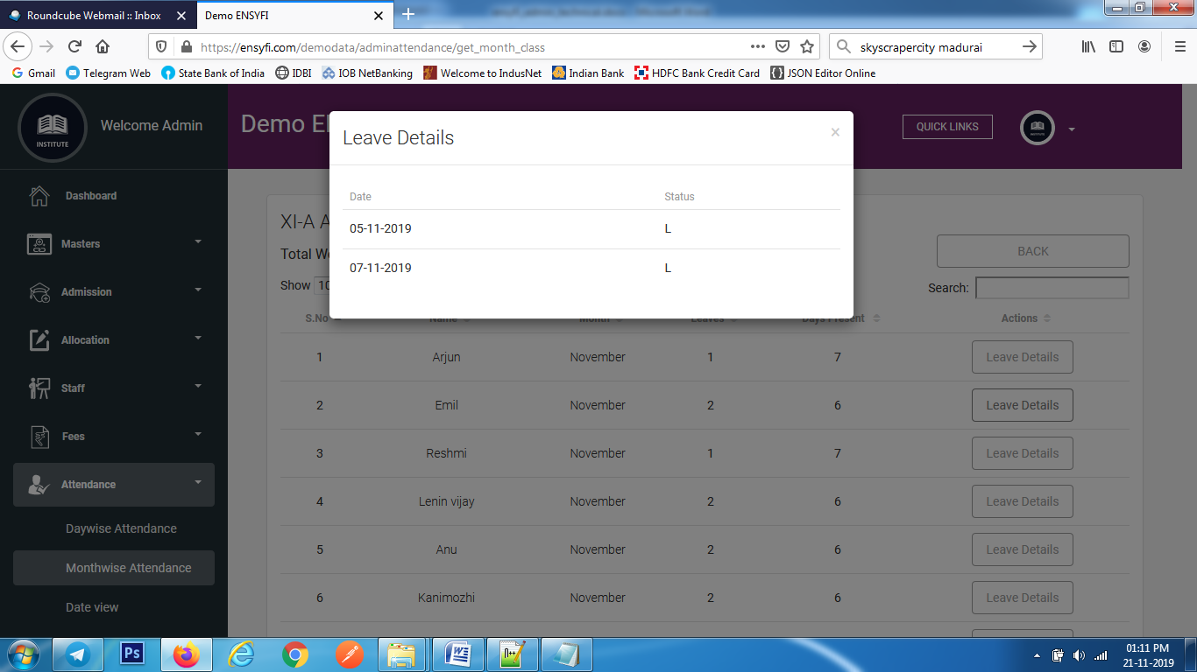

|  |  |  |
| --- | --- | --- |
| **Controller** | **Model** | **View** |
| Adminattendance (monthclass) | Adminattendancemodel (get_all_class) | attendance/monthclass |
| Adminattendance (month_view_class) | Class_manage (edit_cs) | attendance/month_for_class |
| Adminattendance (month_view_class) | Adminattendancemodel (get_month_class) | attendance/month_for_class |
| Adminattendance (month_view_class) | Adminattendancemodel (get_year_class) | attendance/ month_for_class |
| Adminattendance (get_month_class) | Adminattendancemodel (get_monthview_class) | attendance/ month_view_for_class |
| Adminattendance (get_month_class) | Adminattendancemodel (get_total_working_days) | attendance/ month_view_for_class |
| Adminattendance (view_dates_id) | Adminattendancemodel (get_leave_dates) | attendance/ month_view_for_class |

**56. Date view attendance**

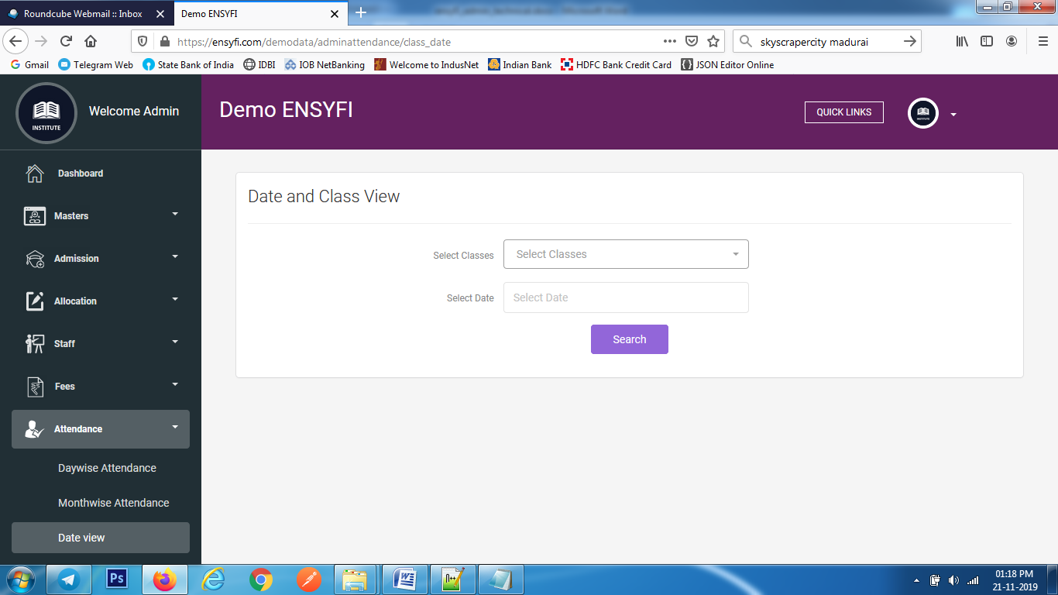

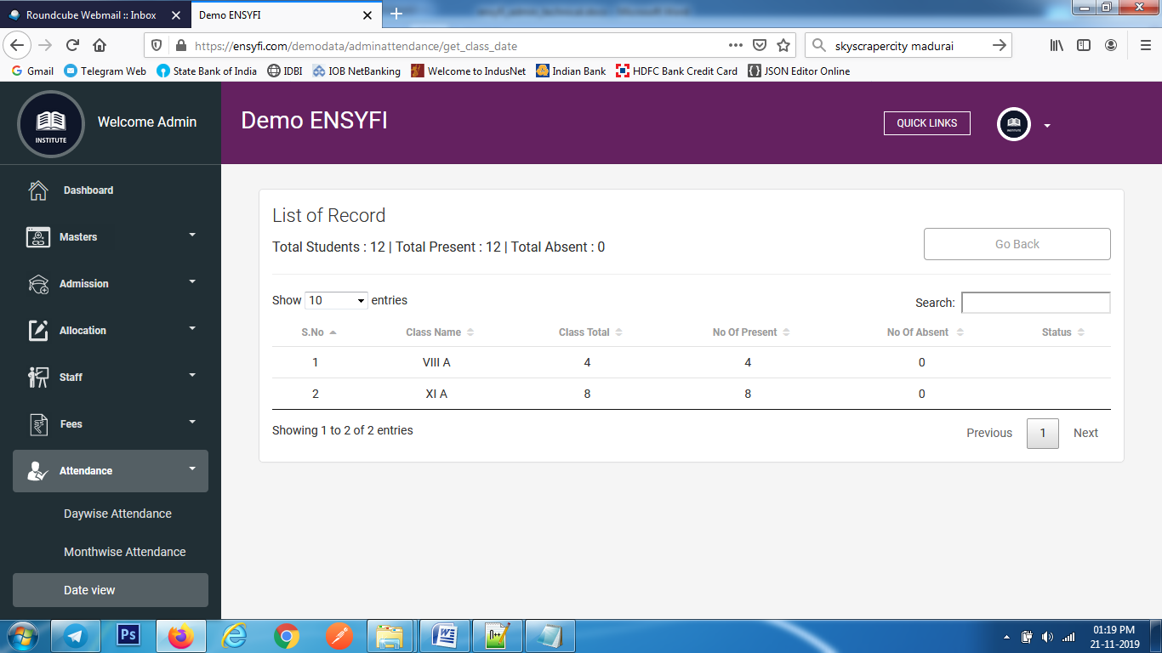

|  |  |  |
| --- | --- | --- |
| **Controller** | **Model** | **View** |
| Adminattendance (class_date) | Adminattendancemodel (get_all_class) | attendance/class_date |
| Adminattendance (month_view_class) | Adminattendancemodel (get_class_date) | attendance/class_date_view |

**57. Create / List/ Edit Events**

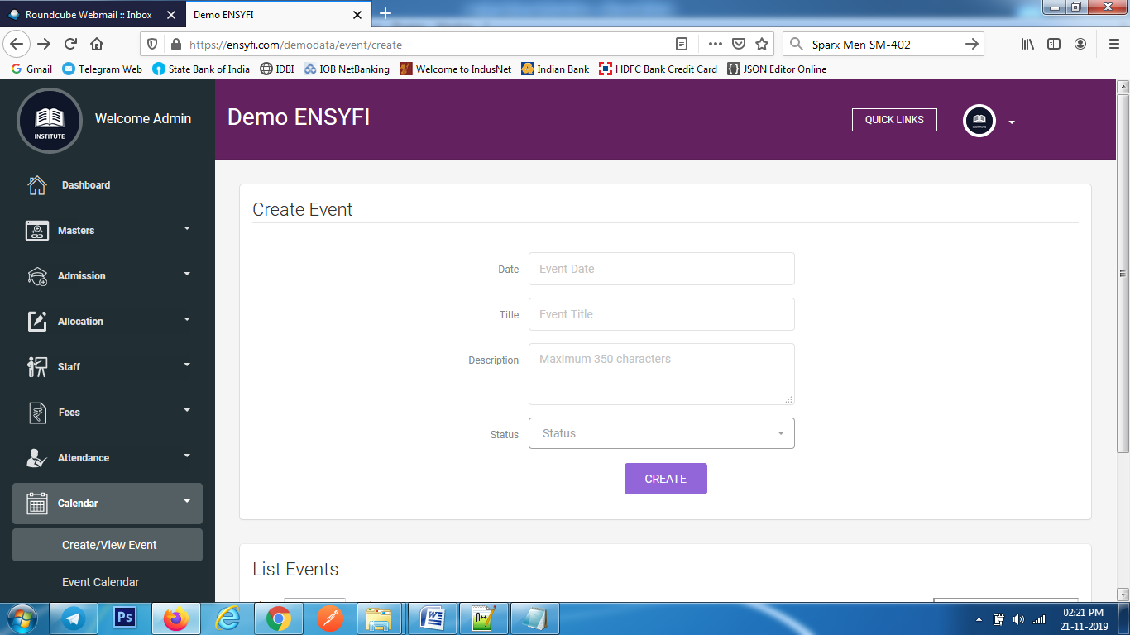

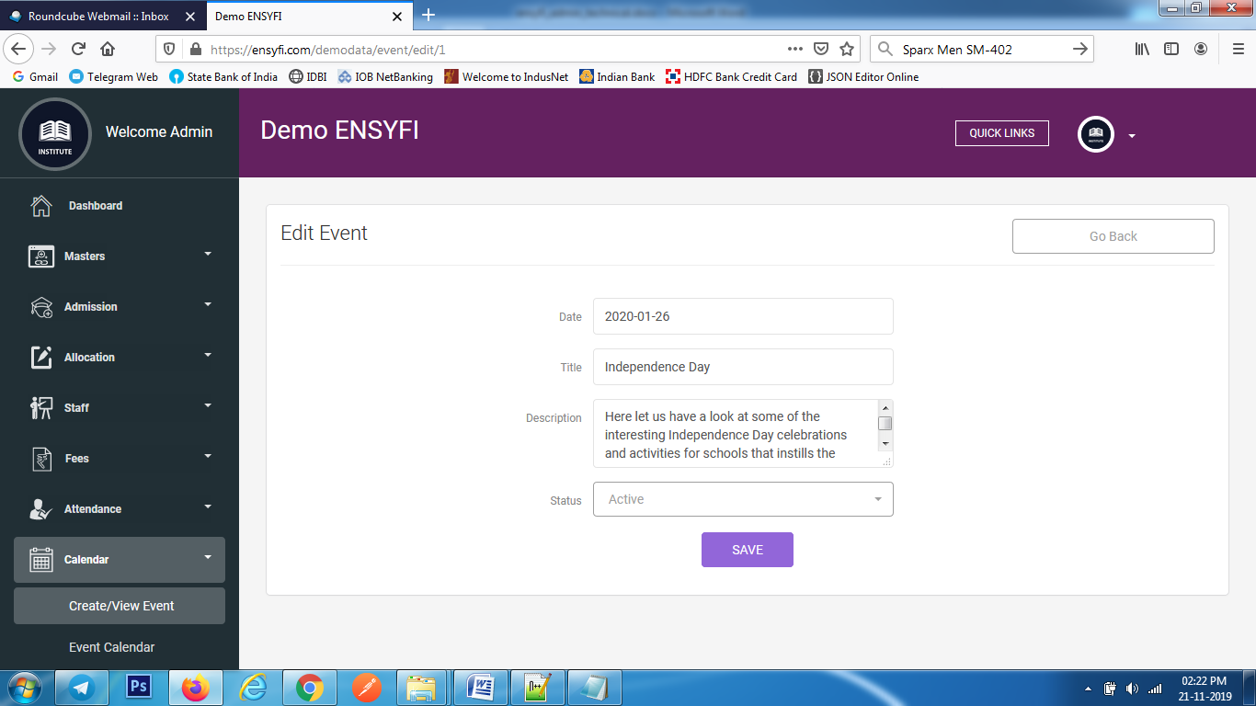

|  |  |  |
| --- | --- | --- |
| **Controller** | **Model** | **View** |
| Event (create) | Eventmodel (getall_events) | event/add |
| Event (add) | Eventmodel (create_event) | event/add |
| Event (edit) | Eventmodel (get_event_id) | event/edit |
| Event (save) | Eventmodel (save_event) | event/ edit |

**58. Assign / List/ Edit Coordinator for Events**

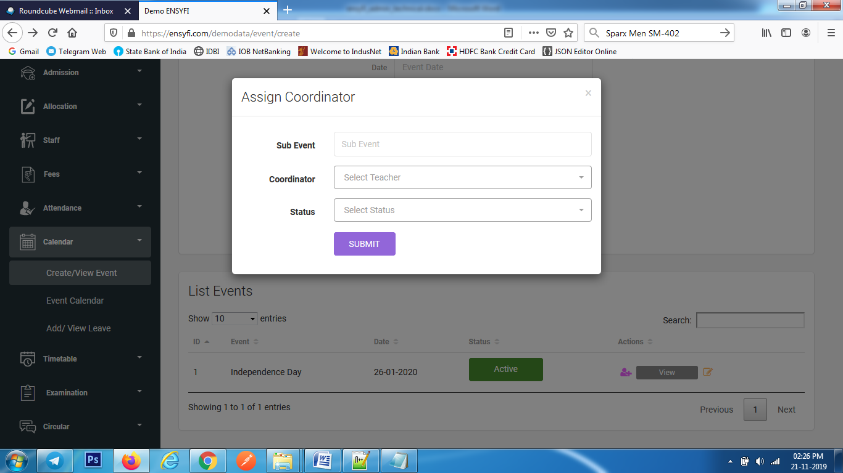

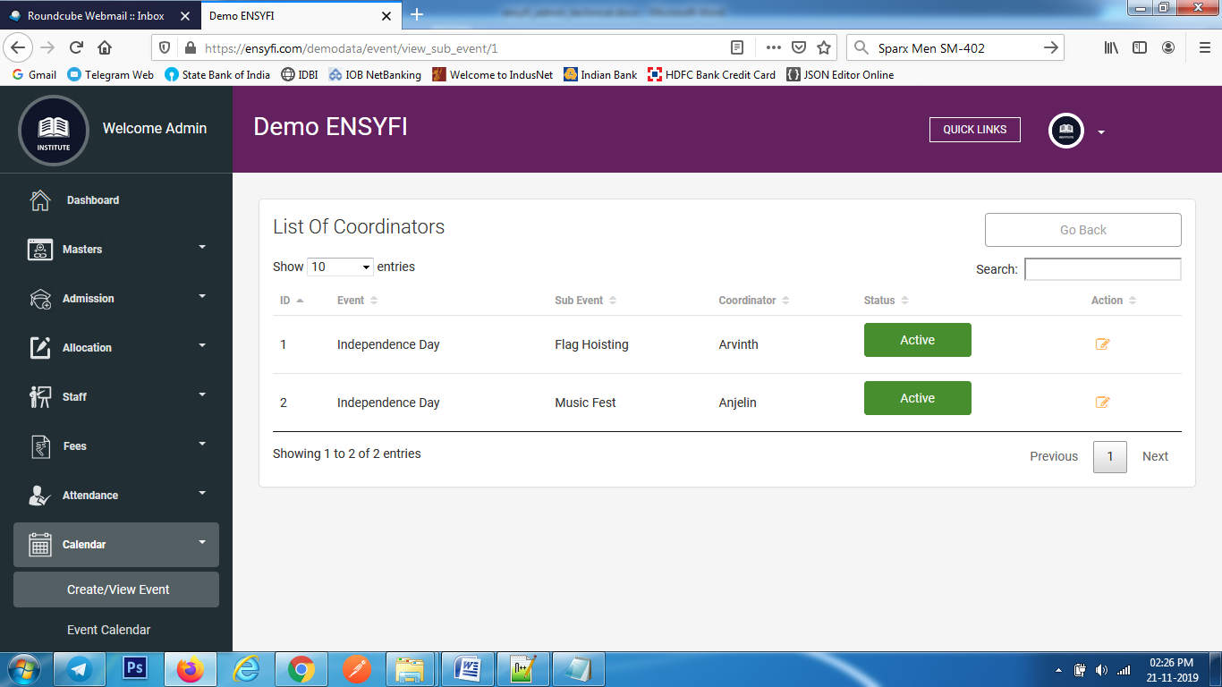

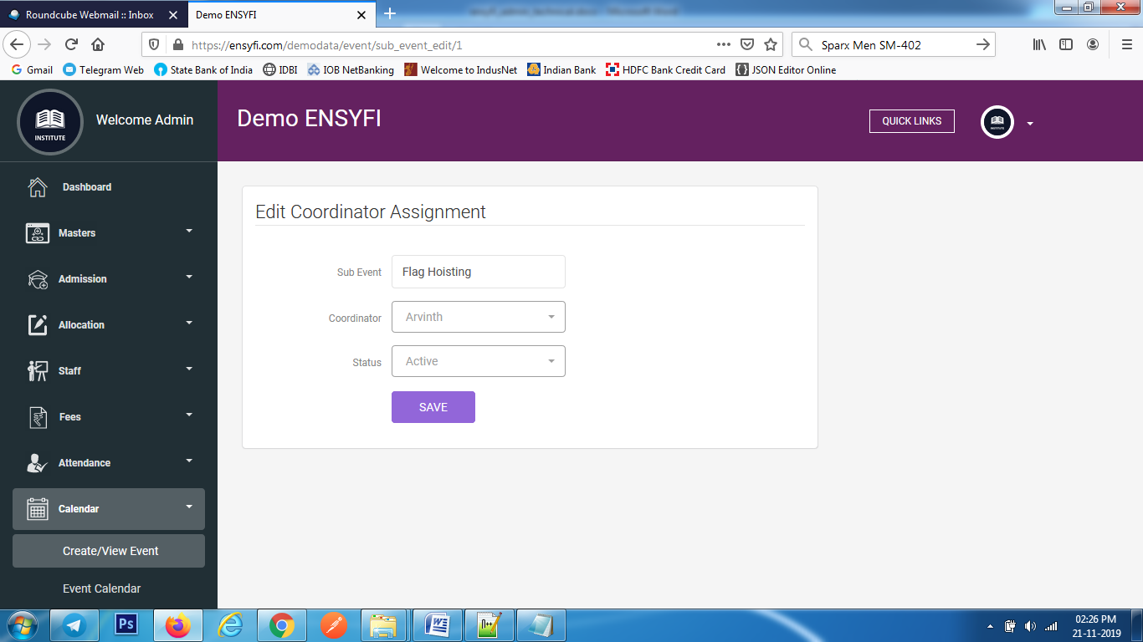

|  |  |  |
| --- | --- | --- |
| **Controller** | **Model** | **View** |
| Event (create_sub_event) | Eventmodel (save_sub_event) | event/add |
| Event (view_sub_event) | Eventmodel (view_sub_event) | event/sub_event_view |
| Event (sub_event_edit) | Eventmodel (edit_sub_event) | event/edit_sub_event |
| Event (sub_event_update) | Eventmodel (update_sub_event) | event/edit_sub_event |

**59. Event Calendar**

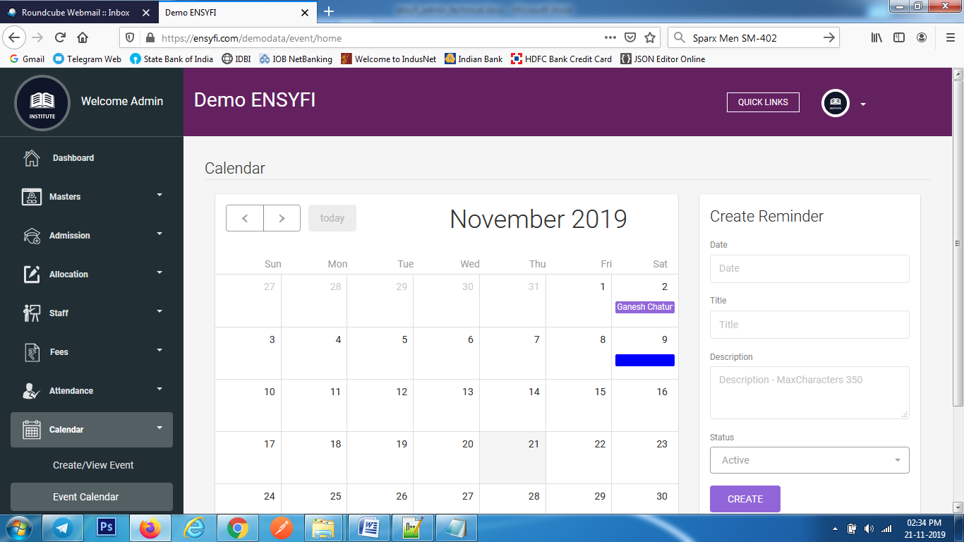

|  |  |  |
| --- | --- | --- |
| **Controller** | **Model** | **View** |
| Event (getall_act_event) | Eventmodel (getall_act_event) | event/ calender |
| Event (get_all_regularleave) | Eventmodel (get_all_regularleave) | event/ calender |
| Event (view_all_reminder) | Eventmodel (view_all_reminder) | event/ calender |
| Leavemanage (get_all_special_leave) | Leavemodel (get_special_leave_all) | event/ calendar |
| Event (todolist) | Eventmodel (save_to_do_list) | event/ calendar |

**60. Create / View Leaves**

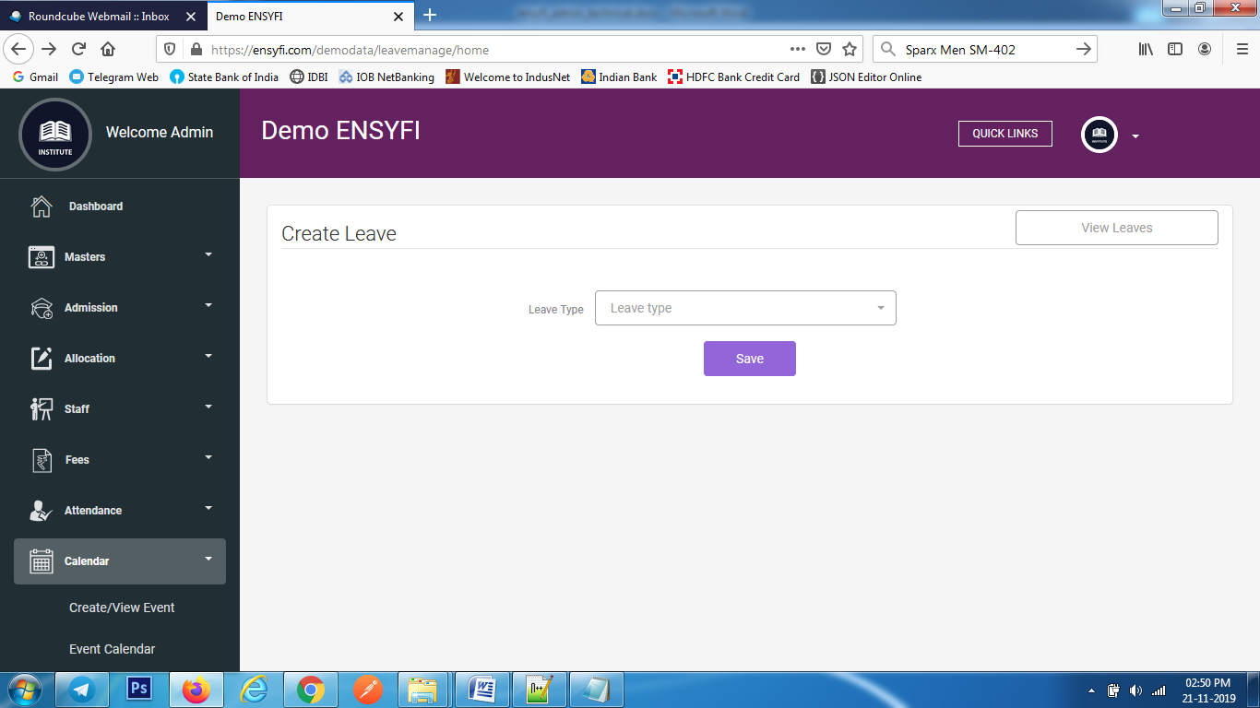

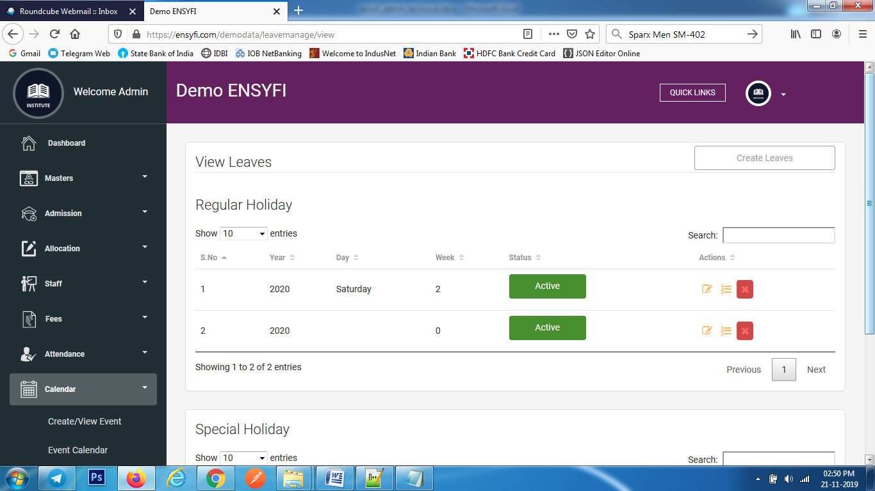

|  |  |  |
| --- | --- | --- |
| **Controller** | **Model** | **View** |
| Leavemanage (home) | Class_manage (getall_class) | leavemanage/add |
| Leavemanage (add) | Leavemodel (create_leave) | leavemanage/add |
| Leavemanage (view) | Leavemodel (get_regular) | leavemanage/view |
| Leavemanage (view) | Leavemodel (get_special) | leavemanage/view |
| Leavemanage (delete_regular) | Leavemodel (delete_regularleave_dates) | leavemanage/view |
| Leavemanage (specialdate_delete) | Leavemodel (delete_specialleave_dates) | leavemanage/view |

**61. Edit Leaves**

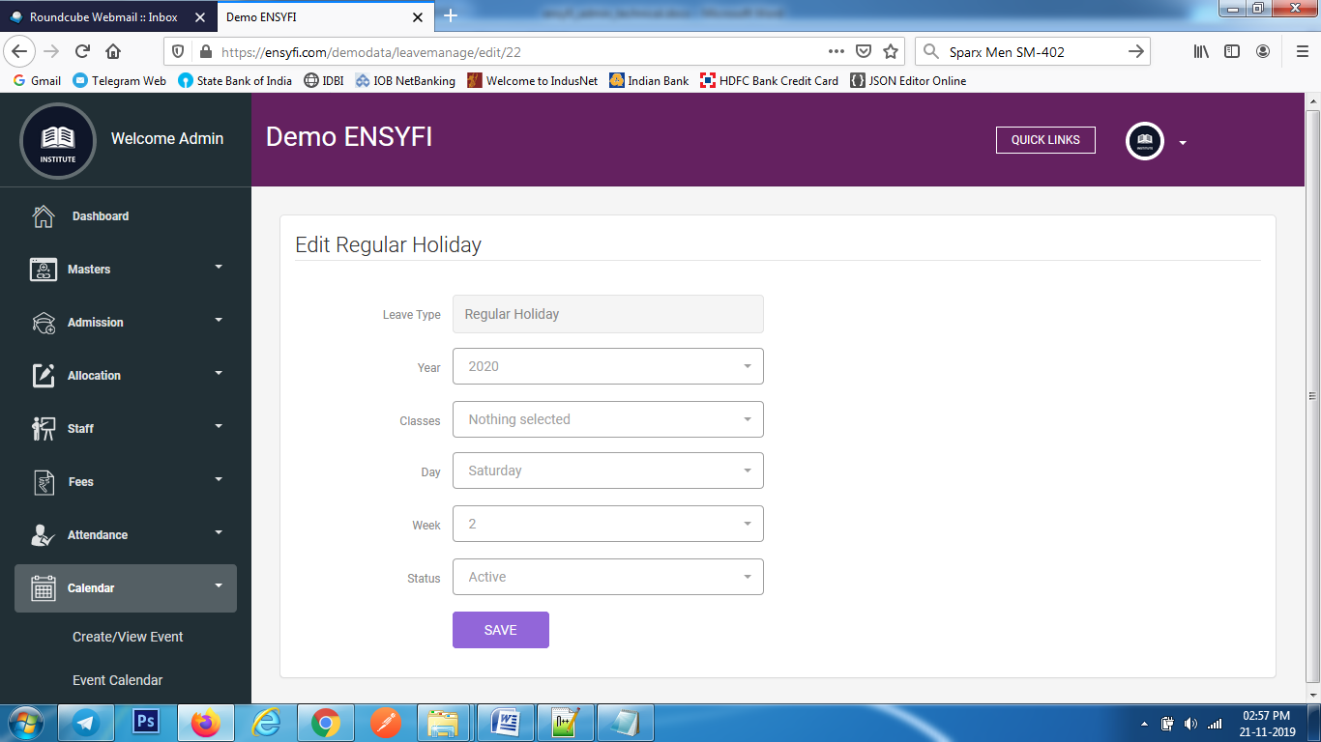

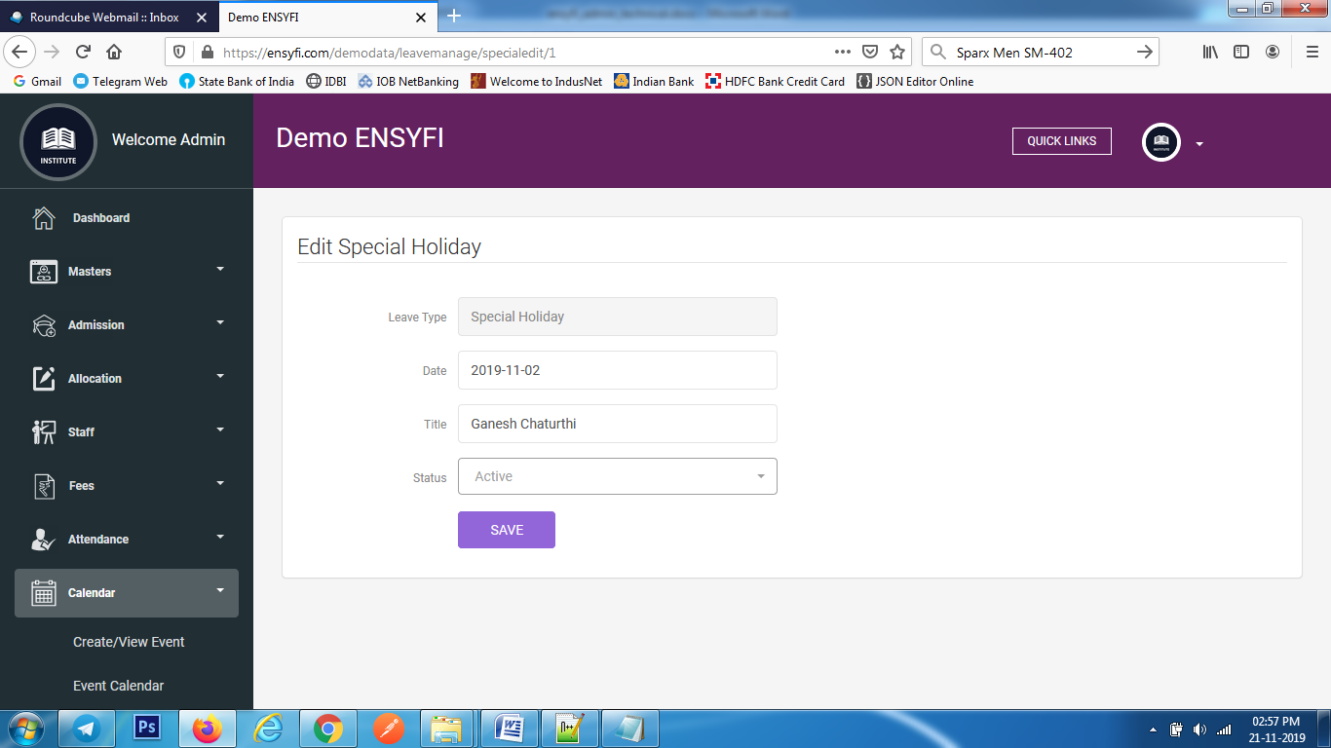

|  |  |  |
| --- | --- | --- |
| **Controller** | **Model** | **View** |
| Leavemanage (edit) | leavemodel (get_leave_id) | leavemanage/edit |
| Leavemanage (update_regular) | Leavemodel (udate_regular_leave) | leavemanage/edit |
| Leavemanage (specialedit) | Leavemodel (get_special_leave_id) | leavemanage/special_edit |
| Leavemanage (special_update) | Leavemodel (udate_special_leave) | leavemanage/special_edit |

**62. List/Remove Regular Holidays**

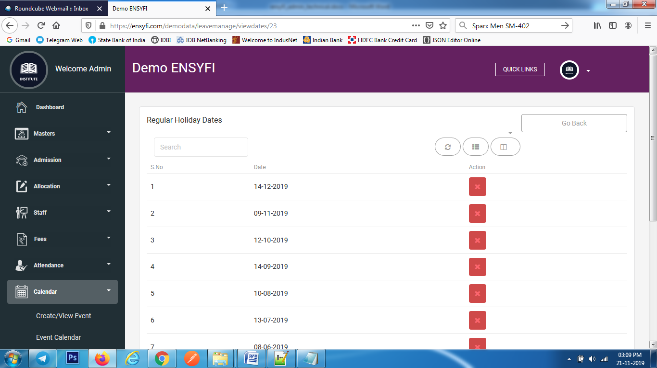

|  |  |  |
| --- | --- | --- |
| **Controller** | **Model** | **View** |
| Leavemanage (viewdates) | leavemodel (get_allregular_leave_id) | leavemanage/viewdates |
| Leavemanage (deletedate) | Leavemodel (delete_leave_dates) | leavemanage/viewdates |

**63. Create Timetable**

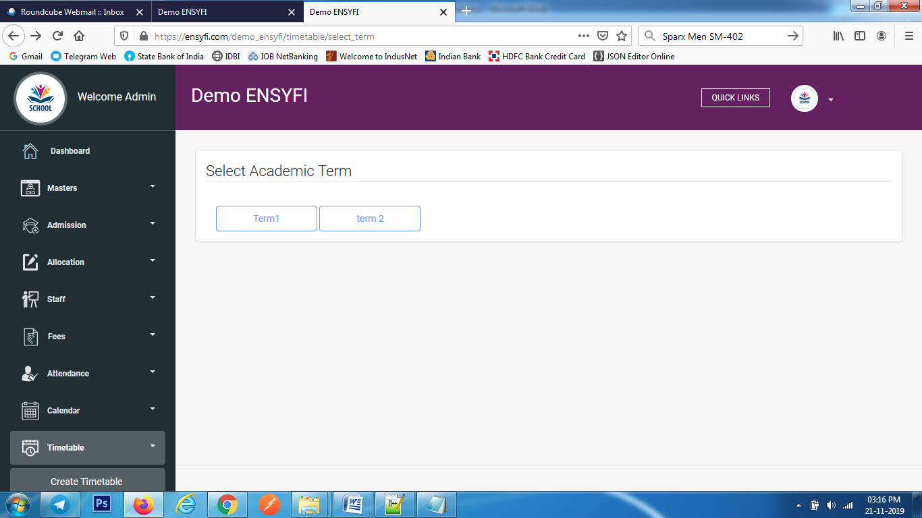

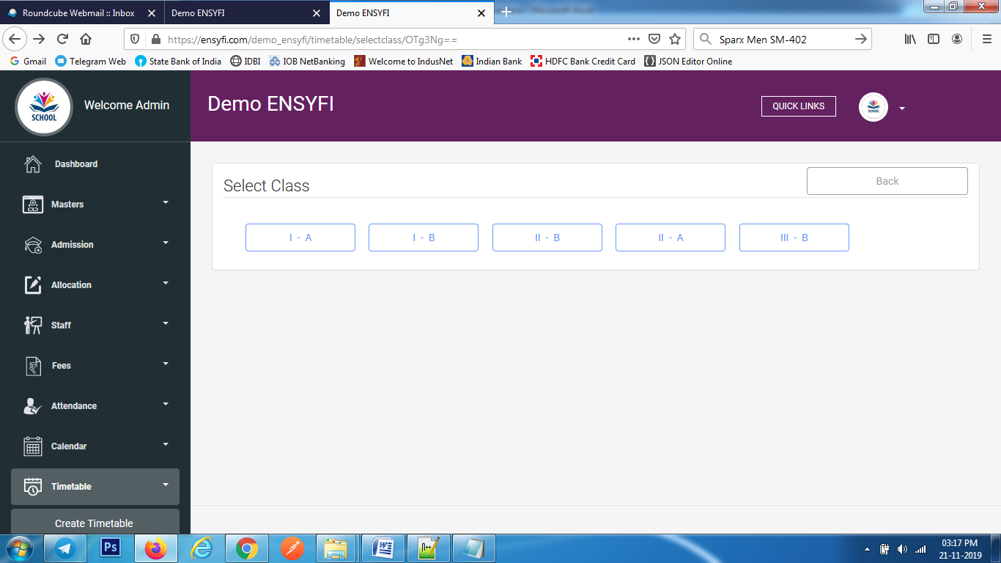

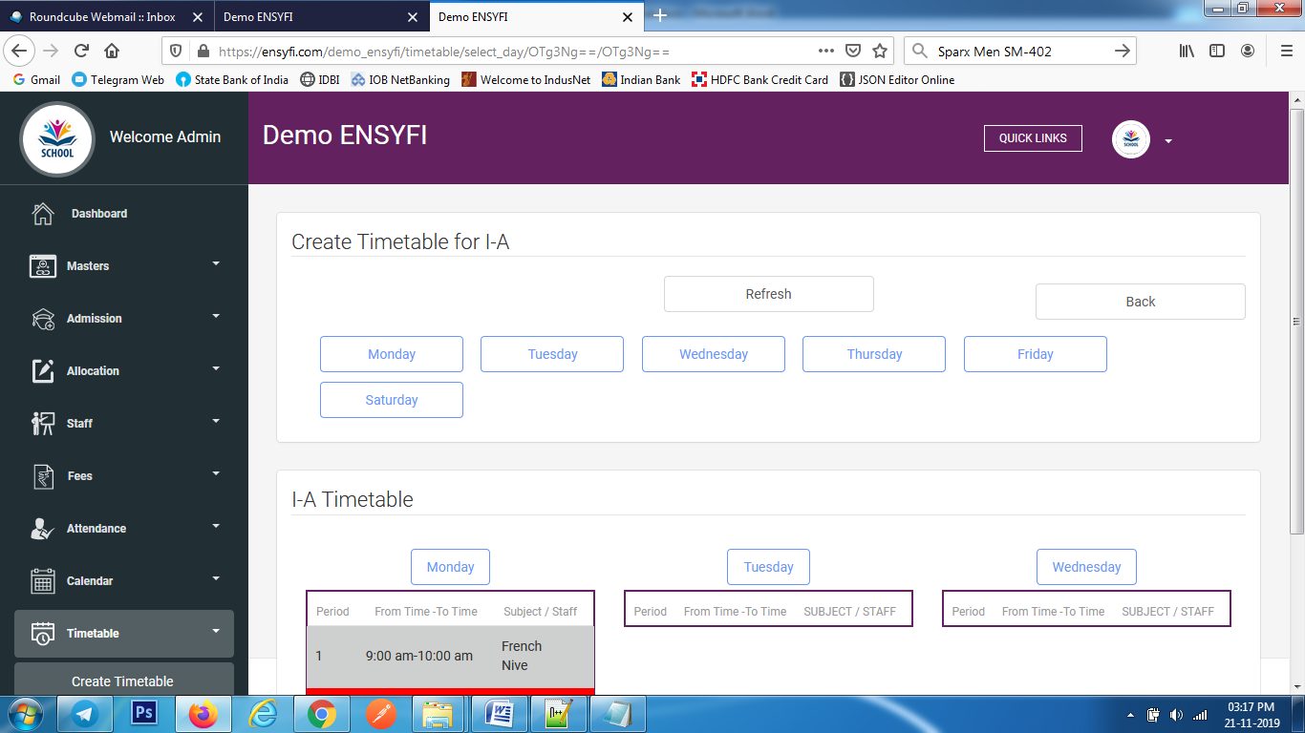

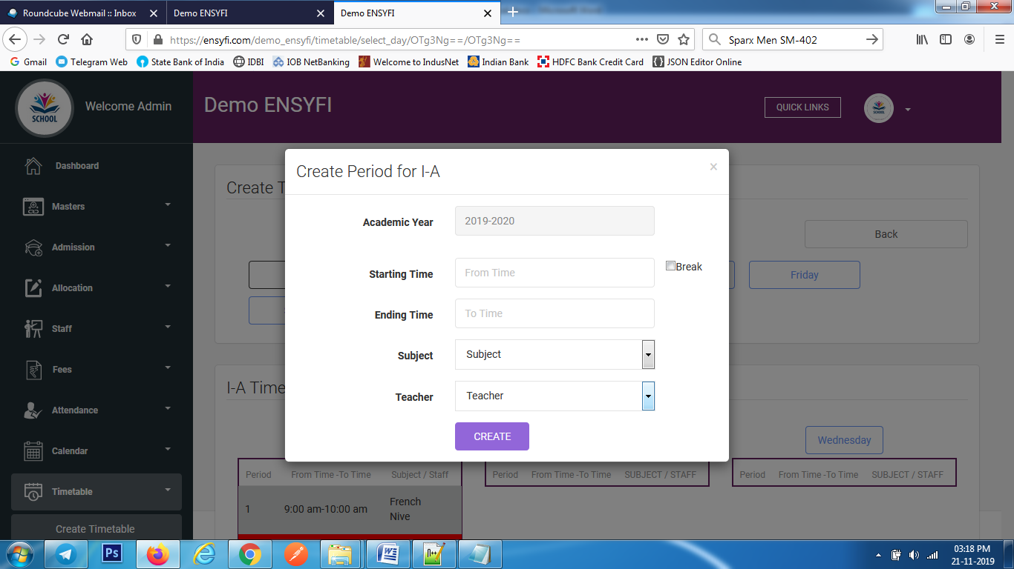

|  |  |  |
| --- | --- | --- |
| **Controller** | **Model** | **View** |
| Timetable (select_term) | Yearsmodel (getall_terms) | timetable/select_term |
| Timetable (selectclass) | Class_manage (getall_class) | timetable/select_class |
| Timetable (select_day) | Timetablemodel(get_subject_class) | timetable/select_days |
| Timetable (select_day) | Timetablemodel(get_teacher_class) | timetable/select_days |
| Timetable (select_day) | Timetablemodel(get_all_days) | timetable/select_days |
| Timetable (select_day) | Timetablemodel(timetable_for_class) | timetable/select_days |
| Timetable (create_timetable_for_class) | Timetablemodel(create_timetable) | timetable/select_days |

**64. Manage Timetable**





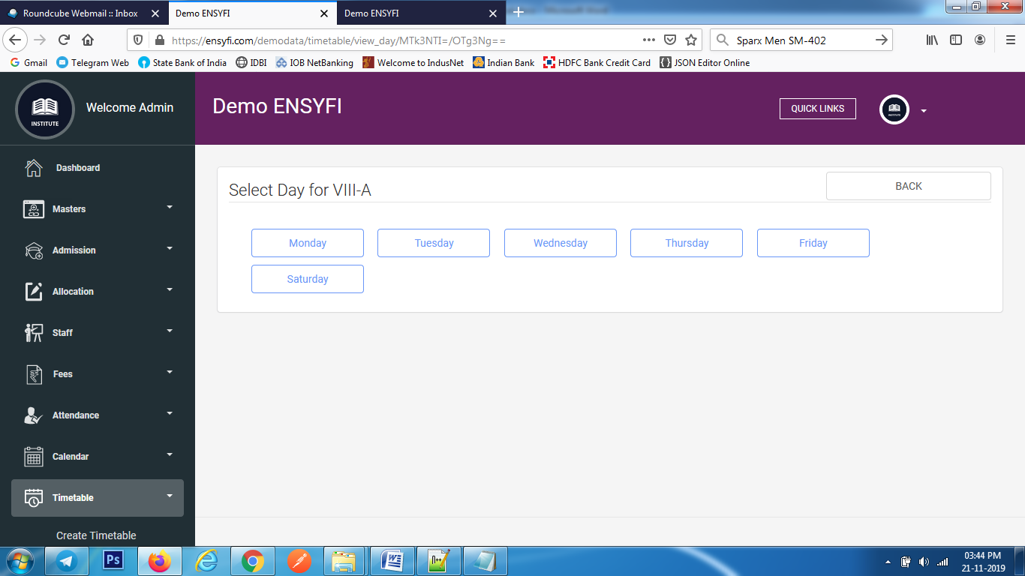

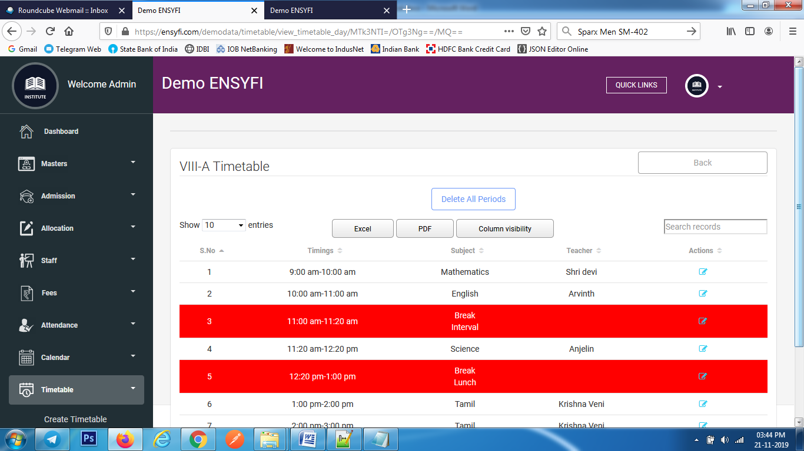

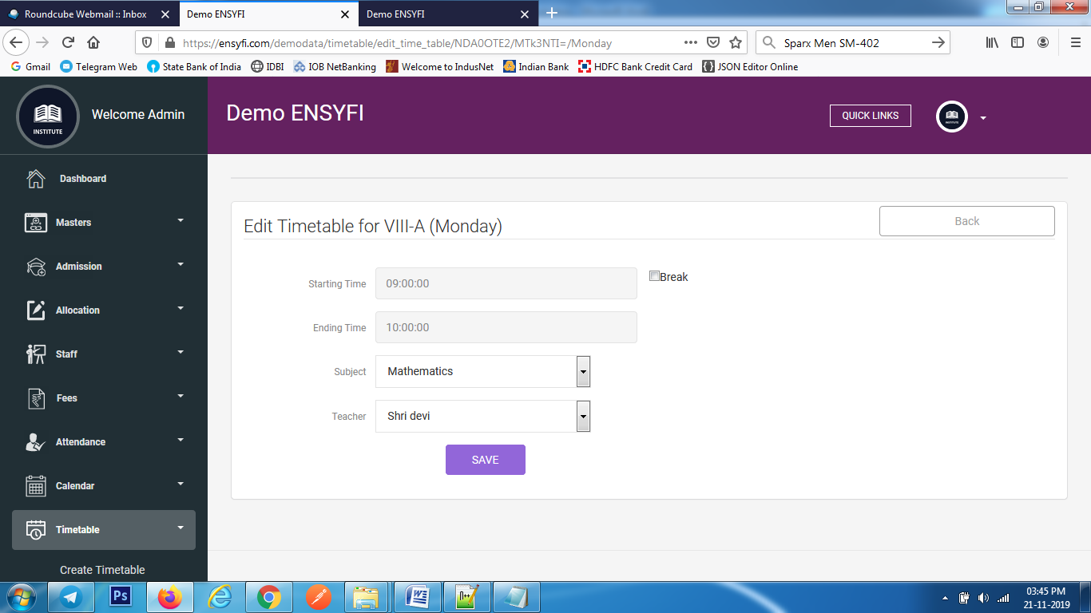

|  |  |  |
| --- | --- | --- |
| **Controller** | **Model** | **View** |
| Timetable (view_term) | Yearsmodel (getall_terms) | timetable/view_terms |
| Timetable (view_class) | Class_manage (getall_class) | timetable/select_class |
| Timetable (view_day) | Timetablemodel(get_all_days) | timetable/view_days |
| Timetable (view_timetable_day) | Timetablemodel(view_timetable_day) | timetable/view_timetable_day |
| Timetable (edit_time_table) | Timetablemodel(edit_time_table) | timetable/edit_time_table |
| Timetable (update_timetable_for_class) | Timetablemodel(update_timetable_for_class) | timetable/edit_time_table |
| Timetable (delete) | Timetablemodel(delete_time) | timetable/view_timetable_day |

**65. Create / List Examinations**

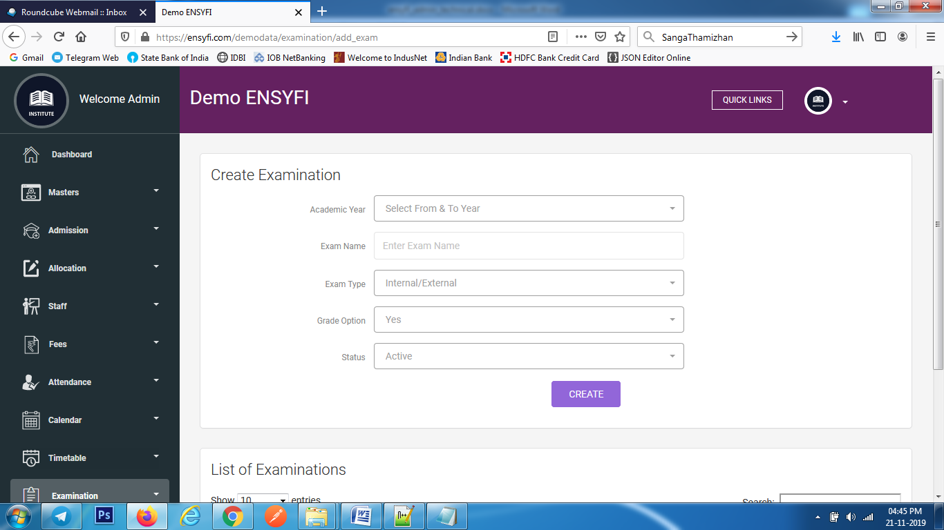

|  |  |  |
| --- | --- | --- |
| **Controller** | **Model** | **View** |
| Examination (add_exam) | Examinationmodel (get_exam_details) | examination/add |
| Examination (add_exam) | Examinationmodel (get_years_details) | examination/add |
| Examination (create) | Examinationmodel (exam_details) | examination/add |

**66. Edit Examination**

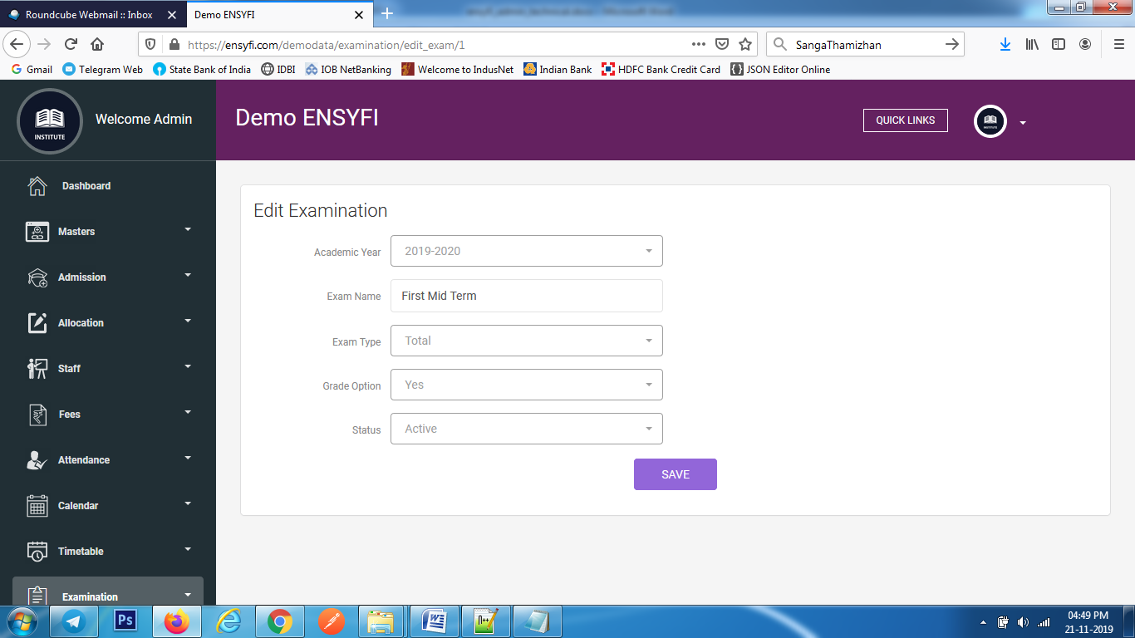

|  |  |  |
| --- | --- | --- |
| **Controller** | **Model** | **View** |
| Examination (edit_exam) | Examinationmodel (edit_exam) | examination/edit |
| Examination (update) | Examinationmodel (update_exam) | examination/edit |

**67. Create / List Examination Calendar**

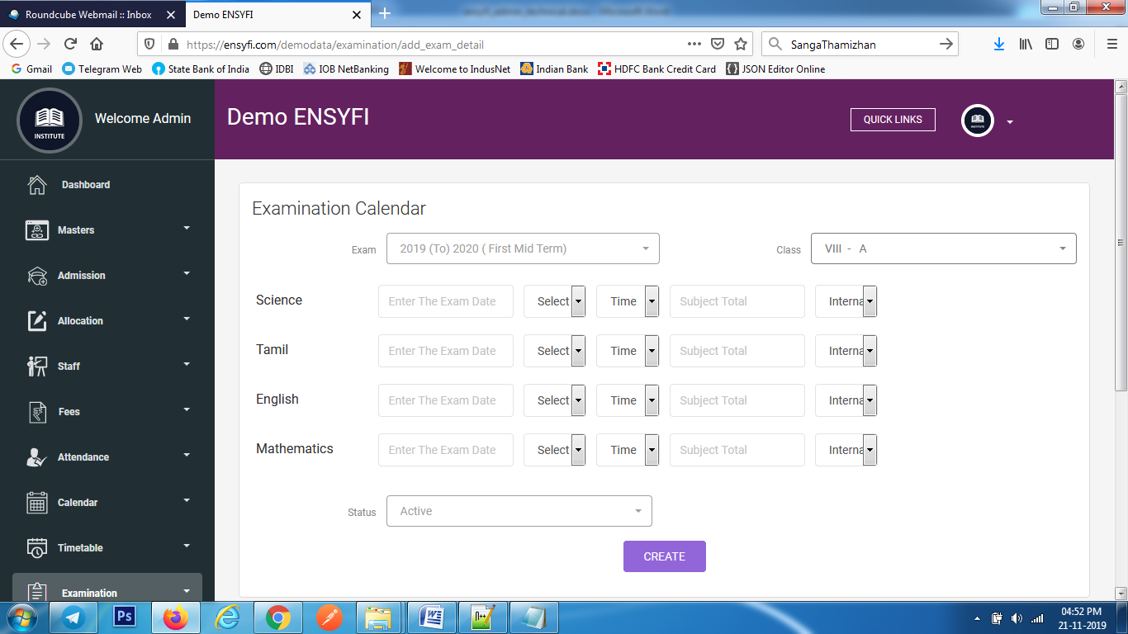

|  |  |  |
| --- | --- | --- |
| **Controller** | **Model** | **View** |
| Examination (add_exam_detail) | Examinationmodel (search_details_view) | examination/add_exam_details |
| Examination (add_exam_detail) | Examinationmodel (get_exam_details) | examination/add_exam_details |
| Examination (add_exam_details) | Examinationmodel (add_exam_details) | examination/add_exam_details |

**68. View/Update Examination Calendar**

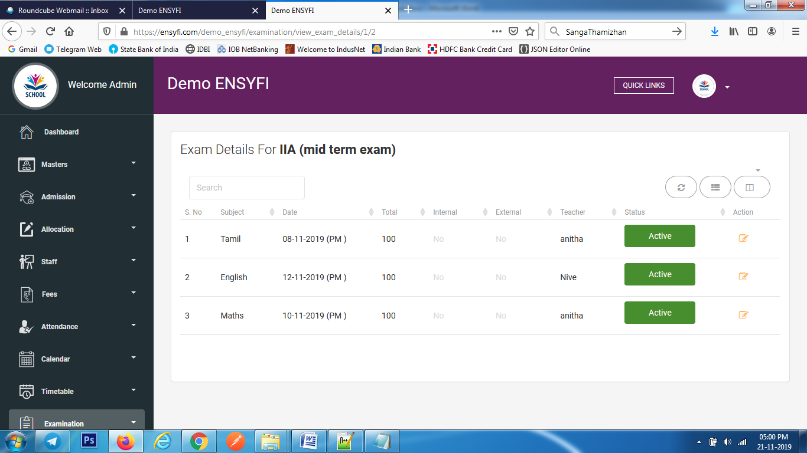

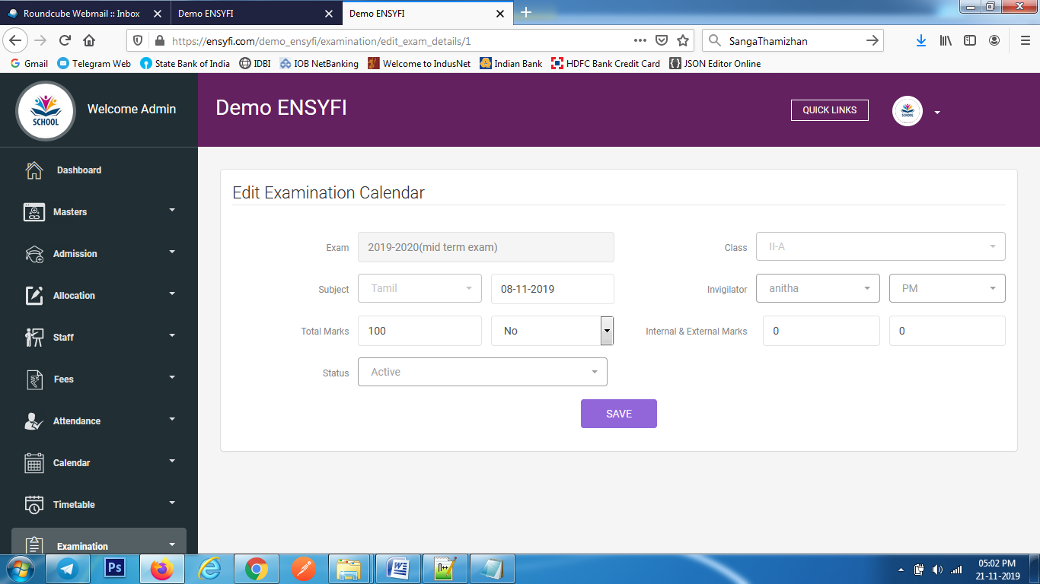

|  |  |  |
| --- | --- | --- |
| **Controller** | **Model** | **View** |
| Examination (view_exam_details) | Examinationmodel (view_exam_details) | examination/view_exam_details |
| Examination (edit_exam_details) | Examinationmodel (edit_exam_details) | examination/edit_exam_details |
| Examination (update_exam_details) | Examinationmodel (update_exam_detail) | examination/edit_exam_details |

**69. Exam Results**

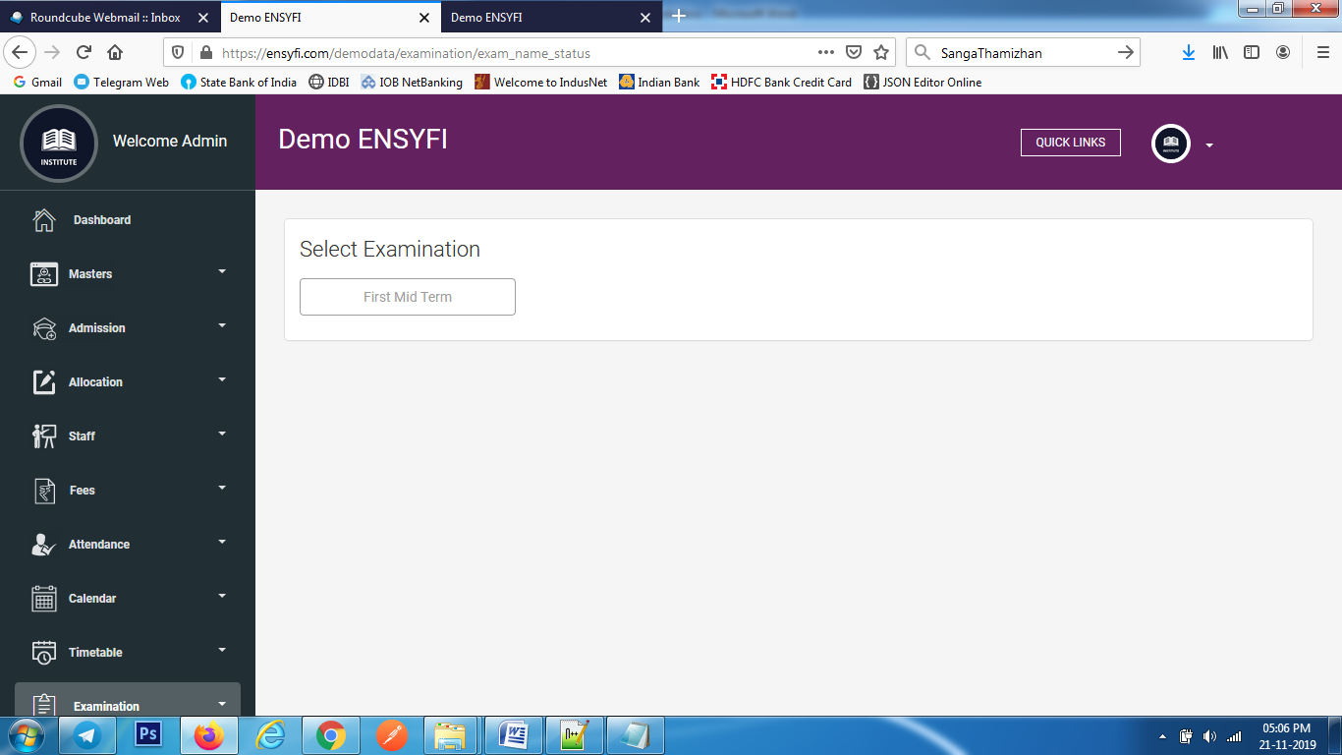

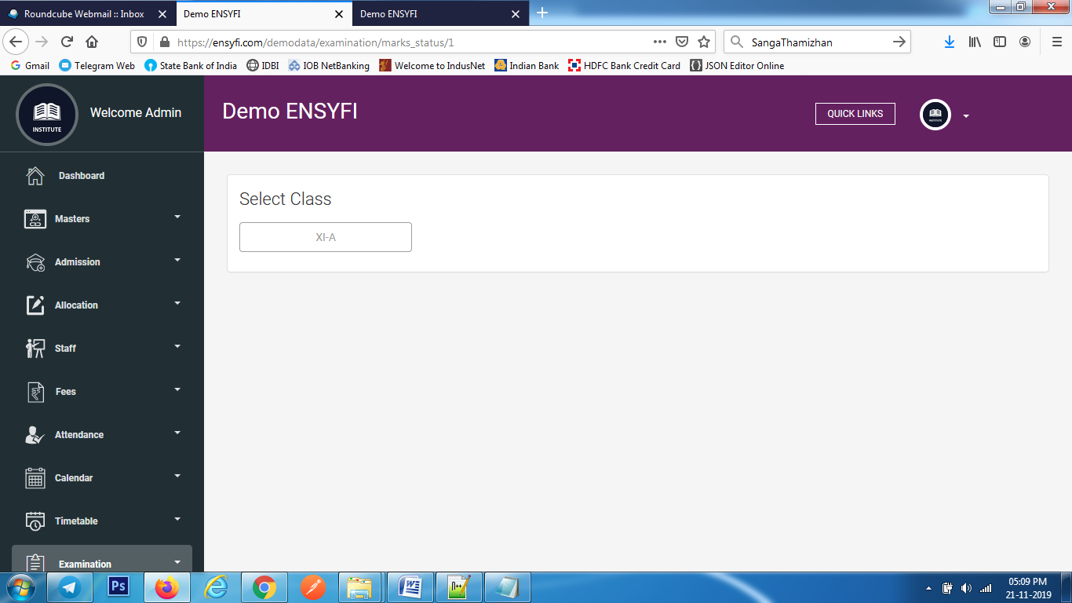

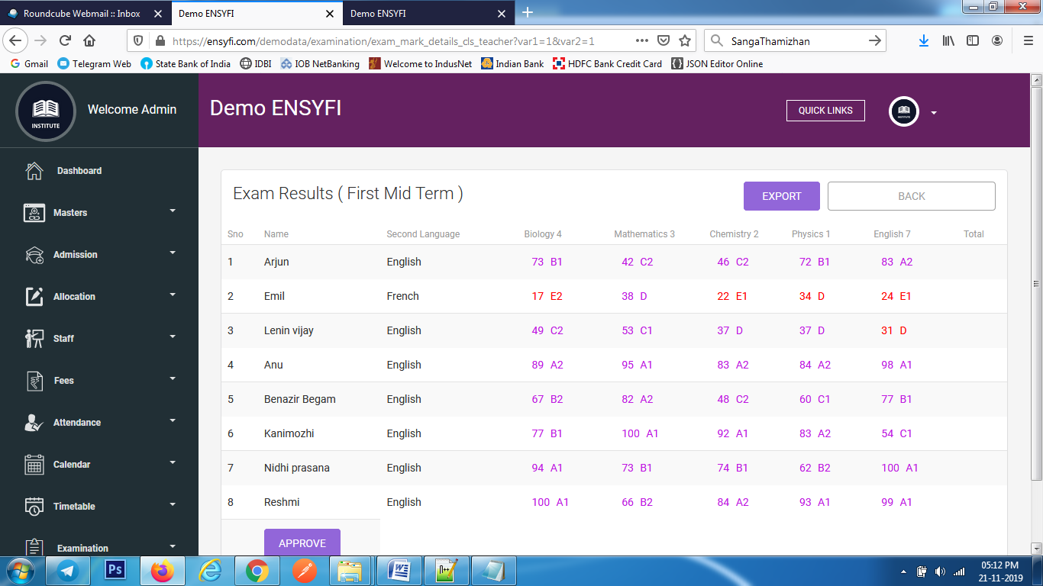

|  |  |  |
| --- | --- | --- |
| **Controller** | **Model** | **View** |
| Examination (exam_name_status) | Examinationmodel (exam_name_status) | examination/exam_name |
| Examination (marks_status) | Examinationmodel (marks_statuss) | examination/exam_result |
| Examination (exam_mark_details_cls_teacher) | Examinationmodel (getall_subname) | examination/examination/exam_class_result |
|  |  |  |
| Examination (exam_mark_details_cls_teacher) | Examinationmodel (getall_stuname) | examination/examination/exam_class_result |
| Examination (exam_mark_details_cls_teacher) | Examinationmodel (clsname_examname) | examination/examination/exam_class_result |
| Examination (exam_mark_details_cls_teacher) | Examinationmodel (marks_status_details) | examination/examination/exam_class_result |
| Examination (exam_mark_details_cls_teacher) | Examinationmodel (getall_exam_inter_exter_details) | examination/examination/exam_class_result |
| Examination (marks_status_update) | Examinationmodel (update_exam_status) | examination/examination/exam_class_result |

**70. Create / List Circular**

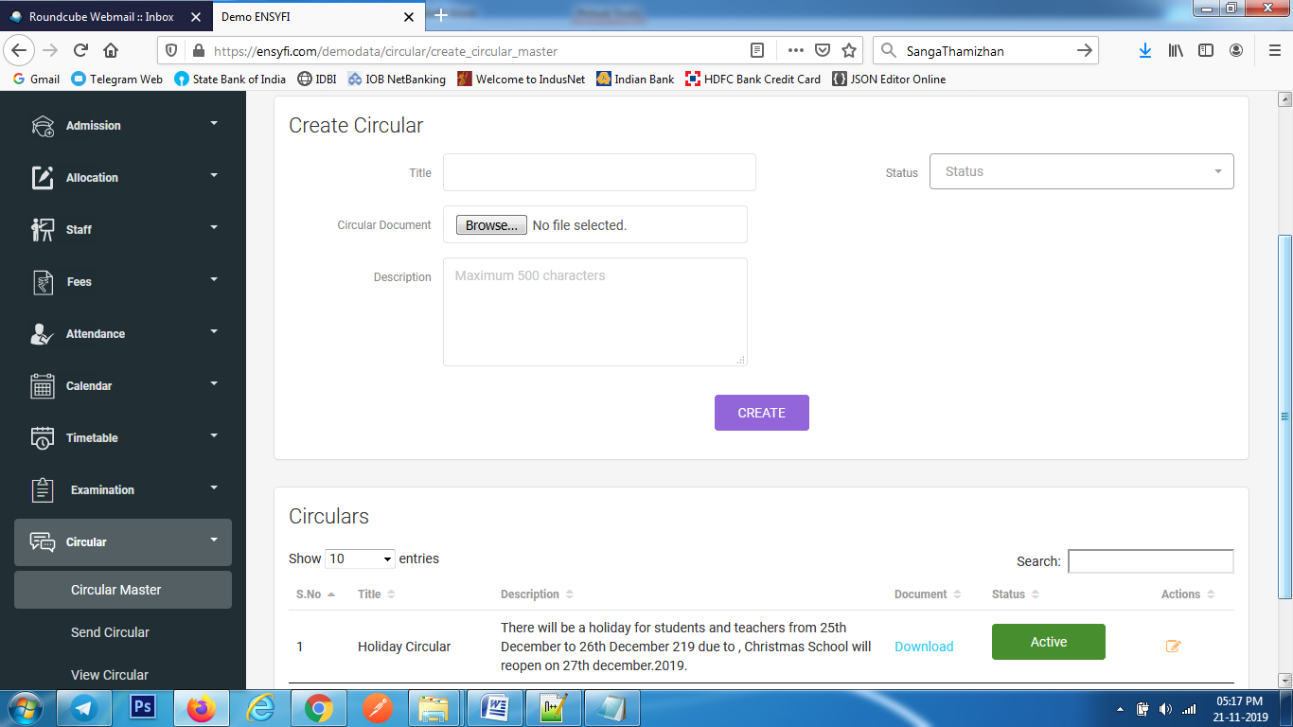

|  |  |  |
| --- | --- | --- |
| **Controller** | **Model** | **View** |
| Circular (create_circular_master) | Circularmodel (get_current_years) | circular/create_circular_master |
| Circular (create_circular_master) | Circularmodel (get_all_result) | circular/create_circular_master |
| Circular (add_circular_master) | Circularmodel (create_circular_masters) | circular/create_circular_master |

**71. Update Circular master**

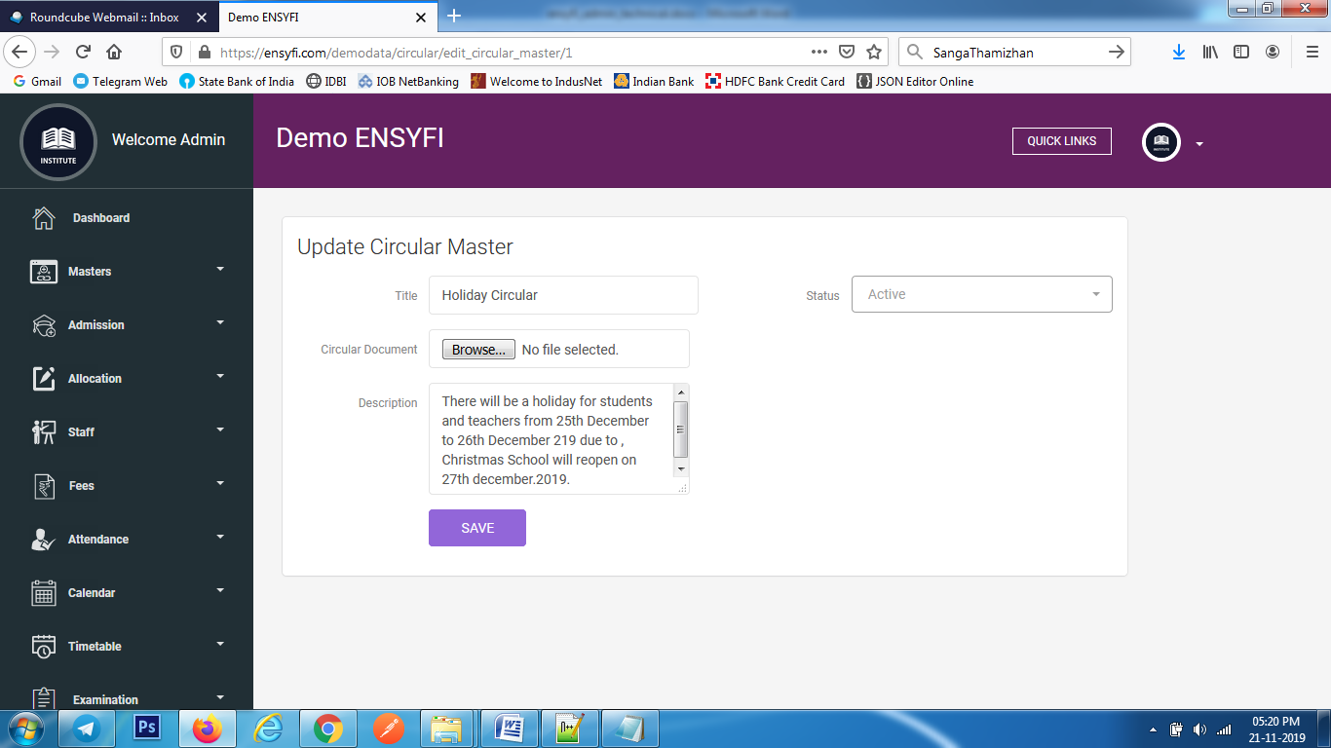

|  |  |  |
| --- | --- | --- |
| **Controller** | **Model** | **View** |
| Circular (edit_circular_master) | Circularmodel (edit_all_result) | circular/edit_circular_master |
| Circular (update_circular_master) | Circularmodel (update_circular_masters) | circular/create_circular_master |

**72. Send Circular**

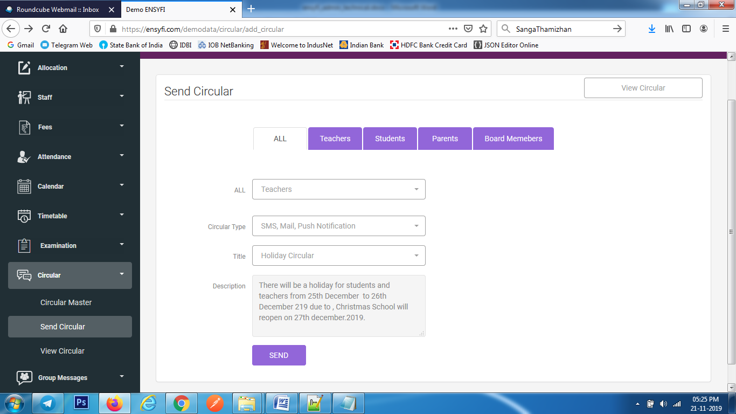

|  |  |  |
| --- | --- | --- |
| **Controller** | **Model** | **View** |
| Circular (add_circular) | Class_manage (getall_class) | circular/add |
| Circular (add_circular) | Circularmodel (get_teachers) | circular/add |
| Circular (add_circular) | Circularmodel (getall_parents) | circular/add |
| Circular (add_circular) | Circularmodel (get_all_board_members) | circular/add |
| Circular (add_circular) | Circularmodel (getall_roles) | circular/add |
| Circular (add_circular) | Circularmodel (cmaster_type) | circular/add |
| Circular (create) | Circularmodel (circular_create) | circular/add |
| Circular (create) | Smsmodel (send_circular_via_sms) | circular/add |
| Circular (create) | Mailmodel (send_circular_via_mail) | circular/add |
| Circular (create) | Notificationmodel (send_circular_via_notification) | circular/add |

**73. View Circular Details**

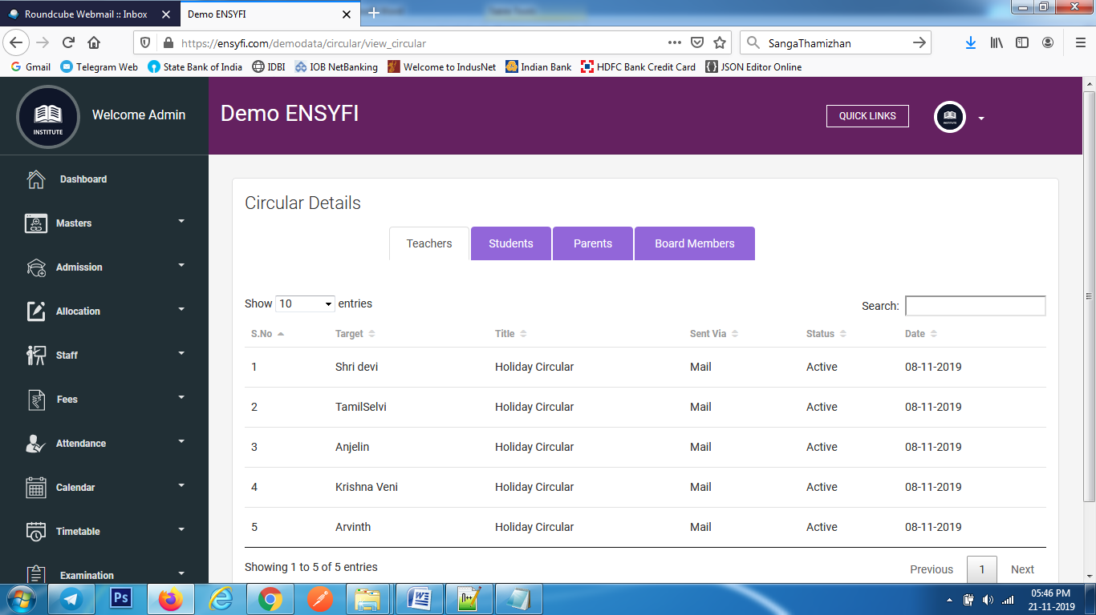

|  |  |  |
| --- | --- | --- |
| **Controller** | **Model** | **View** |
| Circular (view_circular) | Circularmodel (get_all_circular) | circular/view |
| Circular (view_circular) | Circularmodel (get_students_circular) | circular/view |
| Circular (view_circular) | Circularmodel (get_parents_circular) | circular/view |
| Circular (view_circular) | Circularmodel (get_bmember_circular) | circular/view |

**74. Create/List Groups**

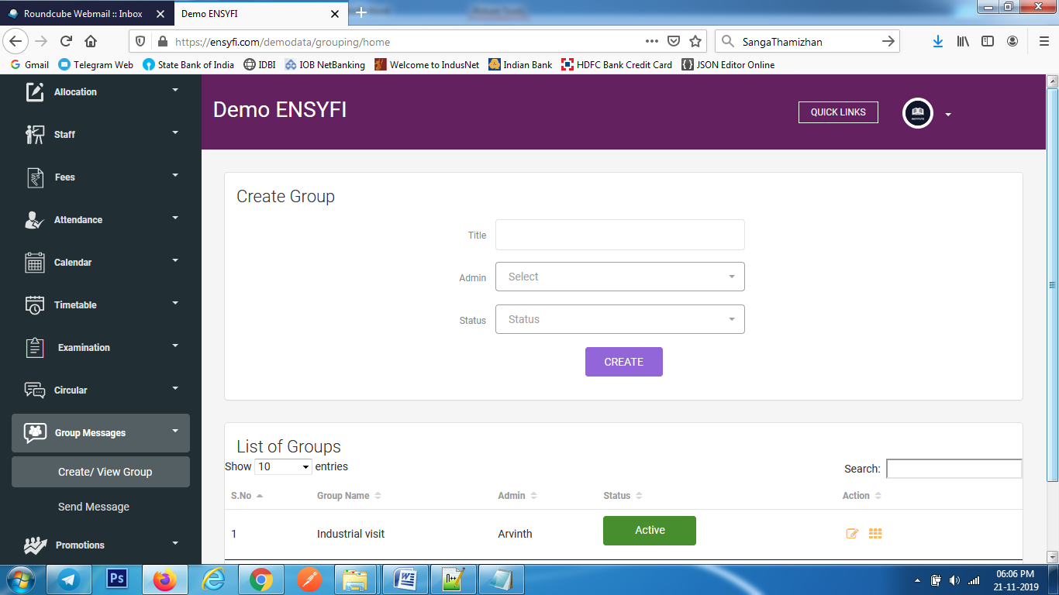

|  |  |  |
| --- | --- | --- |
| **Controller** | **Model** | **View** |
| Grouping (home) | Groupingmodel (get_all_grouping) | grouping/add |
| Grouping (home) | Groupingmodel (get_all_teacher) | grouping/add |
| Grouping (create_group) | Groupingmodel (create_group) | grouping/add |

**75. Edit Group**

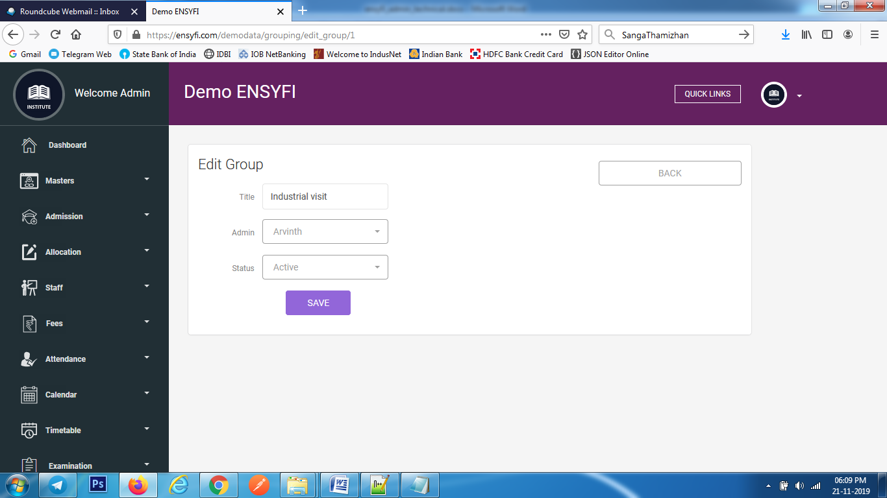

|  |  |  |
| --- | --- | --- |
| **Controller** | **Model** | **View** |
| Grouping (edit_group) | Groupingmodel (get_group_id) | grouping/edit_group |
| Grouping (edit_group) | Groupingmodel (get_all_teacher) | grouping/edit_group |
| Grouping (save_group) | Groupingmodel (save_group) | grouping/edit_group |

**76. View Group Members**

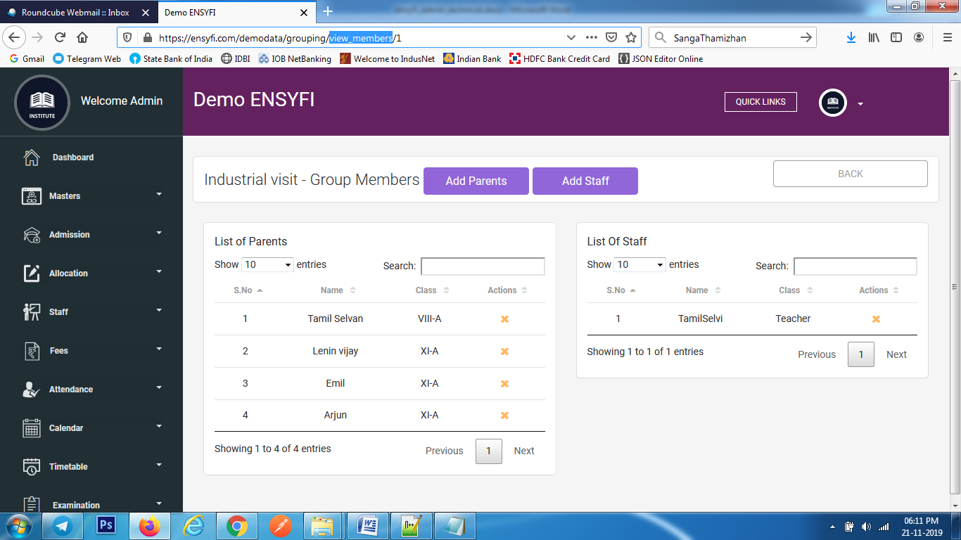

|  |  |  |
| --- | --- | --- |
| **Controller** | **Model** | **View** |
| Grouping (view_members) | Groupingmodel (view_members_in_groups) | grouping/view_members |
| Grouping (view_members) | Groupingmodel (view_members_in_groups_staff) | grouping/view_members |
| Grouping (view_members) | Groupingmodel (get_group_name) | grouping/view_members |
| Grouping (view_members) | Groupingmodel (get_all_classes_for_year) | grouping/view_members |
| Grouping (view_members) | Groupingmodel (get_all_member_role) | grouping/view_members |
| Grouping (deleteing_member) | Groupingmodel (delete_member) | grouping/view_members |

**77. Group Add Parents / Staff**

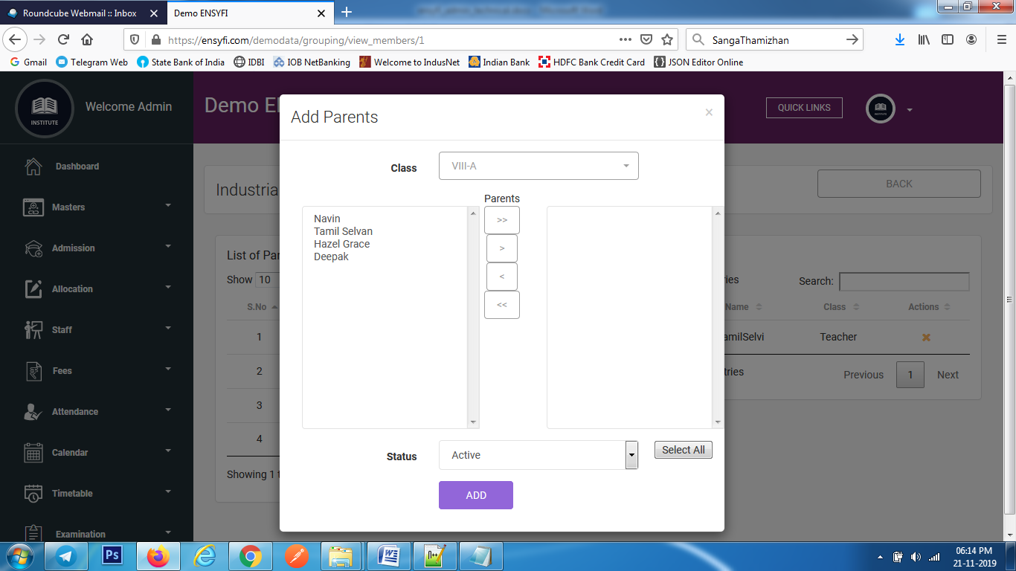

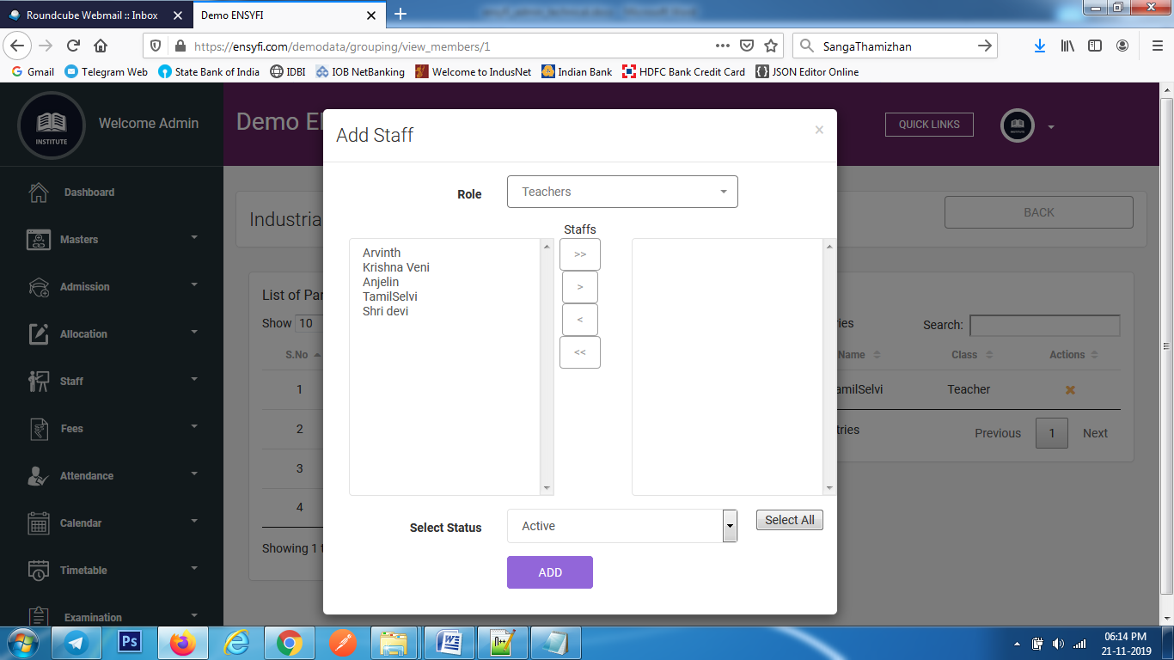

|  |  |  |
| --- | --- | --- |
| **Controller** | **Model** | **View** |
| Grouping (getListstudent) | Groupingmodel (getListstudent) | grouping/view_members |
| Grouping (get_staff_list) | Groupingmodel (get_staff_list) | grouping/view_members |
| Grouping (adding_members_to_group) | Groupingmodel (adding_members_to_group) | grouping/view_members |

**78. Send Message / History**

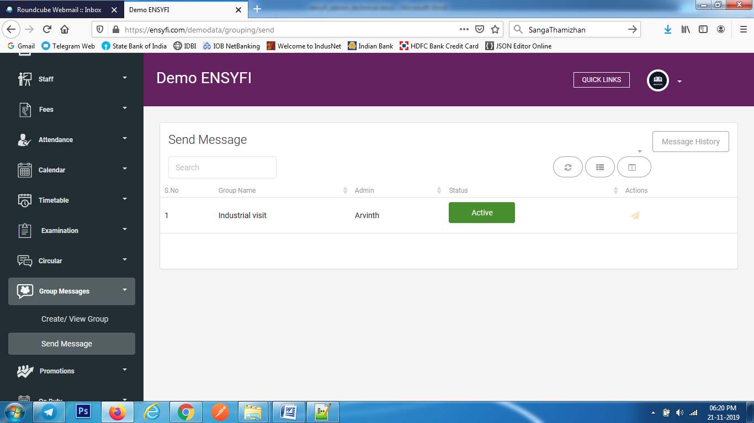

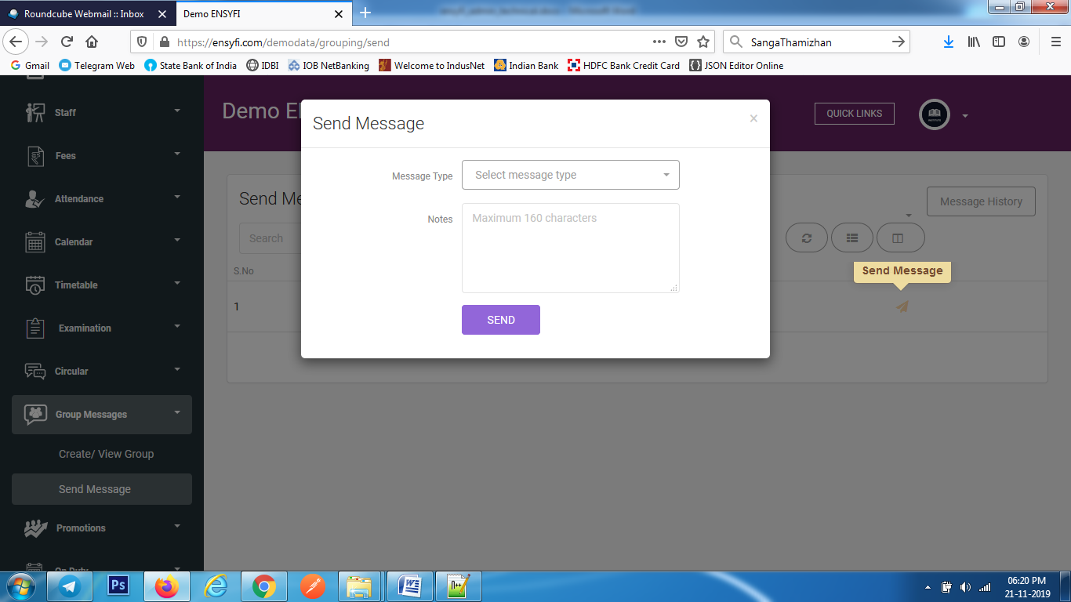

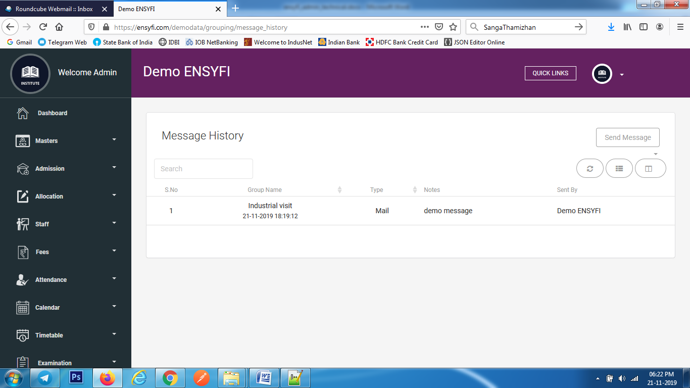

|  |  |  |
| --- | --- | --- |
| **Controller** | **Model** | **View** |
| Grouping (send) | Groupingmodel (get_all_grouping) | grouping/send |
| Grouping (send) | Groupingmodel (get_board_members) | grouping/send |
| Grouping (send_msg) | Groupingmodel (save_group_history) | grouping/send |
| Grouping (send_msg) | Smsmodel (send_msg) | grouping/send |
| Grouping (send_msg) | Notificationmodel (send_notification) | grouping/send |
| Grouping (send_msg) | Mailmodel (send_mail) | grouping/send |
| Grouping (message_history) | Mailmodel (get_message_history) | grouping/message_history |

**79. Promotions**

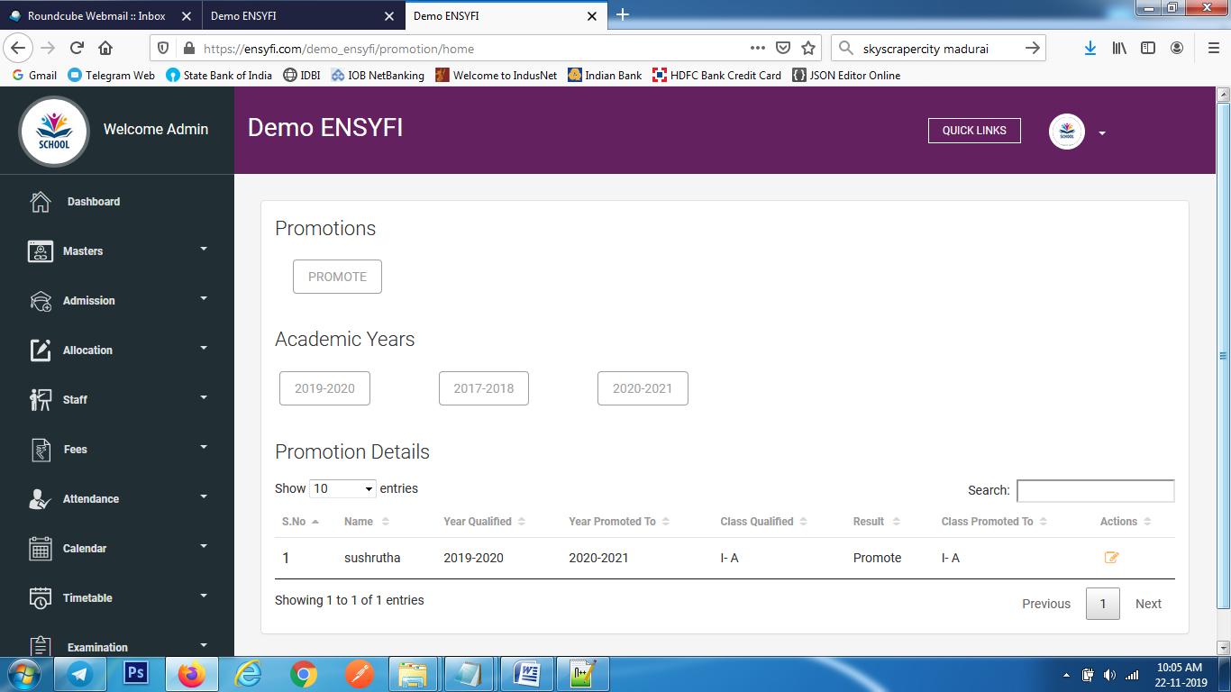

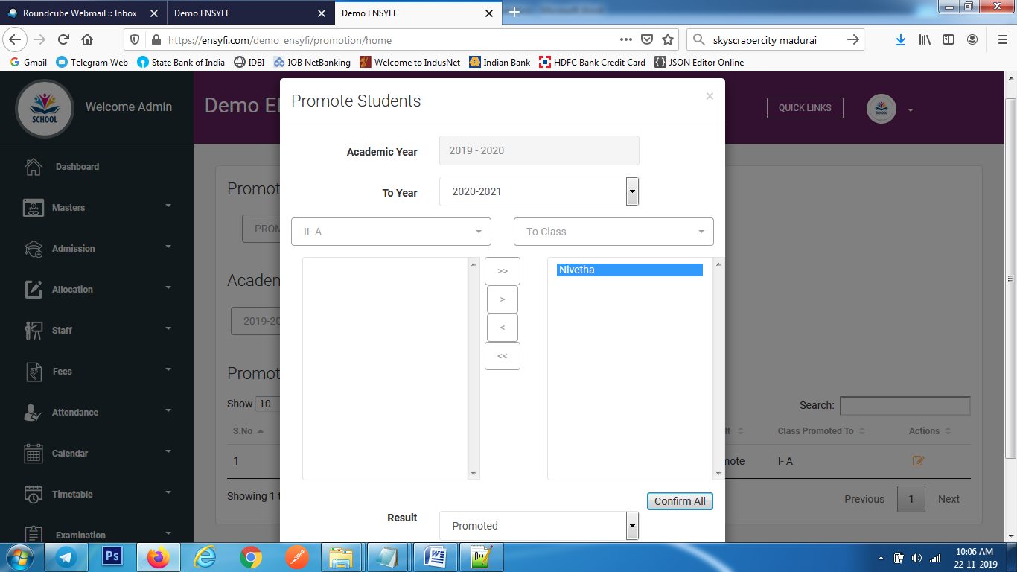

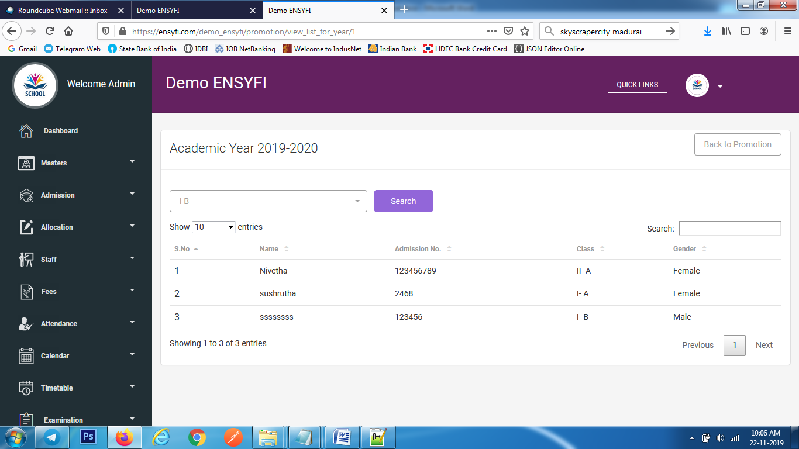

|  |  |  |
| --- | --- | --- |
| **Controller** | **Model** | **View** |
| Promotion (home) | Promotionmodel (promotion_history) | promotion/add |
| Promotion (home) | Promotionmodel (getall_years) | promotion/add |
| Promotion (home) | Promotionmodel (get_all_classes_for_year) | promotion/add |
| Promotion (home) | Promotionmodel (get_all_academic_year) | promotion/add |
| Promotion (home) | Groupingmodel (get_all_classes_for_year) | promotion/add |
| Promotion (create_promotion) | Groupingmodel (create_promotion) | promotion/add |
| Promotion (view_list_for_year) | Promotionmodel (view_list_for_year) | promotion/view_list_for_year |
| Promotion (view_list_for_year) | Promotionmodel (get_year_name) | promotion/view_list_for_year |
| Promotion (view_list_for_year) | Promotionmodel (view_classes) | promotion/view_list_for_year |

**80. Edit Promotion**

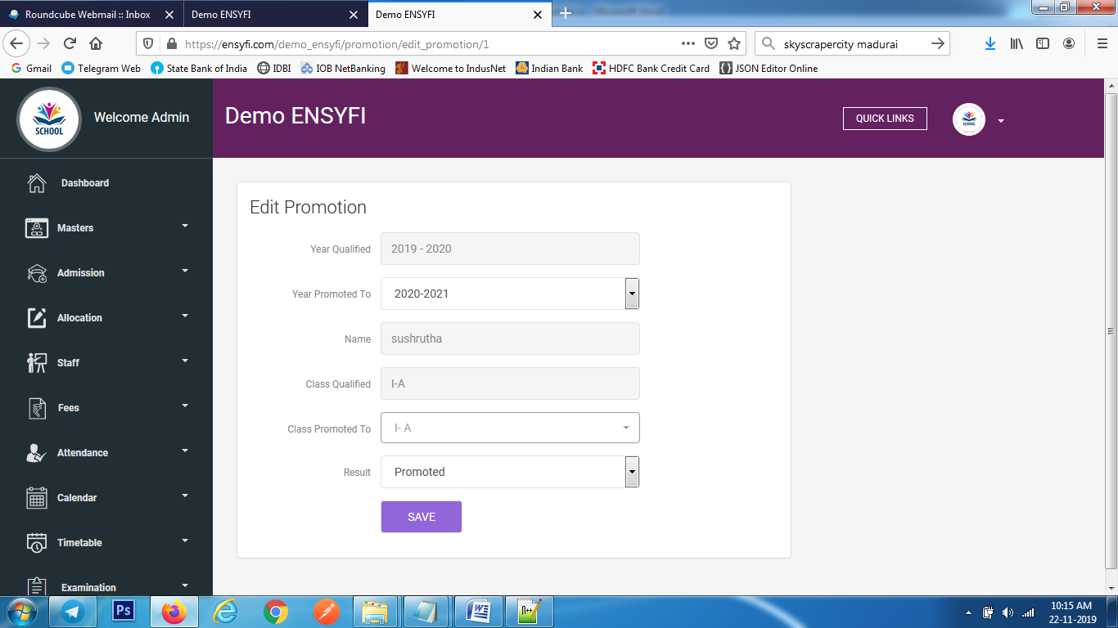

|  |  |  |
| --- | --- | --- |
| **Controller** | **Model** | **View** |
| Promotion (edit_promotion) | Promotionmodel (promotion_history) | promotion/edit_promotion |
| Promotion (edit_promotion) | Promotionmodel (getall_years) | promotion/edit_promotion |
| Promotion (edit_promotion) | Promotionmodel (get_all_classes_for_year) | promotion/edit_promotion |
| Promotion (edit_promotion) | Promotionmodel (get_all_academic_year) | promotion/edit_promotion |
| Promotion (edit_promotion) | Groupingmodel (get_all_classes_for_year) | promotion/edit_promotion |
| Promotion (save_promotion) | Groupingmodel (save_promotion) | promotion/edit_promotion |

**81. Teachers' On Duty Details**

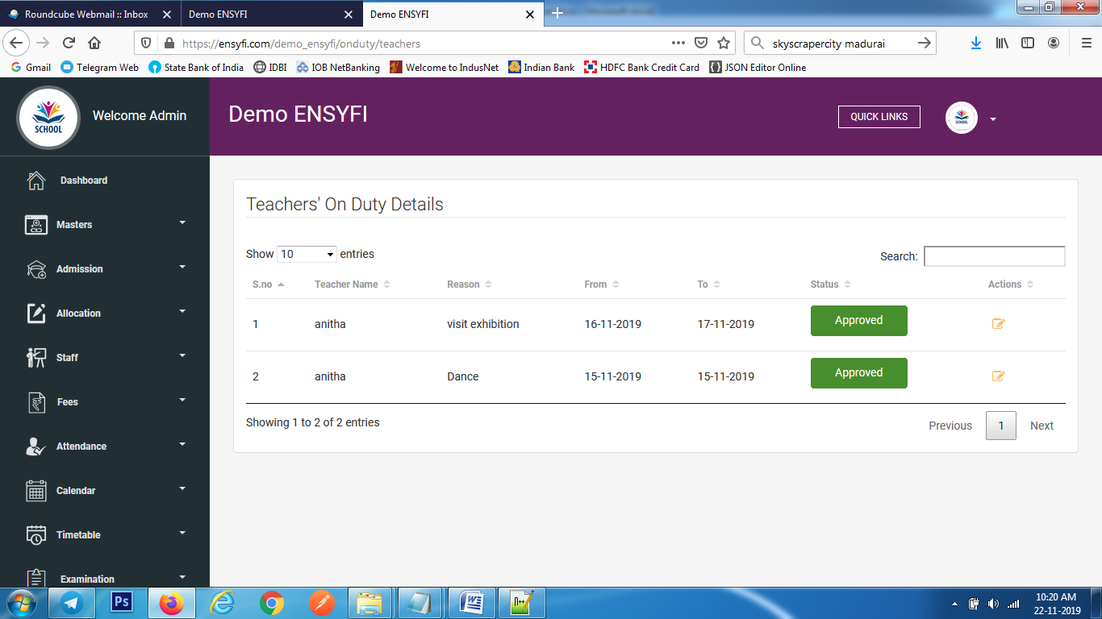

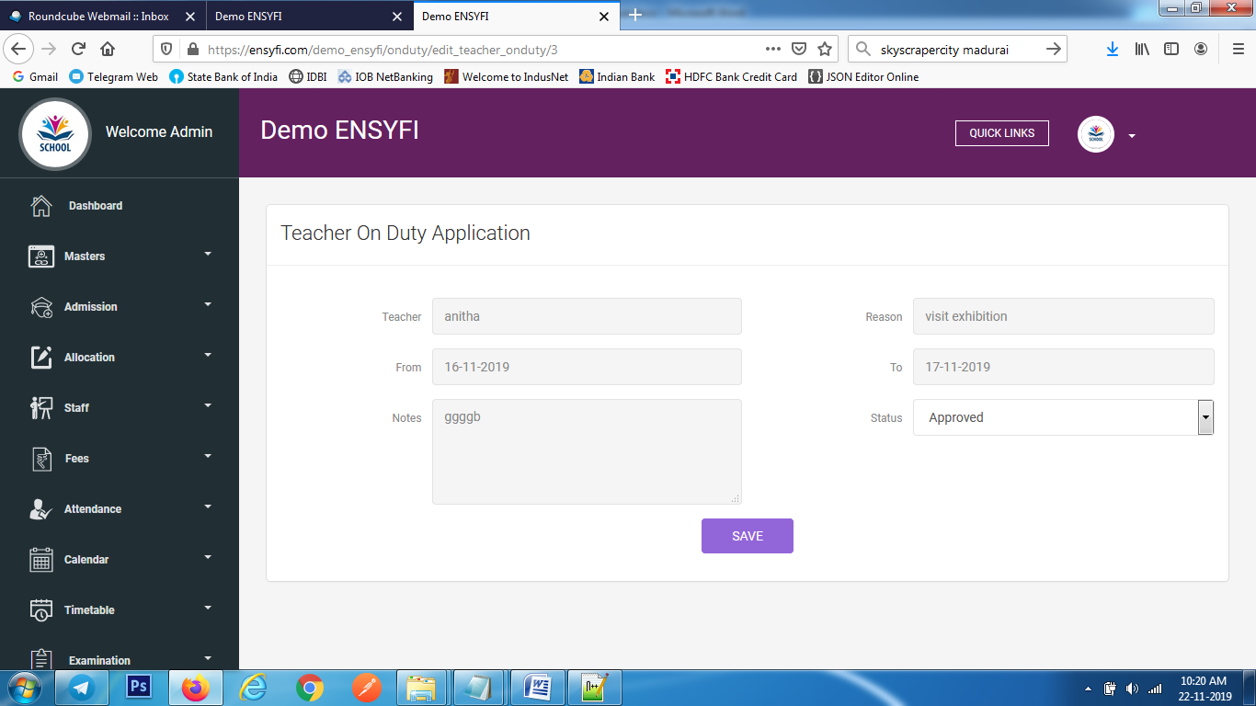

|  |  |  |
| --- | --- | --- |
| **Controller** | **Model** | **View** |
| Onduty (teachers) | Ondutymodel (get_teacher_onduty_details) | onduty/onduty_teacher |
| Onduty (edit_teacher_onduty) | Ondutymodel (edit_teacher) | onduty/edit_teacher_onduty |
| Onduty (update_onduty) | Ondutymodel (update_teacher_onduty) | onduty/edit_teacher_onduty |

**82. Students' On Duty Details**

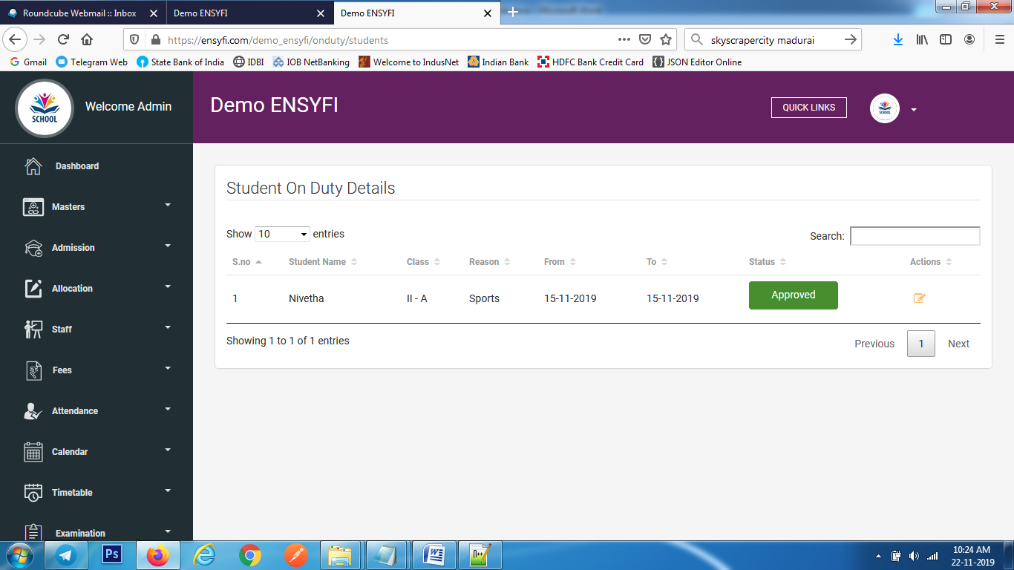

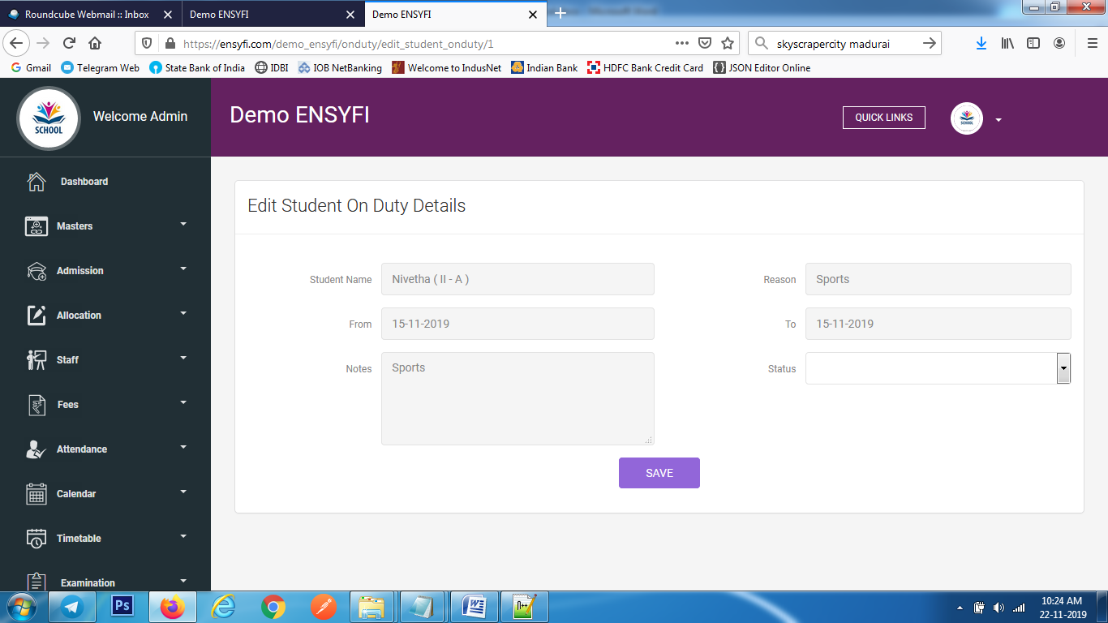

|  |  |  |
| --- | --- | --- |
| **Controller** | **Model** | **View** |
| Onduty (students) | Ondutymodel (get_student_onduty_details) | onduty/onduty_student |
| Onduty (edit_student_onduty) | Ondutymodel (edit_student) | onduty/edit_studentr_onduty |
| Onduty (update_stuonduty) | Ondutymodel (update_student_onduty) | onduty/edit_studentr_onduty |

**83. Control Panel - Teachers**

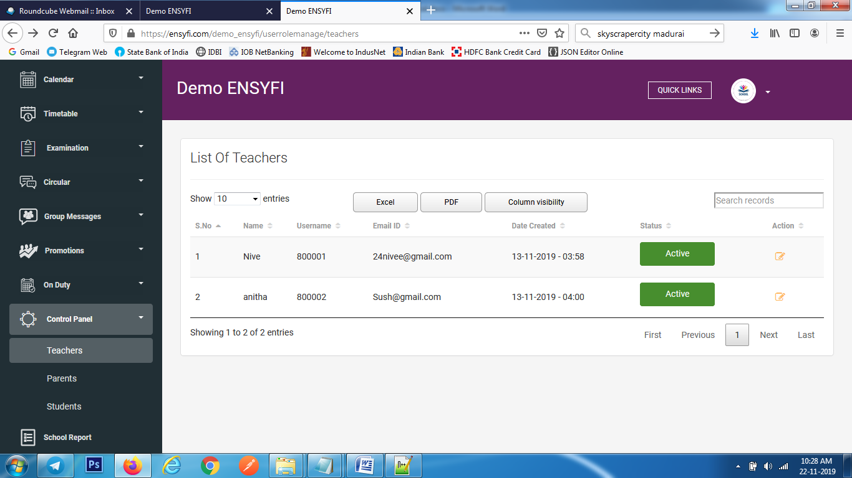

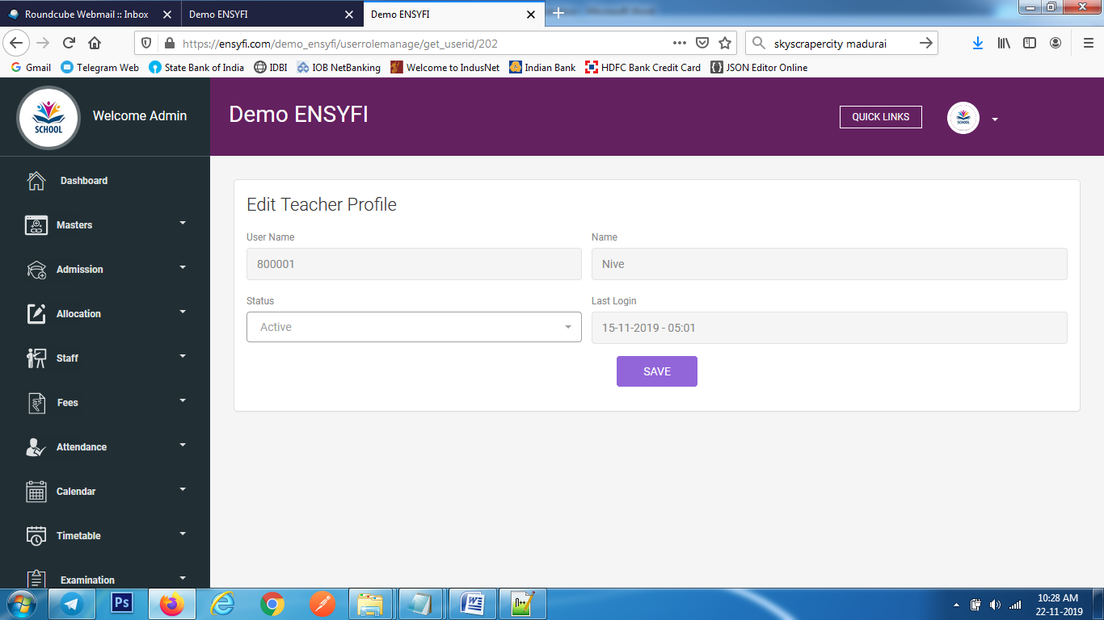

|  |  |  |
| --- | --- | --- |
| **Controller** | **Model** | **View** |
| Userrolemanage (teachers) | Usermodel (get_staff) | userrole/teachers |
| Userrolemanage (get_userid) | Usermodel (get_userid) | userrole/edit |
| Userrolemanage (save_teacher) | Usermodel (save_profile_id) | userrole/edit |

**84. Control Panel - Parents**

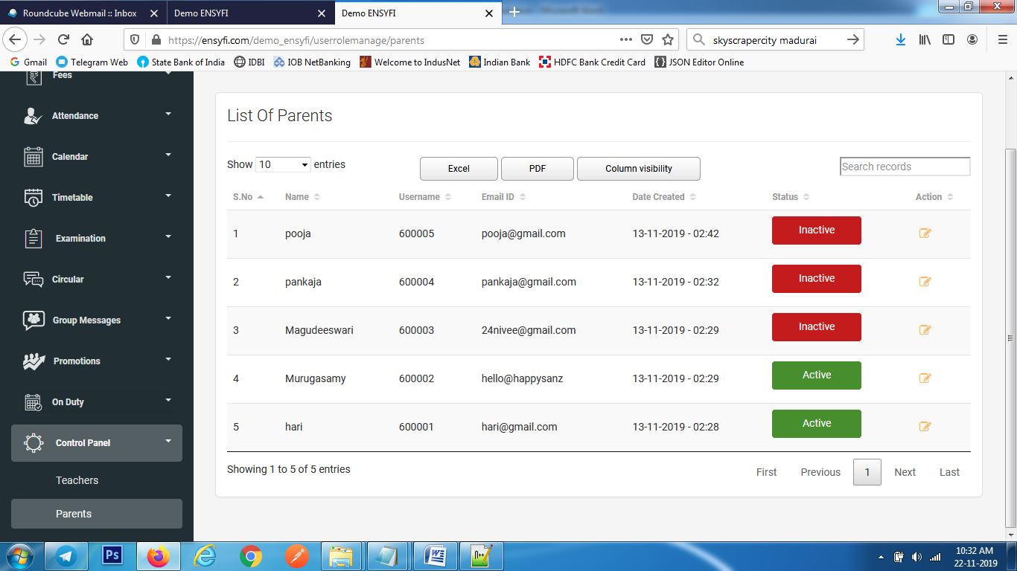

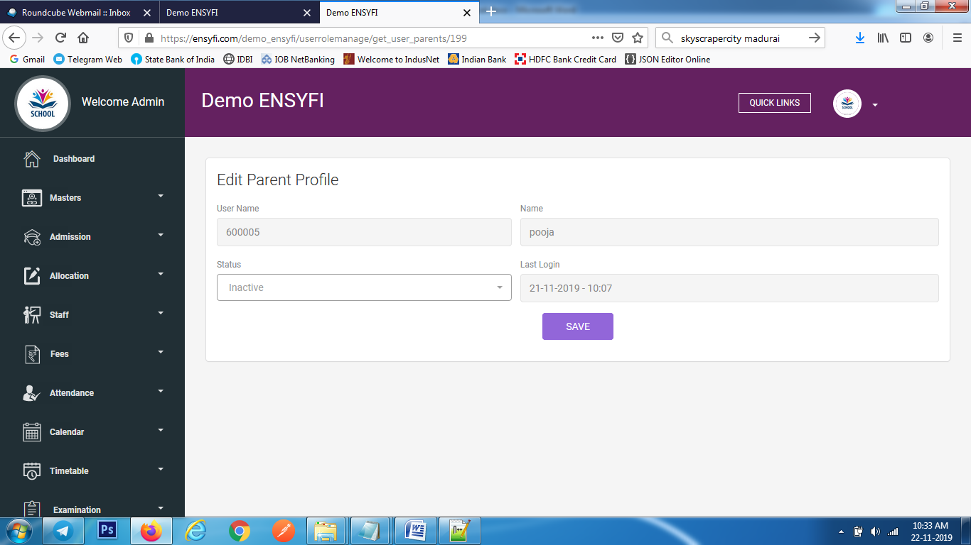

|  |  |  |
| --- | --- | --- |
| **Controller** | **Model** | **View** |
| Userrolemanage (parents) | Usermodel (get_parents) | userrole/parents |
| Userrolemanage (get_user_parents) | Usermodel (get_userid) | userrole/edit_parent |
| Userrolemanage (save_parents) | Usermodel (save_profile_id) | userrole/edit_parent |

**85. Control Panel - Students**

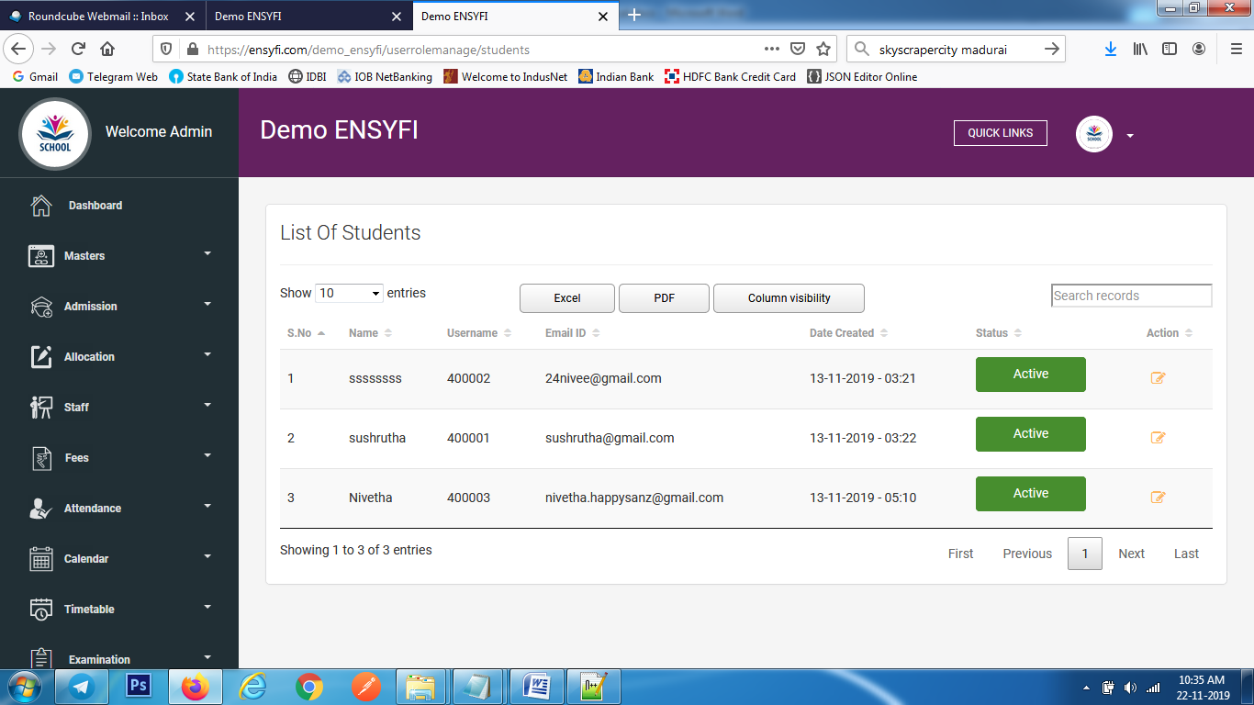

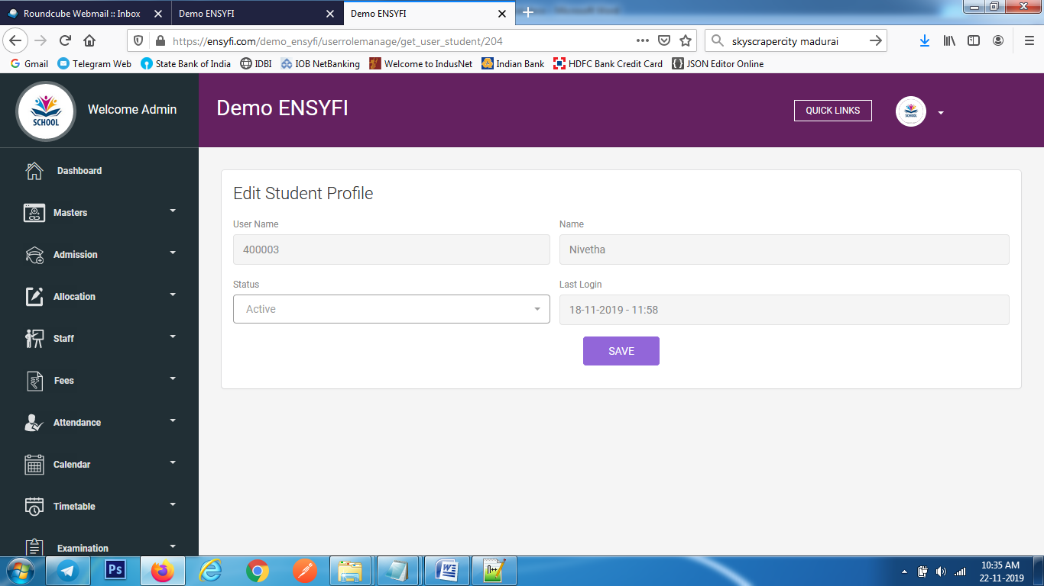

|  |  |  |
| --- | --- | --- |
| **Controller** | **Model** | **View** |
| Userrolemanage (students) | Usermodel (get_student) | userrole/students |
| Userrolemanage (get_user_student) | Usermodel (get_userid) | userrole/edit_student |
| Userrolemanage (save_students) | Usermodel (save_profile_id) | userrole/edit_student |

**86. Student Mark Report**

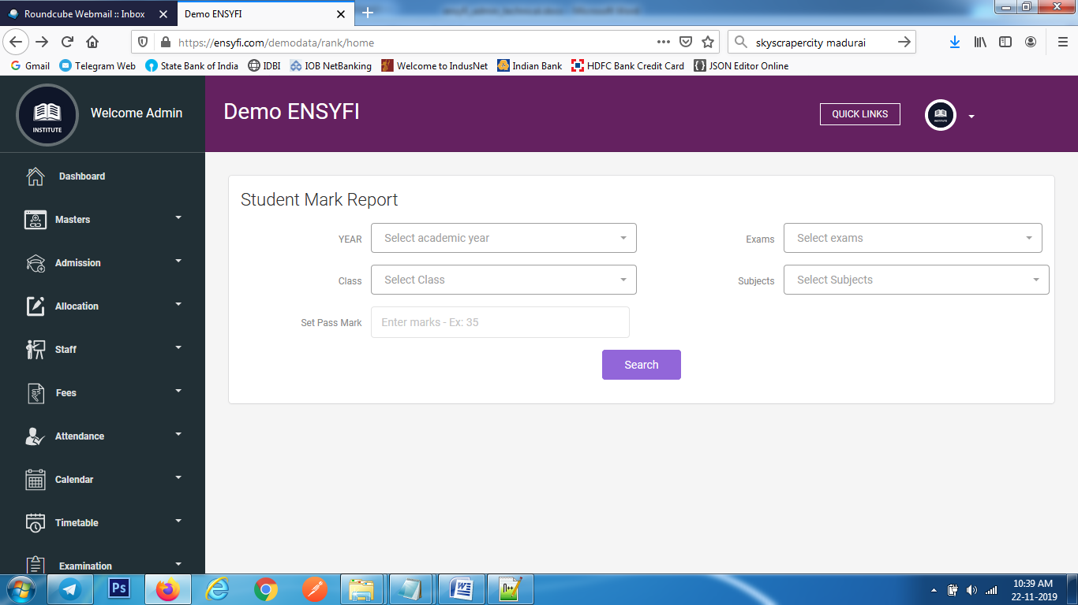

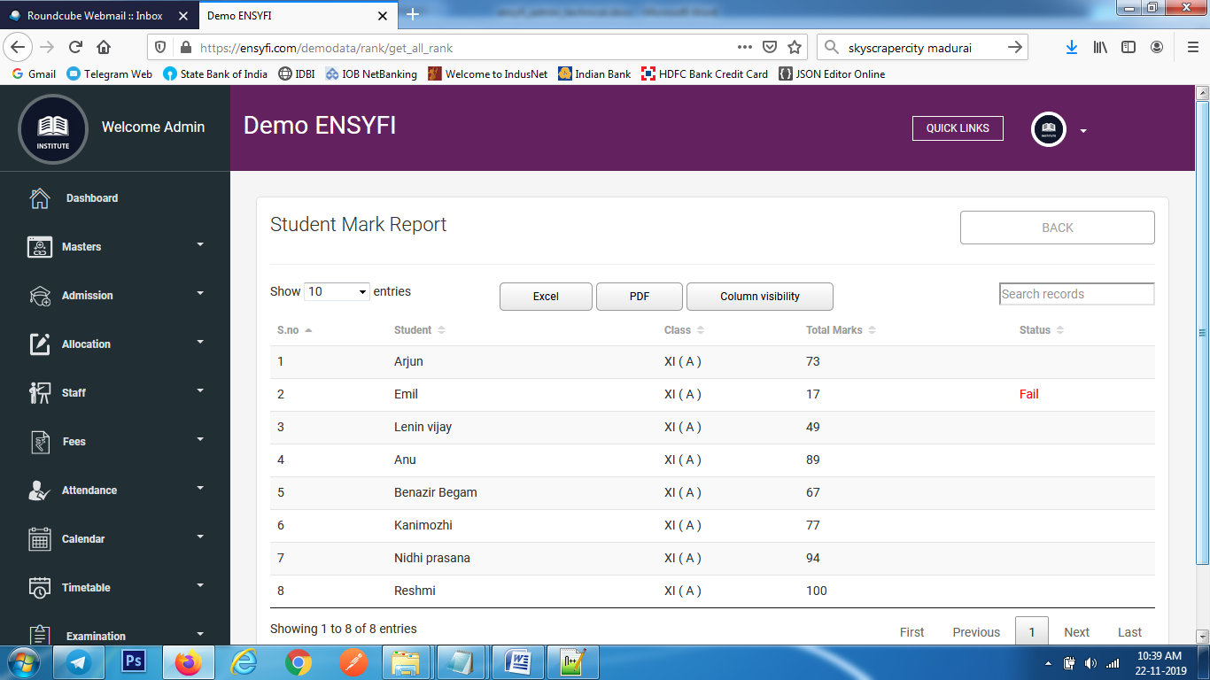

|  |  |  |
| --- | --- | --- |
| **Controller** | **Model** | **View** |
| Rank (home) | Yearsmodel (getall_years) | rank/exam_name_list |
| Rank (home) | Rankmodel (get_exam_details_view) | rank/exam_name_list |
| Rank (home) | Rankmodel (get_cls_details_view) | rank/exam_name_list |
| Rank (get_all_rank) | Rankmodel (get_rank_details_view) | rank/view_rank |

**87. Special Class – Create / list / Edit**

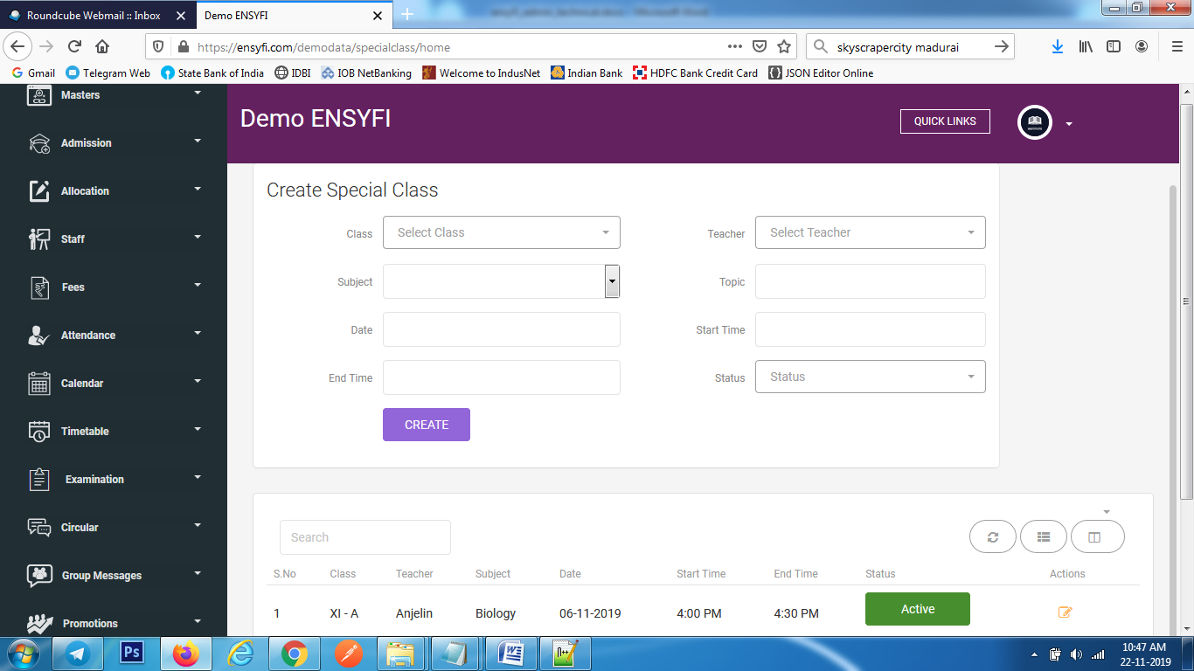

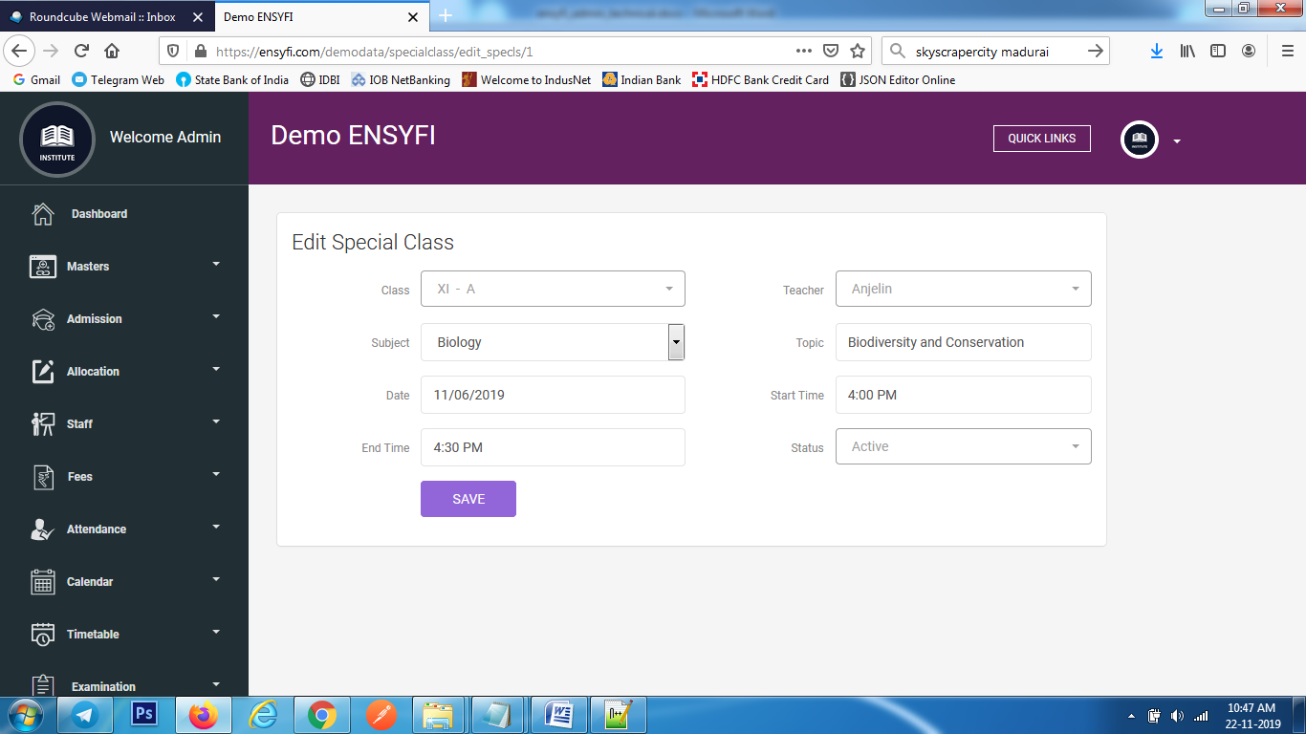

|  |  |  |
| --- | --- | --- |
| **Controller** | **Model** | **View** |
| Specialclass (home) | Specialclassmodel (get_teachers) | specialclass/add_special_cls |
| Specialclass (home) | Specialclassmodel (getall_details) | specialclass/add_special_cls |
| Specialclass (home) | Class_manage (getall_class) | specialclass/add_special_cls |
| Specialclass (add_special_cls) | Specialclassmodel (create_special_class) | specialclass/add_special_cls |
| Specialclass (edit_specls) | Specialclassmodel (edit_special_class) | specialclass/edit_special_cls |
| Specialclass (update_special_cls) | Specialclassmodel (update) | specialclass/edit_special_cls |

**88. Profile Picture Change**

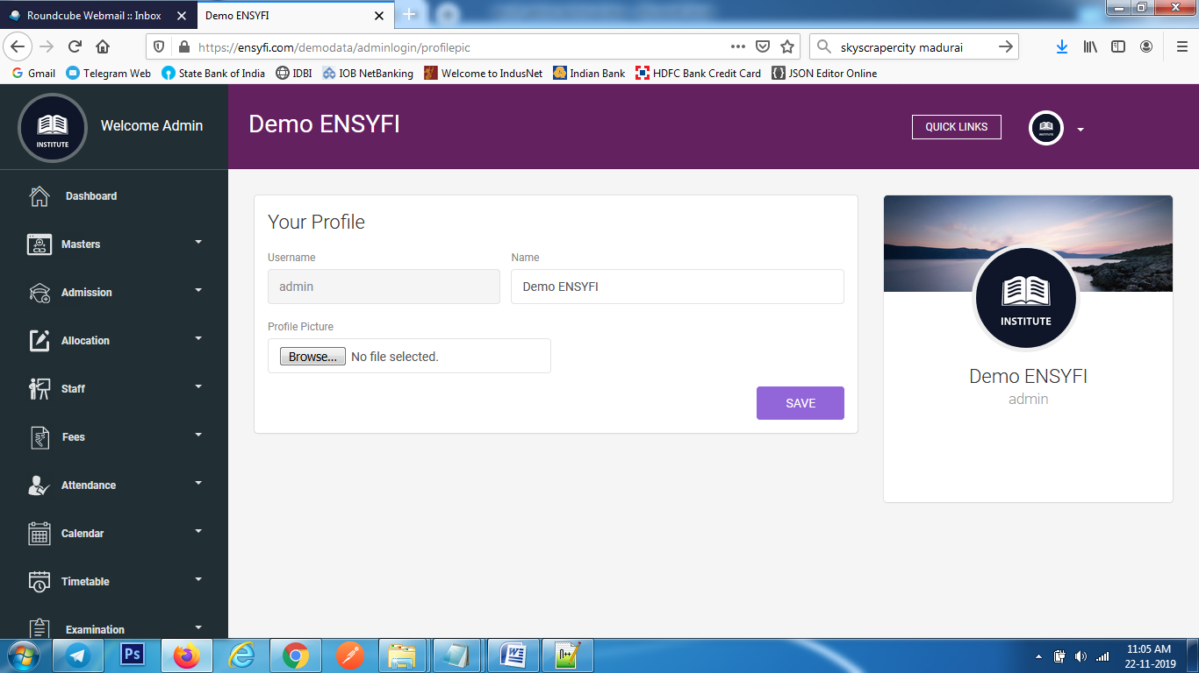

|  |  |  |
| --- | --- | --- |
| **Controller** | **Model** | **View** |
| Adminlogin (profilepic) | Login (getuser) | profile_update |
| Adminlogin (profileupdate) | Login (profileupdate) | profile_update |

**89. Change Password**

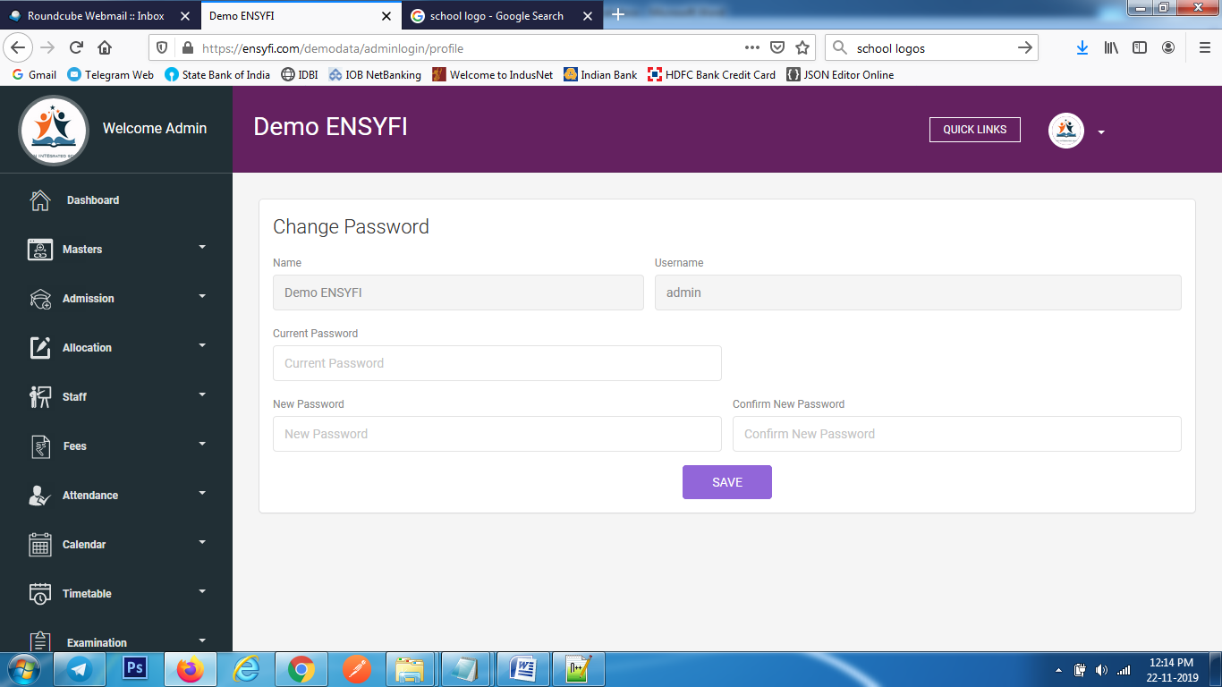

|  |  |  |
| --- | --- | --- |
| **Controller** | **Model** | **View** |
| Adminlogin (profile) | Login (getuser) | resetpassword |
| Adminlogin (updateprofile) | Login (updateprofile) | resetpassword |

**90. Notification Settings**

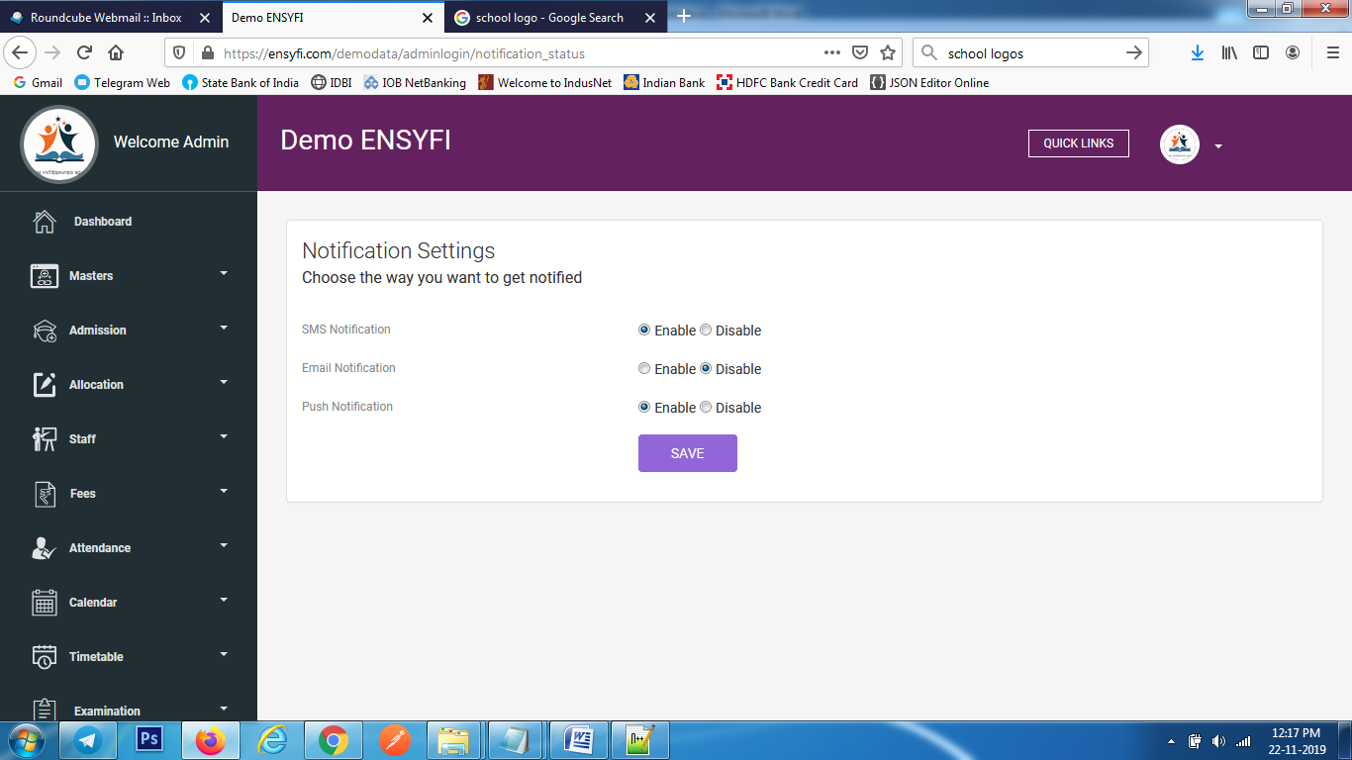

|  |  |  |
| --- | --- | --- |
| **Controller** | **Model** | **View** |
| Adminlogin (notification_status) | Login (getuser) | update_notification |
| Adminlogin (updateprofile) | Dashboard (check_notification) | update_notification |
| Adminlogin (update_notification) | Dashboard (check_notification) | update_notification |

**91. Logout**

* Clear Sessions and User data